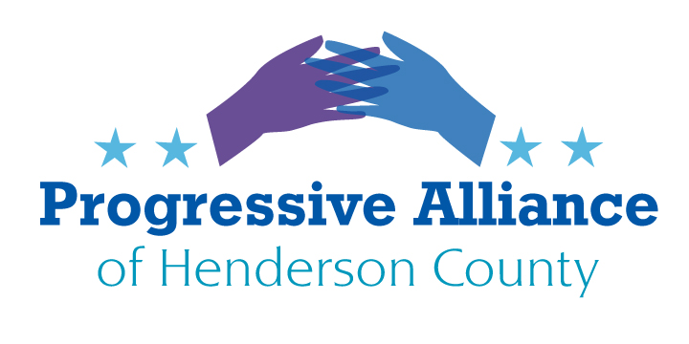
POSTCARD VIRTUAL PARTY #170 APRIL 24, 2020
Coronavirus- Covid-19
The situation changes daily, so current, valid news sources are vital. The tug of war between the administration and the states and municipalities was created by the President’s desire to appear to be on top of the crisis. This lack of leadership from the president has boiled down to the states having to assume responsibility for whatever is getting done to address the virus. Regionally, states have begun to band together to institute strategies for combating the virus and obtaining critical supplies and materials.
Write to Gov. Roy Cooper to encourage him to form an alliance with neighboring states to form realistic public policies to avoid a hodge-podge regionally of what policies/rules apply where. This will be difficult to accomplish since neighboring governors often have vastly different ideas about what is good policy. Everything is a compromise between what the absolute best courses of action are and what are realistically achievable. Gov. Cooper is wise to emphasize testing, tracing and trends (in infections and in healthcare response capacity) to form guidance about changes to current policies. We can support him – and this strategy – by so instructing our legislators, and by creative support of local businesses as we are able.
Covid-19 and Testing
The experts agree, one of the most important activities to control the virus is testing vast numbers of people to determine who is sick with the virus, who is not and who has recovered fully or never experienced symptoms. As one health care scientist stated, “It is impossible to control this crisis without identifying what is happening. We cannot rely on who has had the virus and on the morbidity rate, we need to know the disease’s future progress. Many of the sick may not show symptoms for days or even weeks following exposure, making this virus especially contagious. “
The President worsened this crisis even before there was a pandemic. First, he limited quick understanding and mobilization when he fired the White House staff that dealt with Pandemics in 2017. Then, word spread in January 2020 that a virus that was a serious public health threat was in China. He then denied it was serious for America; then, that it was going to be widespread. Then he assured us it would be gone by April, then that testing was soon to be available to anyone who wanted it. At every turn he lied, minimized, denied responsibility, downplayed and ultimately threw up his hands and said it was the States’ responsibility. As one Republican Representative from Texas stated Friday, “That’s just his style.” We cannot afford such posturing and deceit now, or at any time, from our President.
Write our legislators, Congress and Senators to encourage them that unified, coordinated, comprehensive actions must be taken now to address testing, hospital shortages, medical staff shortages (by denying entry to alien medical students and graduates), vital equipment and supplies for health care workers. This is indeed a war, and we are grievously short of these necessities.
Covid-19 and the Economy
The President is more concerned with his reelection than the crisis facing every person living in this country and across the globe. His only claim to fame, even though it is not deserved, has been the economy. This crisis is laying to waste any gains made by many Americans since the last crisis of the great recession. The President is scrambling to turn back the clock, hoping the crisis will just go away, and that any real damage will be limited to an indeterminate number of older or medically vulnerable Americans.
By pushing for a quick return to work and business-as-usual he is endangering huge numbers of citizens and residents. It seems that sacrificing American lives so that he can get his reelection will be easier to explain away and cover up than an economy that is struggling to recover come November.
Write your legislators to ignore the President and his unhinged and deadly plans and schemes. Demand that we achieve progress by making reasoned compromises, knowing that each decision may not be perfect but is the best we can do, given the circumstances.
Pandemics- who knew what and when
It is interesting and enlightening to see what had been predicted about our current pandemic situation. Take a few minutes to view the historic videos from two past presidents on YouTube:
George W. Bush Pandemics
https://www.youtube.com/results?search_query=george+w+bush+pandemic+speech
Obama Pandemic Predictions
https://www.youtube.com/results?search_query=obama+pandemic+speech
The thoughts were there but we, as a nation, totally missed the execution.
Write your representatives to demand that we have a unified approach to future health threats.

Pandemics and “The Greatest Healthcare System in the World”
“Our public health care system has been exposed for the threadbare veneer it has always been. Public health care dependent on private profit appears to be irreconcilable,” writes David Weintraub of the Center for Cultural Preservation.
Medical system consolidation and ‘not for profit’ hospitals have removed many of our resources, especially in rural areas. Hospitals run as businesses would seem to operate just like any other corporate entity- no excess capacity (hospital beds), minimum staff at the cheapest wages possible, money making equipment vs. essentials (ventilators, masks, etc.) and levels of service dependent on profit margins.
The Congress at large has written and approved policy over the last decades that have made this scenario possible. We cannot bury our heads in the sand and deny that real change is mandatory. We cannot afford to monetize everything.
Write our federal, state and local representatives to pressure them to plot a different course for our health care system. Health resources are going overmuch into boutique specialties and facilities, and cost of capital (return on investment), but not enough into basic care, prevention, and resiliency planning.
The US Postal Service and Privatization
As if on cue, our fearless leader is again calling for the US Postal Service to be privatized. Part of his reason is Amazon uses the Post Office and he hates Jeff Bezos. He also has connections to FedEx investors.
Republicans have hammered on the notion of privatizing the postal service for many years. It is the only government agency that is viewed as being required to pay for its own operations. What other major agency (Defense, Interior, EPA, Health, etc.) brings in public money directly to fund all its services? The only conclusion is the desire for a private enterprise to make billions in profits. Why not privatize everything in the government? This seems to be a Republican goal. If the post office loses too much money, raise the postal rates. This doesn’t sit well with the businesses (and their lobbyists) that utilize the bulk of the post office’s services. Under private ownership do we think the rates would go down? The notion that all organizations should be ‘run like a business’ has been proven false time and time again.
Write your Senators and Representatives to voice your opposition to the privatization of the US Postal Service. During a time of steep decline in use of several mail categories (ads, event announcements, items with online alternatives) this means Congress should take up part of the burden; rates should absorb some need also, with as little burden as possible on service standards. Please also ask for elimination of the 2006 standard requiring 75-year advance funding of Postal pensions- an absurd burden.
Public Service & Food for Thought
Looking for examples of true leadership in a crisis?
From Iceland to Taiwan and from Germany to New Zealand women are stepping up to show the world how to manage a messy situation for our human family. Add in Finland and Denmark and this pandemic is revealing that women in leadership have what it takes. The above countries’ women leaders have been faced with the same challenges this virus presents to the rest of the world and have taken tough, decisive actions to protect their countries as well as possible. Is the US lagging behind?
A Best Use for Government Stimulus Dollars
What is the best way to use the government check that many of us have or will receive? How they spend the money will not be an option for many of us, needing to buy food, medicines, pay rent, mortgages and a host of essential expenses. For others who have a livable fixed income or greater assets the choices may be less crucial. Helping relatives or friends is another choice. Spending the money to put more dollars in circulation in the economy will help everyone, directly or indirectly, but saving it will not have the same level of benefit. Spending it locally, as opposed to online through Amazon, Walmart, Apple, etc., would seem to have more benefit to those closer to home. Local small businesses are obviously struggling. Many restaurants have had to close temporarily. For those with options, buying into the future, so to speak, through gift cards and discount offers will put cash into the hands of businesses who might otherwise not make it through this period. It shows faith in our local market and hope for a faster return to a robust economy.

