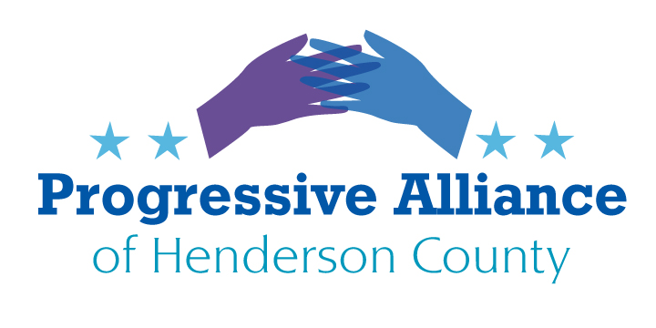

**Post Card Party # 265 October20, 2023**

**NATIONAL DOMESTIC VIOLENCE AWARENESS MONTH, 2023 THEME:  
IT’S IN OUR CONTROL TO END COERCIVE CONTROL**

**HOW TO END COERCIVE CONTROL IN NORTH CAROLINA**

**NEWS WE CAN USE:**  
RALEIGH, NC – August 17 2023 – Today, Legal Aid of North Carolina announced it has been awarded a $500,000 grant from the Governor’s Crime Commission, the chief advisory body on crime and justice issues to North Carolina’s Governor and Secretary of Public Safety, to support survivors of domestic violence, while also increasing awareness and education statewide.

**Please write to our State Senate and State House representatives to ask how they are supporting local domestic violence services and why they are committed to “end coercive control in North Carolina”. And/or write to NC Attorney General Josh Stein to ask how Henderson County receives a share of domestic violence services grants from state agencies, and why he is committed to “end coercive control in North Carolina”.**

**DIVERSITY, EQUITY, AND INCLUSION – BRING THE ISSUES HOME:   
Safelight publicly states that it “is committed to diversity, equity and inclusion (DEI).** To that end, we pledge to always self-reflect and regularly assess ways that we can continually improve our policy and procedures to best serve our community.

“This means we will:

* Be advocates for underrepresented groups in our area of expertise in our community
* Encourage community collaborations to assist our work in the community to serve underrepresented groups
* Continually learn and reevaluate to reflect best DEI practices in our policy and procedures
* Promote DEI through ongoing trainings for current staff
* Safelight welcomes all survivors (and their families) of domestic violence, sexual assault and child abuse regardless of race, color, religion, sex (including pregnancy, sexual orientation, or gender identity), national origin, disability, age, genetic information (including family medical history).”

**Please write to our state legislators to ask how they are supporting DEI at local domestic violence services and at other critical human services non-profits. And/or write to NC Attorney General Josh Stein to ask how he is supporting DEI throughout the state at local domestic violence services and at other critical human services non-profits.**

**NEWS THAT WORRIES US (1):**After lawmakers [**repealed pistol permit requirements**](https://www.dailytarheel.com/article/2023/04/city-pistol-permit-repeal-becomes-law) spring of 2023, overriding Gov. Roy Cooper's veto, some domestic violence advocates in the state have raised concerns about perpetrators’ access to firearms.  
  
**Please write to our state legislators to ask that they support sensible gun safety legislation to limit domestic abusers’ access to firearms, in order to reduce the risks partners face from domestic violence abuse that may involve gun violence that can wound and kill. And/or write to NC Attorney General Josh Stein to ask how he is supporting sensible gun safety legislation to reduce the risks stated above.**

**NEWS THAT WORRIES US (2):**North Carolina has a mandatory reporting law, NCGS § 7B-301 that states "any person or institution who has cause to suspect that any juvenile is abused, neglected, or dependent, as defined by NCGS § 7B-101, or has died as the result of maltreatment, shall report the case of that juvenile to the director of the department of social services in the county where the juvenile resides or is found.”

School personnel are all too often put in the position of observing signs of suspected child abuse and neglect, including but not limited to domestic violence situations. Republican Senate and House supermajorities just passed a “Parents Bill of Rights”, overriding Gov. Cooper’s veto. This legislation raises serious questions about assuring that school personnel report are not intimidated when reporting suspected child neglect and abuse. Will the “Parents Bill of Rights” give some parents and guardians the mistaken assumption that schools should favor their “rights” over the right of their children to not be abused or neglected?

**Please contact our state legislators to demand that they speak in support of school personnel when they must unfortunately make referrals to child protective services. And/or write to NC Attorney General Josh Stein to ask what actions he can take to limit damages that may result from the imposition of this so-called “bill of rights”.**