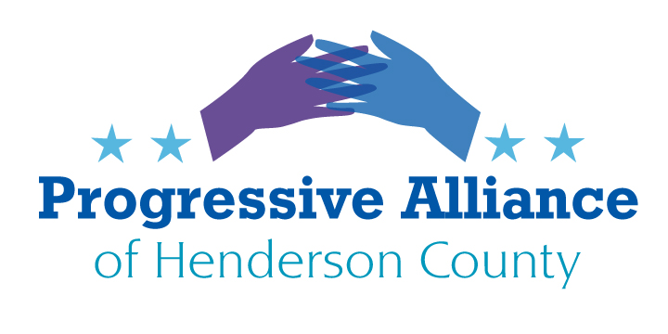

**Postcard Party #197**   **October 30, 2020**

**National**

(Note – this item was passed on from Vets for Peace, via Chris Berg):

Someone wrote about the stress Dr. Fauci is under, caused by the current administration and how many of his TV appearances are being canceled by the White House. She got an address for The National Institute of Allergy and Infectious Diseases and thought we all should send him a Thank You card...by mail.

The postage purchased will help the USPS and the cards may make Dr. Fauci's day and let him know how much he's respected and appreciated by most Americans.

If you're interested send a card to:

Dr. Anthony Fauci c/o  
NIAID Office of Communications and Government Relations  
5601 Fishers Lane, MSC 9806  
Bethesda, MD 20892-9806

**Logging in the Tongass National Forest**

President Trump will open up all 16.7 million acres of Alaska’s Tongass National Forest to logging and other forms of development, according to [a notice](https://public-inspection.federalregister.gov/2020-23984.pdf?utm_campaign=pi%20subscription%20mailing%20list&utm_source=federalregister.gov&utm_medium=email) posted Wednesday, stripping protections that had safeguarded one of the world’s largest intact temperate rainforests for nearly two decades.

As of Thursday (October 30), it will be legal for logging companies to build roads and cut and remove timber throughout more than 9.3 million acres of forest — featuring old-growth stands of red and yellow cedar, Sitka spruce and Western hemlock. The relatively-pristine expanse is also home to plentiful salmon runs and imposing fjords. The decision, which will be published in the Federal Register, reverses protections President Bill Clinton put in place in 2001 and is one of the most sweeping public lands rollbacks Trump has enacted.

Write to House Speaker Pelosi – it is time for the House to suspend appropriations for agencies intent on destroying our environment.

Honorable Nancy Pelosi

1236 Longworth HOB

Washington, DC 20515

**(From the Never-too-late-to-Act File):**

**The Senate Democrats’ Special Committee on the Climate Crisis is asking for your input.**

Senate climate hawks, led by Sen. Brian Schatz (a Climate Hawks Vote endorsee), are looking for bill ideas, whether this session or under a Joe Biden presidency, and they want to hear from you. Whether you’re a survivor of a climate disaster or you have a smart idea, squawk up!  
Not sure what to write? The Democrats want to hear how climate change is already affecting you, your family, your business, and your community, and how Congress can best facilitate the transition to a clean economy and a healthier environment for the benefit of all Americans.

Below are some questions to prompt ideas:

1. How has climate change impacted you, your family, and your community?
2. Are there existing programs or strategies that you or your community are using to address climate change that could be implemented at the federal level?
3. What national policies do you currently support that will mitigate climate change and improve American lives?
4. What types of federal investments do you see getting the biggest return in terms of mitigating climate impacts?
5. Have federal incentives prompted you or others in your community to purchase electricity from renewable sources, an electric car, or other low-emission technologies? If current incentives have not, what types of incentives might be more appealing?

Reference: [https://www.vox.com/energy-and-environment/21252892/climate-change-democrats-joe-biden-renewable-energy-unions-environmental-justice](https://click.everyaction.com/k/17872316/209570843/-898741880?nvep=ew0KICAiVGVuYW50VXJpIjogIm5ncHZhbjovL3Zhbi9FQS9FQTAwNS8xLzc2NjM2IiwNCiAgIkRpc3RyaWJ1dGlvblVuaXF1ZUlkIjogImJkNDllYTFlLTExYWYtZWExMS05YjA1LTAwMTU1ZDAzOWU3NCIsDQogICJFbWFpbEFkZHJlc3MiOiAibmR)

Senator Brian Schatz

722 Hart SOB

Washington, DC 20510

**North Carolina**

**NC Policy Watch: "Supreme Court refuses to take up Equal Rights Amendment dispute; advocates persist"** "One month after Supreme Court Justice Ruth Bader Ginsburg died, having argued that the nation needs the Equal Rights Amendment, the surviving justices have dismissed an effort by women’s groups to enshrine the ERA in the U.S. Constitution. The court refused to take up the matter at the behest of ERA proponents, who will instead make their case before the U.S. Court of Appeals for the 1st Circuit, which they’d hoped to bypass. Advocates including Equal Means Equal and the National Conference of Mayors are seeking to force the Trump administration to acknowledge that the required 38 states have ratified the amendment and that it should become the law of the land. Attorney General William Barr is officially ignoring the amendment’s ratification by the 38th state, Virginia. Barr’s Department of Justice instructed the federal archivist, David Ferriero, to reject the ratification documentation on the basis that it arrived decades too late to be counted. But so did the 36th and 37th ratification votes, by Illinois and Nevada, in 2017 and 2018, which Ferriero did accept and record after the deadline, which was set in a preamble to the amendment itself and later revised by Congress." (NC Policy Watch, [10/27/20](http://r20.rs6.net/tn.jsp?f=001JCA-aTjLSHqtByhATV6FQl976ituLYIxTV48EkSAhZHOWmLePlNYOqPLsvemjn53XaB_9cAvkgUshPrAfDouhnKzHfHA0SxORoQnP-_8FRlMpgBbyTDe0z1zckljLmlXY9_O4_SVDdLkP38oB9sXCUJngCTs_j0kDHq1joEldxkwtGHCck2Lt7maSdUuolo9WEDHOLgtTG1c-iq3FmtcbfqIRXkrzm6))

**Recommended action: Contact your newly-elected/reelected NC General Assembly members (State Representatives and Senators) and demand that NC join the electoral and legal fight to enshrine the ERA in our national Constitution.**

**Local**

The frenetic 2020 election will soon be in our rearview mirrors, why not take advantage of the temporary lull and get directly involved in local politics? Both the County and City have numerous Boards and Commissions which allow citizens to weigh in on myriad issues. It takes no special expertise – this writer has been appointed to 3 such boards in the past 14 months just by filing an application with the City and the County. Openings occur constantly as members drop off or reach the end of their terms. Check for descriptions and applications at the following URLs:

City of Hendersonville:

https://www.hendersonvillenc.gov/boards-and-commissions

<https://www.cognitoforms.com/CityOfHendersonville4/boardcommissioncommitteeappointmentapplication>

Henderson County:

<https://www.hendersoncountync.gov/boc/page/citizen-participation-boards-and-committees>

<https://www.hendersoncountync.gov/sites/default/files/fileattachments/board_of_commissioners/page/4851/application3.pdf>

**From the HCDP Alert on Oct. 28:**

Announced Tuesday:  
Justice Kavanaugh laid a shot across the bow of “the” North Carolina voters. While this was just an “opinion” (that absentee ballots received after 5 pm on November 3, 2020 should not be counted).

Announced Wednesday:

The Supreme Court rejected the trump campaign’s attempt to block NC counting ballots postmarked by Nov. 3rd, yet received after the 3rd.

Let’s be careful to ensure your absentee ballot-vote is counted.  
  
If you still have your absentee ballot or have a friend/relative who still has their ballot, return it NOW. Today. IN PERSON. Advisable NOT to mail it at this (late) date per USPS!

BE ON THE SAFE SIDE