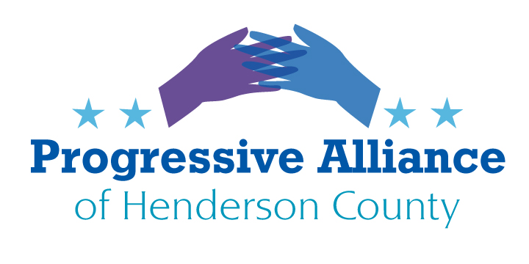
Virtual Post Card Party # 249 September 16, 2022
THE LOCAL FOCUS: THE DRAFT HENDERSON COUNTY COMPREHENSIVE PLAN
Round 2 of our suggestion concerning the Henderson County Comprehensive Plan:
At the 9/6 Commissioners’ meeting to address the draft Henderson County Comprehensive Plan, the Commissioners said they hadn’t yet reviewed the draft plan (and that they hadn’t prepared it themselves).
The draft plan is now on the county’s website, all 92 pages of it. As PAHC we don’t have a single unified set of recommendations about what the final adopted plan should look like. We do recommend that PAHC participants look at the links provided below to form your own perspectives about elements of the plan, and that you use the feedback/comments opportunities to state what you think should be in the plan, should be amended, or should be removed from it.
Most important right now is to demand that the Commissioners hold a series of public meetings at varied times about each section of the plan, with a comprehensive report on all public and private comments, including those submitted online, in correspondence, and verbally or in writing at public or private meetings. As this process develops, PAHC participants can suggest areas of concern that postcard parties could address in specific ways.
To send a postcard to one or more of the Commissioners:
1 Historic Courthouse Sq, Hendersonville, NC 28792
J. Michael Edney jmedney@hendersoncountync.gov
David Hill davidhill@hendersoncountync.gov
Daniel Andreotta dandreotta@hendersoncountync.gov
William Lapsley wlapsley@hendersoncountync.gov
Rebecca McCall rmccall@hendersoncountync.gov
Comprehensive plan main page:
https://www.hendersoncounty2045.com/
Draft plan:
https://www.hendersoncountync.gov/sites/default/files/fileattachments/planning_board/page/136226/hccp_2045_draft_2022_09_09_reduced.pdf
Community survey:
https://www.hendersoncounty2045.com/_files/ugd/d01c76_8b6853a406bc4ec88939d1939ba23999.pdf
DO DEBATES RATE: YES!
Republican NC 11 Congressional candidate Chuck Edwards was in favor of multiple candidate debates when he was seeking the Republican nomination. Now he is running scared, despite having structural advantages in running against Democrat Jasmine Beach-Ferrara in usually reliably Republican Western North Carolina, and he has agreed to only one debate with his personable and articulate opponent. Please let him know you demand that there be many more debates this fall to cover areas of concern that can’t possibly be covered in only one. Please see the contact information following the next item.
WHOSE FAMILY FIRST?
Republican NC 11 Congressional candidate Chuck Edwards appears to have taken a leadership role in the new arch-conservative (a/k/a reactionary) group Family First. Please contact him to ask who counts as a family in his calculus and what should be done about or to the families that don’t count as acceptable, perhaps even legal, in his estimation.
Chuck Edwards [Republican for US Congress – NC 11]
300 N. Salisbury Street, Rm. 628
Raleigh, NC 27603
https://www.chuckedwardsforcongress.com/
PREPARE FOR THE WORST IN VOTER SUPPRESSION CORRUPTION
This fall the U.S. Supreme Court will hear a case called Moore v. Harper, centered on newly drawn maps of voting districts for North Carolina's 14 seats in the next U.S. House of Representatives. This obscene arrogation of power was cooked up by the slavering Republican majority in the North Carolina General Assembly, expecting to get the hyper-right-wing Supreme Court to neuter state courts based on the ”independent state legislature theory,” which three justices have already signaled they would support. The Republican NC lawmakers argue that the U.S. Constitution's Elections Clause gives state legislatures the power to determine how congressional elections are conducted without any checks and balances from state constitutions or state courts.
We must prepare for the worst to happen. The following organizations are among those mobilizing in frontline communities in North Carolina to educate and empower voters in the upcoming 2022 elections and beyond. The Progressive Alliance of Henderson County is also implementing a broad Get Out the Vote campaign. Please contact these groups to offer whatever support you are able to provide. Remember that as an NC Senator, Chuck Edwards is an enthusiastic litigant, seeking to subvert everyone’s right to vote.
North Carolina Asian Americans Together (NCAAT) supports equity and justice for all by fostering community among Asian Americans and allies in North Carolina through civic engagement, leadership development, grassroots mobilization, and political participation.
711 Hillsborough Street, Suite 102, Raleigh, NC 27603
Democracy North Carolina uses research, organizing, and advocacy to strengthen democratic structures, build power among disenfranchised communities, and inspire confidence in a transformed political process that works for all. They organize on the grassroots level to promote safe voting sites and expand access for eligible voters through their election advocacy and protection programs.
3000 Aerial Center Pkwy Suite 160, Morrisville, NC 27560
Forward Justice is a law, policy, and strategy center dedicated to advancing racial, social, and economic justice in the U.S. South via a number of avenues, including removing barriers to vote post-incarceration and increasing public understanding of the racially discriminatory origins of voter suppression tactics.
400 W Main St, Durham, NC 27701
El Pueblo builds collective power through leadership development, organizing, and direct action so that the Latinx community and other marginalized communities control their own stories and destinies.
2321 Crabtree Blvd, Suite 105, Raleigh, NC 27604
Muslim Women For works to foster and nurture vibrant Muslim societies that create positive social change and uplift their communities through political education, leadership development, relationship building, women of color empowerment, and grassroots organizing.
1127 Kildaire Farm Road, Cary, NC 27511
Advance Carolina is a Black-led organization that educates and mobilizes African-American and progressive voters to take charge of their communities by building and supporting permanent political and electoral infrastructures and exercising and expanding political influence.
6409 Fayetteville Rd #120-179, Durham, NC 27713
LOCAL** Down Home North Carolina is unique in their focus on building permanent, statewide organizing infrastructure in North Carolina’s rural places through their growing network of member-led, county-based chapters.
301 N Haywood St, Waynesville, NC 28786
The Southern Coalition for Social Justice believes that communities engaged in social justice struggles need a multi-pronged approach including a team of attorneys, social scientists, researchers, community organizers, and media specialists to support them in their efforts to dismantle structural racism and oppression.
1415 W North Carolina 54 Suite 101, Durham, NC 27707

