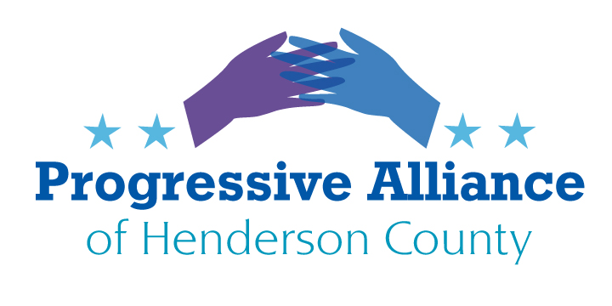
Post Card Party # 260 March 17, 2023
HENDERSON COUNTY COMPREHENSIVE PLAN 2045: LOOK TO THE FUTURE BY PROTECTING OUR COUNTY’S ENVIRONMENT & DIVERSE ECOSYSTEMS & VALUED RURAL CHARACTER
Nancy Diaz of MountainTrue, our local environmental advocacy organization, provided an extended analysis and a letter that was sent to the commissioners several weeks ago. We have paraphrased a few statements one might be summarized on a postcard. https://mountaintrue.org/open-letter-re-henderson-county-comprehensive-plan/
- Henderson County Commissioners need to go back to to the language of the 2045 Comprehensive Plan before it was eviscerated in the December revision.
- Henderson County residents have made our priorities clear: protect open spaces and forests, preserve farmland, and conserve unique natural areas.
- Henderson County residents expressed strong support for improving water quality; for reducing vulnerability to wildfires, flooding, and landslides; and for increasing energy efficiency.
- The Commissioners should implement a preservation program to establish agricultural conservation easements.
- The County Commissioners should “encourage the preservation of open space and conservation areas in and around areas with a high potential for landslides” by establishing a strong steep slopes construction code.
- The County Commissioners should incorporate this definition: Green infrastructure is a network of natural and built green spaces that provide environmental, economic, and social benefits. It includes green spaces such as parks, trees, urban forests, streetscapes, green roofs and green walls, rain gardens, and more. These green spaces help to mitigate the effects of urbanization, protect ecosystems, reduce pollution, and improve public health.
- The County should restore this assertive, necessary language: “As the frequency of extreme weather events increases, flooding, landslides, and drought-induced fires are likely to become a more regular occurrence” and should now add: “The County will develop policies and procedures that will improve the resiliency of the County to wildfires, flooding, and landslides.”
- The County should restore the recommendation to introduce Smart Solar programs.
For postcards, the Henderson County Commissioners’ address is: 1 Historic Courthouse Sq, Hendersonville, NC 28792
They can be contacted via email at:
David Hill – davidhill@hendersoncountync.gov
William Lapsley – wlapsley@hendersoncountync.gov
Rebecca McCall – rmccall@hendersoncountync.gov
Mike Edney – jmedney@hendersoncountync.gov
Daniel Andreotta – dandreotta@hendersoncountync.gov
Hendersonville’s City Councilors have a role to play in joint planning with County government to increase environmental safeguards and needed infrastructure within the city limits while judiciously supporting multi-unit housing and sustainable industrial and commercial development.
The councilors can be contacted via email at:
For postcards, the Hendersonville Councilors’ address is: 160 Sixth Ave. E., Hendersonville, NC 28792
They can be contacted via email at:
Barbara Volk: bvolk@hvlnc.gov
Lynsey Simpson: lsimpson@hvlnc.gov
Jennifer Hensley: jhensley@hvlnc.gov
Debbie O’Neal-Roundtree: droundtree@hvlnc.gov
Jerry Smith: jerrysmith@hvlnc.gov
Our representative in the NC Senate and House ought also to careful stewards of our county’s resources and opportunities. One can also send them postcards urging them to support a Comprehensive Plan 2045 that commits to protecting our environment and preserving the most valued parts of our community heritage and diversity.
By the way, so far it appears that none of our postcard writers have ever received a reply from Tim Moffitt in his years in the NC House or now that he’s an NC Senator. House member Stephanie Balkcom also appears disinclined to respond to us. Data on responses from Jake Johnson will also be welcome. Please contact PAHC leadership or the Facebook page if you receive a response from any of them.
Representative Tim Moffitt, 16 W. Jones St., Room 2111, Raleigh, NC 27601-1096 Tim.Moffitt@ncleg.gov 919-733-5745
Jennifer Balkcom, 16 West Jones Street, Rm. 2215, Raleigh, NC 27601-1096 ennifer.Balkcom@ncleg.gov 919-733-5956
Jake Johnson, 300 N Salisbury St., Room 306B1, Raleigh, NC 27603 Jake.Johnson@ncleg.gov 919-715-4466

