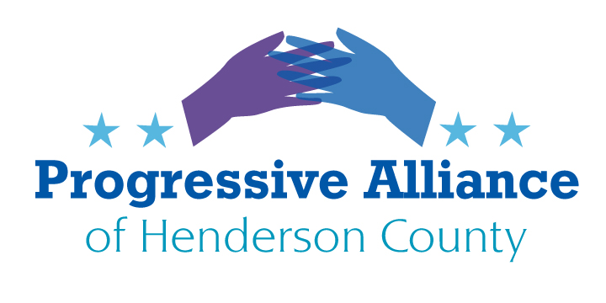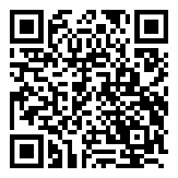
September 25, 2020 Suggestion Sheet #192

Have you filled out your Census for yet? Thousands of dollars per year, for 10 years, are lost for every person who doesn't reply. The deadline is September 30. Go to:

my2020census.gov

RBG

Friends, there is NO choice but to launch a full-fronted, daily assault on the U.S. Senators whose decisions are key in preventing another radical right-wing bigot being appointed to SCOTUS, and returning the status of women and minorities to the 1950s or earlier. We won't bore you with the facts - you already know them. POUND on Sen. Tillis and Burr, as futile as it may seem. Also contact the senators (especially Republican) on the Senate Judiciary Committee (list appended). The committee members can be reached at:
224 Dirksen SOB
Washington, DC 20510
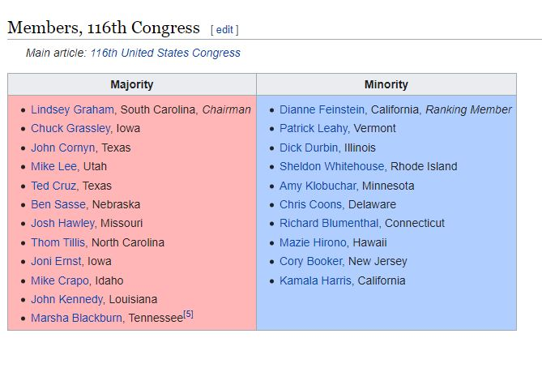
Election 2020

Everyone on this list knows this is the most important election of our lifetimes. What you may not know, is just how dire the scenarios are for anything but an overwhelming, incontestable Biden victory, with as many votes as possible in as early as possible-- and what you can do to help ensure them.
I urge you to read this cautionary piece by Rosa Brooks, the convener of the Transition Integrity Project, to see how dire anything short of that could be: What’s the worst that could happen?
Many of you are leading or staffing organizations that are working 24/7 on this and need no suggestions. Thank you for all you do—and are doing right now to stop the GOP from stealing Ruth Bader Ginsburg’s seat to award it to the likes of Ted Cruz.
But for the many readers who have asked what they can do, particularly in bright blue or deep red states where your efforts might feel superfluous now, below are links to groups doing excellent work in swing states that would welcome your help with phone-banking, text-banking, letter-writing, and more. COVID has taken away canvassing so this work is all the more crucial—and it can all be done virtually from afar!
I will list several organizations because they run phone banks and text banks at different times so you can see which fit your availability, if interested.
- Flip NC has been doing fabulous work in NC for 2018 and now 2020 and has superb data and calling technology to make efficient use of you shifts. It is so heartening to us in NC to see folks from other states joining the phone banks!
- Red2Blue is a national organization I’ve heard good things about from a friend who has been calling with them from Brooklyn to swing states for months.
- Swing Left is another national organization whose remote work I’ve heard good things about.
For those of you would rather write than call voters, I’ve heard praise for Vote Forward.

State

Virtual Public School:
A complaint lodged by John Scanlon and his family was the catalyst for a damning state audit that found courses offered by NCVirtual Public School lacked quality and rigor, and that educators hired to create content for an honor’s history course engaged in plagiarism and copyright infringement. The state Department of Public Instruction is the administrator for the school.
State Auditor Beth Wood cited the family’s role in the investigation while presenting the findings to the Joint Legislative Education Oversight Committee on Tuesday.
But the Scanlon family did not celebrate its hard-fought victory.
“We were never looking for vindication, and do not gain any satisfaction from today’s hearing,” John Scanlon told Policy Watch on Tuesday. “We spent hundreds of hours forcing DPI [NC Department of Public Instruction] to produce documents, reviewing them, and piecing together the picture of mismanagement at NCVPS.”
Scanlon said he is grateful for Wood’s tenacity in pursuing the truth. But he is “disheartened” by the response from the State Board of Education and DPI, who, he said, appear interested only in protecting their image.
“Clearly, they are more focused on not looking bad than in providing a quality education to North Carolina’s students,” Scanlon said. “Will the [Joint Legislative Education Oversight] Committee hold them accountable for fixing the problems at NCVPS? Only time will tell. So far, we have found few people in our state government who care enough to see this work done.”
Write to the members of the State Board of Education and demand that they make the NCVirtual Public School accountable for their massive infusion of taxpayer money.

Reopening Schools in NC, safely.
Headline: "Teachers group to fight reopening NC elementary schools. NCAE says move unsafe." "Citing COVID-19 concerns, the North Carolina Association of Educators is asking teachers to lobby school districts not to reopen elementary schools for full-time, in-person instruction. Gov. Roy Cooper announced Thursday that he's allowing school districts to reopen elementary schools, starting October 5, under a "minimal social distancing" option called Plan A. that allows all students to be on campus daily. It eliminates the current requirement that elementary schools reduce capacity to maintain social distancing in classrooms. At an emergency town hall meeting Thursday night, NCAE leaders told the 1,000 virtual attendees that Cooper’s decision endangers students and school employees. Bryan Proffitt, NCAE’s vice president, said they’re now being “forced to fight against our principals, our school boards and our school district administrators” to keep schools from adopting Plan A." (News & Observer, 9/18/20)
Write to your State reps, as well as Gov. Cooper, and insist that teachers, staff, and parents not be forced to put their lives in danger in the rush to send children back to physical school.

