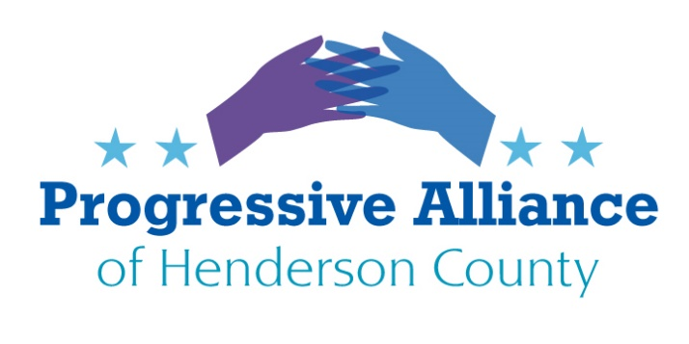

Postcard Party # 145 November 1, 2019

National

Contempt of Congress:

To Senators Burr and Tillis and Representative Meadows: If you don’t start arresting those who are in contempt of Congress, you will become irrelevant, especially under a dictatorship. Do your job and use your power wisely; or pack up and go home permanently.

The flash mob mentality exhibited by the Republicans storming a closed session, had the optics of interfering with the conduct of the House inquiry and obstructing testimony, and also witness intimidation and tampering.

Moving Money to Pay for a Border Wall:

Write Senators Burr and Tillis and Representative Meadows: There is NO national emergency on the southern border except in the minds of Trump and his minions. Quit moving needed funds for infrastructure and military housing to pay for a ludicrous campaign promise. NO WALL.

Whistleblower Protection Program

Write Department of Labor Secretary Eugene Scalia, and Senators Burr and Tillis and Representative Meadows: Whistleblower laws are enforced by OSHA. OSHA has not had a leader since Trump took office. His last nominee, Scott Mugno, withdrew. Protect whistleblowers fully, any leak of an identity will reflect badly on anyone who cannot protect a whistleblower. Burr should especially use his Intelligence brief and should be incensed by Attorney general Barr acting like 45’s sledgehammer to suppress anyone. Do your job!

State & Local

Write to City Council members: A program in Little Rock, Arkansas called Bridge to Work pays homeless people (people without shelter) $9.25 an hour to pick up trash around the state capital. In our area there are many parks and forests that could really use some clean-up help to make us even more beautiful. There are about 100 documented people without shelter in Hendersonville. Many would appreciate an opportunity to do something. (Mayor Barbara Volk, Mayor Pro Tem Ron Stephens, and Council Members Steve Caraker, Jerry Smith, and Jeff Miller; all at City Hall, 160 6th Ave. E., Hendersonville, 28792).

Write Sheriff Griffin: We would very much appreciate and enjoy chatting with you at an upcoming Postcard Party, sponsored by the Progressive Alliance of Henderson County, held every Friday from 4:30 to 6 PM at Sanctuary Brewing, 147 1st Ave. E, Hendersonville. It would be an opportunity for you to mingle with very active and involved citizens of Henderson Co. We hope to see you very soon.

Colorado Sanctuary state

Write Governors of Colorado and North Carolina, and NC Senator Edwards and Representative McGrady. President Trump: Thank Governor Jared Polis who signed HB19-1124 (Protect Colorado Residents from Federal Government Overreach) act in an effort to become a sanctuary state for immigrants. Ask our state legislators to pass similar bills. Tell Trump: Colorado teaches geography in kindergarten.
Vote No on HB 140

Contact State Sen Edwards and Rep. McGrady to express your opinion regarding HB 140.
HB 140 would allow the current Republican majority to reject the first redistricting plan submitted by the Legislative Services Office and subsequently amend the second plan to suit their own partisan purposes. Governor may not have the authority to override with a veto.

HB 140 is defective in this respect in that it purports to provide for an independent commission to draw and submit legislative and Congressional district maps to the General Assembly. Pull the curtains back. The bill assigns responsibility for this duty to the Legislative Services Office. The Legislative Services office is not an independent commission. It is established by statute but its members and conditions of employment are determined by the Legislative Services Commission (NCGS 120-32(1)). The Legislative Services Commission is appointed by the majority leaders of both houses. So it's smoke and mirrors. If the GA Republicans really wanted to assure nonpartisan independently drawn legislative and Congressional districts, we would have a bill that provided for a Commission composed of, say, 7 members; 3 selected by the leadership of each party and the 7th by majority vote of the 6. Or something similar to that.

In adding a new section to Article II of the NC Constitution entitled, "Section 25. Redistricting," paragraph (3) of the same reads as follows: “Redistricting commission. The General Assembly may authorize a redistricting commission to establish Congressional and legislative districts."

It seems to be in direct conflict with the express purpose of the proposed Constitutional Amendment which provides in detail for such a commission (the Legislative Services Office; 120-4.52 and 4.53.) This paragraph says the General Assembly "may," authorize, not "shall" authorize a redistricting commission.

Finally, "120-4.55. Temporary Advisory Commission" states that the commission "shall be established as provided by this section." I couldn't find anything in that section addressing how the commission would be established. It's likely that the un-amended portions of GS 120 dealing with the authority and duties of the Legislative Services Commission (remember them?) provide for the appointment of members of legislative commissions. Surely they didn't have such a partisan political scheme in mind when drafting this little paragraph.

In summary, there are at least 4 areas of concern with HB 140. It's a puppet show. Even the title of the bill is deceptive: ". . . FAIRNESS AND INTEGRITY . . . NONPARTISAN REDISTRICTING . . . "Whistleblower Protection Program

>The Progressive Alliance of Henderson County’s individual members have their own opinions and positions on many varied, important issues. We respect and appreciate fact-based opinions and encourage open-minded critical analysis. As an entity, we endorse no specific political candidates.

