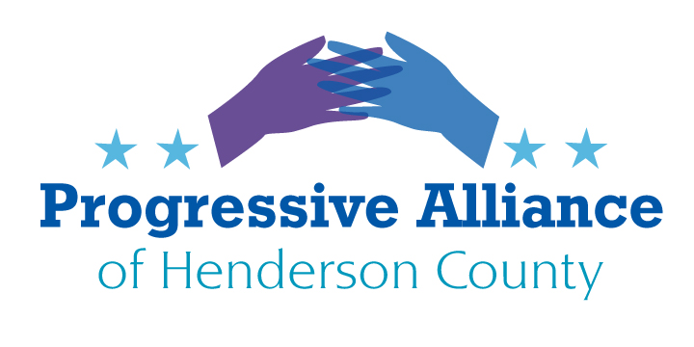

POSTCARD PARTY VIRTUAL #186 August 14, 2020

National

THE CENSUS
An estimated one million children under the age of five were NOT counted in the 2010 Census. That is believed to be the most numerous by-age undercount. IF you see a parent with young ones locally you can talk to briefly, please ask them to go to https://2020census.gov/ - or call 844-330-2020 [English] or 844-468-2020 [Spanish] if they have not responded to Census. The website ‘contact us’ option also has call-in numbers for eleven other languages and for the hard-of-hearing [TDD 844-467-2020] are at the site, also explanations of the confidentiality of responses, even from law enforcement agencies (with severe penalties), as are many reasons to respond.

Immigration Fees: from NC Policy Watch 8/10
The Trump administration has nearly doubled the cost of applying to become a U.S. citizen, a development immigration advocates are likening to “another form of voter suppression.”
U.S. Citizenship and Immigration Services (USCIS) published a final rule in the Federal Register recently detailing a hike in fees for some of its most common immigration procedures, including an 81 percent increase in the cost to apply for U.S. citizenship through naturalization.
The fee to apply for naturalization will increase from $640 to $1,160 if filed online, or $1,170 in paper filing. The agency also announced increases in fees for dozens of other immigration and work applications set to go into effect on Oct. 2.
Critics of the fee increases argue that the new financial burdens during a major economic downturn will prevent lawful permanent residents — also known as “green card” holders — from seeking full U.S. citizenship and gaining the right to vote.
“In short, we see this as an attack on immigrants on behalf of the current administration,” said Rosa Molina, director of immigration services for the Progressive Leadership Alliance of Nevada (PLAN). “What they want is to prevent people from becoming citizens, thus suppressing the vote.” Direct your ire at anybody and everybody who is complaining about illegal immigration.

State & Local
Headline: "Housekeepers at NC universities worry about safety as students move back into dorms" "College students at UNC System schools are starting to move back to campus for the fall semester, and the universities have been working to create a safe environment for their return. But some housekeepers who are going in and cleaning those dorms, bathrooms, kitchens and classrooms say it’s too dangerous. “It’s a scary feeling, needing this job, but not feeling like it’s safe,” UNC-Chapel Hill housekeeper Jermany Alston said. “It is a lose-lose situation, and there’s no way around it.” Alston, 31, is assigned to regularly clean two residence halls and said she was around the UNC football players who tested positive earlier this year. She said the universities should not be reopening with coronavirus cases in North Carolina rising, because it’s putting everyone on campus at risk." (News & Observer, 7/31/20) Ask your NC reps and senators how many deaths of support personnel are acceptable so that college students can congregate in close groups.

NC Unemployment Benefits and Minimum Wage: From NC PolicyWatch 8/5
Here in early August, roughly five months since the pandemic hit, we face what amounts to a test case for those responsible for stemming the damage. Among the first countermeasures approved by Congress was a program to boost unemployment benefits across the country so that people thrown out of work could continue to buy groceries and pay the rent or mortgage — and so money could keep flowing through the system that provides goods and services.
That $600-per-week program now is over - replaced by a bogus and paltry Executive Order by 45. This is an especially bitter pill for North Carolinians, whose state unemployment benefits are among the nation’s stingiest. Perhaps five months was a reasonable duration to set when nobody knew how the virus threat would play out over the summer. But now it’s clear that as the menace continues, job prospects are nowhere near improving to the point where unemployment aid can be dialed back without putting millions of Americans – many of our North Carolina neighbors among them — up against a financial wall. Tell your NC legislators to fix the real problem - too many business models in this state are based on paying employees a non-living wage!
MISSION HCA NURSES SEEK A UNION [Carolina Public Press]
The National Labor Relations Board announced that mail ballots will be sent to registered nurses at Mission Hospital on Aug. 18 so they can decide whether to join a union.

Votes will be counted on Sept. 16 by NLRB officials in the secret-ballot election, said Bradley Van Waus, the southern regional director for National Nurses Organizing Committee, an affiliate of National Nurses United.
https://carolinapublicpress.org/36991/asheville-nc-mission-hospital-nurses-win-union-ruling-protest-hca-policies/
National Nurses United is seeking to represent all full-time, regular part-time and per diem registered nurses employed by Mission at 509 Biltmore Ave. and 428 Biltmore Ave. in Asheville. It expects about 1,600 employees to be represented by the union if it wins the election.
“I don’t think it’s a coincidence” that NLRB’s announcement of an election date fell on the same day that RNs at Mission announced a protest event, Van Waus said.
Please send a postcard or note in support of the union organizers to the Asheville Citizen-Times or Mountain Xpress. Citizen Times, P.O. Box 2090, Asheville, NC 28802; Xpress, P.O. Box 144, Avl NC 28802.
“We know that collective action works.… You can’t disregard the voices of the nurses.”

PROPOSED EAST FLAT ROCK ASPHALT PLANT
Please look at the website www.friendsofeastflatrock.org and consider writing to our newly appointed County Commissioner with your thoughts on the appropriateness of this proposed rezoning (actually implementation of a conditional zoning, so if you think of specific conditions that should apply, that is also useful to talk about).

