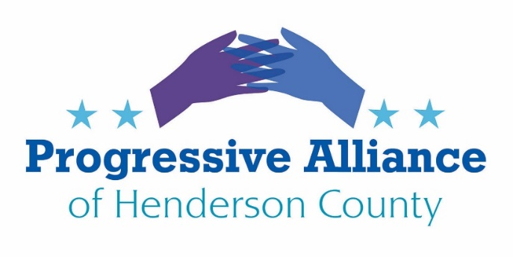

Postcard Party # 137 September 6, 2019

National

UNIVERSAL MANDATORY FEDERAL BACKGROUND CHECKS FOR ALL GUN PURCHASES. AND NO FILIBUSTER.
Republican Senators hold the key to passage of any gun safety legislation this year. Any package of gun safety measures must include closing the gun show and person-to-person loopholes in background check requirements.
Action: Contact Senators Thom Tillis and Richard Burr to tell them to 1) vote against any filibuster of gun safety legislation and 2) vote affirmatively to require federal background checks for ALL gun purchases. For example: HR 8, Bipartisan Background Checks Act of 2019.

START DIALOGUE IN NC’s 11th CONGRESSIONAL DISTRICT.
Mark Meadows’ office sometimes replies to our postcards. The office writes relatively detailed replies that may not be form letters. While that may be appreciated, there is actually very little democratic interchange with Rep. Meadows. He basically meets only with his supporters, especially the lobbyists who count on his votes.
Action: Contact Representative Mark Meadows. Ask him to schedule face-to-face meetings with representatives of the PAHC starting this October. Remind him that unfettered dialogue will be valuable for his decisions about how to vote on issues that affect all of his constituents.

IT’S ABOUT TIME THE UNITED STATES ONCE AGAIN VOCALLY SUPPORTED DEMOCRACY.
The pro-democracy grass roots efforts in Hong Kong merit our support and admiration. While the pro-mainland Hong Kong government may have partially backed down (as of Sept. 4), it is necessary that the so far nearly silent Trump administration speak clearly and forcefully to support democratic people-power in Hong Kong.
Action: Contact Senators Thom Tillis and Richard Burr and Rep. Mark Meadows to tell them to publicly call on Pres. Trump and Secretary of State Mike Pompeo to officially state that the United States supports the Hong Kong people’s rights of free speech and assembly so that their government will be responsive to them, rather than to the distant, repressive regime in Beijing.

PICK A TOPIC FROM THIS SMORGASBORD OF CONCERNS:
The Trump administration has used regulatory decisions to undermine civil and human rights, damage the natural environment, and reduce access to essential health care (among other ill effects).
Action: Pick one of the matters listed below and contact Senators Richard Burr and Thom Tillis and Rep. Mark Meadows to ask them to co-sponsor legislation to roll back destructive regulatory and other actions recently taken by the Trump administration.

- On August 15, Trump’s Department of Labor proposed a rule that would allow businesses with federal contracts to discriminate against workers based on “religious objections”—the administration’s latest attack on workers’ rights under the guise of religious freedom. Under the rule, businesses could legally fire or refuse to hire unmarried pregnant people, LGBTQ+ people, and other marginalized workers. To comment by Mail: Harvey D. Fort, Acting Director, Division of Policy and Program Development, Office of Federal Contract Compliance Programs, Room C-3325, 200 Constitution Avenue NW, Washington, DC 20210. Comments due by September 15. Refer to RIN 1250-AA09. Or write Congress, below.
- The Trump Administration plans to divert $271 million in federal disaster aid to beef up funding for ICE detention facilities at the U.S.-Mexico border. The Department of Homeland Security explained this in a letter to Congress—not seeking permission, but simply informing them of the change. This move is in defiance of congressional authority to allocate where funding can go---and is especially outrageous in the middle of hurricane season when DHS’s basic emergency response functions are already understaffed and underfunded. Details from DHS: On July 1, the Emergency Supplemental Appropriations Act was signed, providing $1.339 billion for DHS, but without funding for ICE Detention Beds for single adults. Given the rise of single adults crossing the border, ICE has already had to increase the number of detention beds above what Congress funded. Without additional funding for single adult detention beds and transportation from the U.S. Border Patrol to ICE detention facilities, ICE will not be able to support the influx of migrants from U.S. Customs and Border Protection apprehensions. Congress was notified of the Department’s intent to reprogram ... $116 million to fund ICE single adult detention beds and transportation under the authority provided in the FY 2019 DHS Appropriations Act. DHS also notified Congress of its intent to transfer $155 million to establish and operate temporary Migrant Protection Protocol (MPP) Immigration Hearing Facilities along the Southwest border. MPP court docket backlogs will continue to grow and ICE will not be able to effectively move single adult migrants between detention centers and courtrooms without the funding.
- In July, the Ninth Circuit Court of Appeals refused to block the Trump administration’s rule prohibiting Title X funding from going to health care providers that make abortion referrals, effectively ousting countless clinics from the program. Health care providers are already prohibited by law from using Title X funds for abortion, but that wasn’t enough for Trump. Now, he’s punishing any person who receives reproductive health care at a clinic that also either provides abortion care or makes abortion referrals. And it is having devastating effects by making reproductive health care often inaccessible.
State / Local
START DIALOGUE IN NC’s 48th SENATE DISTRICT.
Chuck Edwards’ office rarely replies to our postcards. There is actually very little public democratic interchange with Sen. Edwards. As far as can be determined from publicly available sources, he basically meets only with his supporters, especially the lobbyists who count on his votes.
Rep. Chuck McGrady is retiring. He has promoted his political career as working to be a bipartisan leader. PAHC as a group has never officially met with him.
Action: Contact Sen. Edwards. Ask him to schedule face-to-face meetings with representatives of the PAHC starting this October. Remind him that unfettered dialogue will be valuable for his decisions about how to vote on issues that affect all of his constituents.
Contact Rep. McGrady. Ask him to use his good offices to urge both Mark Meadows and Chuck Edwards to meet with a wider range of community groups from now on. Also ask him to schedule several face-to-face meetings with representatives of the PAHC this October and November for frank and thorough conversations about Henderson County’s future, no matter who is later elected to fill his seat.

