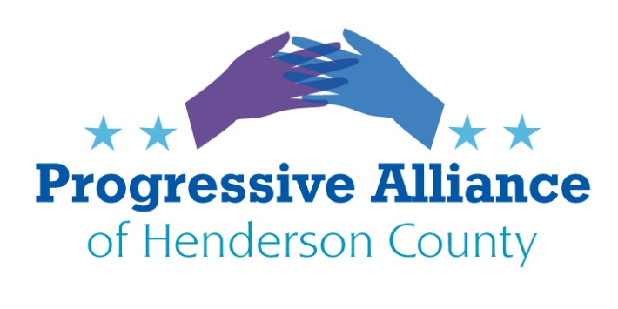

Welcome to our new members.
Even in these times of virtual activities, we appreciate those who are joining our Alliance of like-minded people.

To contact Progressive Alliance of Henderson County:
https://www.progressiveallianceofhendersoncounty.com/contact-us

POSTCARD VIRTUAL PARTY #178 JUNE 19, 2020
Last week’s issues that still may need additional attention:
- NC Politicians Must Welcome Federal Investigations into Police Patterns and Practices
- Support the Heroes Act
- Reach out to Burr, Tillis, and Edwards Staffers to Examine their Consciences and to Change their Grand Old Party: Postcard/email Staffers to no Longer do the Bidding of their Bosses.
- East Flat Rock Asphalt Drum Plant
Local Law Enforcement Leader Deserves our Thanks
- Campaign Zero- Ending Violence in America
- ERA-NC Alliance Action Alert

Contact Information for Each Topic is at the End of This Sheet and this Email
Let’s write to anyone with responsibility about the changes you see needed in our public life.

(NC STATE): Demand Transparency from NC Public Safety Organizations
With respect to racial inequality seen across the nation by law enforcement profiling, lethal use of weapons and tactics ending in black deaths, NC BORN, short for North Carolina Building Our Revolution is calling for the dismantling of state and local law enforcement agencies. They propose replacing the current structure with a series of task forces and community committees demanding full and transparent investigations of past police killings. The group’s 12 for 12 initiative focuses on legislative action that would dramatically change the face of public safety in the state. A few initiatives: ban tear gas, rubber bullets, no-knock warrants, private prisons and prison labor. They want body camera footage of all interactions police have with the public. Charges should be dropped in any case lacking complete video and if an officer fails to turn on the body camera, they should be charged with a felony.
North Carolina Gov. Roy Cooper announced Tuesday that he has signed an executive action on racial inequity. The executive order forms the North Carolina Task Force on Racial Equity and Criminal Justice, which Cooper said “will develop and help implement strategies and policies” that will ensure all state law enforcement agencies have clear duty-to-intervene policies. Erik Hooks, director of the state’s Depart Public Safety. N.C. Supreme Court Justice Anita Earls and Josh Stein, the state’s attorney general, will lead the new task force. They will convene a wide range of stakeholders.
Write and urge the task force to support NC BORN’s initiatives.

(NATIONAL): 60% of Americans Support Extending Boosted Unemployment Benefits as Trump and McConnell Say Let Them Expire

Last month, House Democrats passed a bill that would extend the boosted unemployment benefits through January 2021—but the legislation is likely going nowhere in the Republican-controlled Senate. McConnell and House Republicans vowed that the $600 increase in weekly unemployment payments "will not" be in the next coronavirus stimulus legislation. Policymakers need to do more. The across-the-board $600 increase in weekly unemployment benefits should be extended well past its expiration at the end of July—until unemployment is falling rapidly and is at a manageable level."

Write your Senators to vote to extend unemployment benefits.

(NATIONAL): New Study Shows Millions at High Risk of Covid-19 in US Lack Adequate Health Insurance
More than 18 million adults at severe risk of Covid-19 infection do not have health insurance, especially adults over the age of 65 and non-elderly adults with conditions such as asthma, diabetes, and heart disease. U.S. America's for-profit healthcare system may have exacerbated the deadliness of the virus. High-risk persons living in Medicaid non-expansion states (NC IS ONE) had 52% higher odds of being inadequately insured relative to those in expansion states. The coronavirus pandemic "is laying bare the lethal inequality of American society and American healthcare." Passage of the stopgap Medicare expansion bills introduced by Sen. Bernie Sanders and Rep. Pramila Jayapal would ensure that patients can get the care they need during the crisis, regardless of their diagnosis."
Write your Senators to support bill H.R. 1384. The bill would also immediately halt all medical debt collection, limit prescription drug prices, and prohibit private insurance companies from decreasing coverage.

(NATIONAL): Thank CNN
Thank CNN for standing their ground and saying trump is like a third world dictator

https://www.msn.com/en-us/news/politics/read-cnns-response-to-trump-campaigns-demand-for-an-apology-over-poll-that-shows-biden-leading/ar-BB15jpwQ?ocid=spartanntp

CONTACTS
Senator Mitch McConnell
317 Russell Senate Office Building Washington, DC 20510

CNN
190 Marietta St. NW. Ste 1
Atlanta, GA 30303

(STATE)

Erik Hooks, Director
NC Director of Public Safety
4201 Mail Service Center
Raleigh, N. C. 27699-4201

Anita Earls, Justice
Supreme Court of North Carolina
PO Box 2170
Raleigh, NC 27602

Josh Stein, NC Attorney General
9001 Mail Service Center
Raleigh, NC 27699-9001

