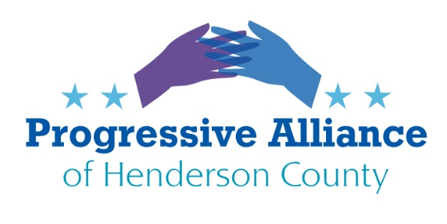
POSTCARD PARTY #152 DECEMBER 20, 2019
Senate Impeachment Trial preparations
Mitch McConnell has been open that his goal is to shut down the Senate Impeachment Hearings, rejecting even the appearance of a fair process. Lindsay Graham pledged his support to Trump. Fighting against having a legitimate inquiry, he said, “I’m not trying to be a fair juror here.” Trump has permanently stained his own presidency, and he has help from senators who now are contributing to the decline of the Senate’s historic reputation for integrity. Sen. Charles Schumer says that all facts should be considered in a Senate impeachment trial, including documents withheld by the White House and witnesses prevented from testifying. Mick Mulvaney, John Bolton and other White House officials should testify. These charges are about obstruction of justice and abuse of power by the President. A fair trial should be required by the American people. Transparency is important, and putting it aside so blatantly is shameful and sets a dangerous precedent.
Action: Tell Senators vulnerable in 2020 reelections that people who care about our democracy viewing an unfair and biased trial will shake their respect for the integrity of our representatives and the Senate as a body of advocates for our democracy. Full and fair consideration of the Impeachment charges is imperative for their legacy and our country’s future.
Write NC Senators Tillis (up for 2020 reelection), and Burr, and Republicans vulnerable to 2020 reelection: Susan Collins, Maine; Cory Gardner, Colorado; Mitch McConnell, Kentucky; Martha McSally, Arizona; Joni Ernst, Iowa. Moderate Republicans: Lisa Murkowski, Alaska; Mitt Romney, Utah; and Lamar Alexander, Tennessee.
Climate Change Inaction
The Conference of Parties United Nations Climate Change Talks in Madrid ended last week with the US and other big polluters blocking measures, even non-binding ones, that would encourage countries to make more ambitious targets for reducing greenhouse gas emissions next year. This was the last chance for US delegates to take a full part in global climate change negotiations, because the US is withdrawing from the Climate Accord next year. The Trump administration even pushed back on proposals to compensate developing countries for losses resulting from rising seas, storms, and droughts. There were big gaps between what scientists say and demonstrate that the world needs and what the powerful leaders of the biggest polluting countries are willing to discuss. Generations in the not too distant future will begin suffering from the lack of clean energy goals today that would have set limits needed to address unmanageable climate changes.
Action: Support HR 5221, 100% Clean Economy Act of 2019, of Reps. Donald McEachin and Debbie Dingell. They, as well as the new Senate Select Committee on Climate Change,

also want all federal agencies committed to efforts to stop the environmental decline and start a path to a clean energy economy and healthy environment. The Senate committee’s members: Brian Schatz, Tammy Baldwin, Michael Bennet, Catherine Cortez Masto, Tammy Duckworth, Martin Heinrich, Jeff Merkley, Tina Smith, Sheldon Whitehouse and Ed Markey. There are some noted environmentalists here. Write to encourage getting some legislation to start our country toward positive changes.
It’s Not About the Second Amendment. It’s About Gun Safety
This week was the 7th anniversary of the Sandy Hook Elementary School Shooting when 20 small children and 6 teachers were killed by a person who should not have had access to a gun. After the shooting at Sandy Hook, Las Vegas, Parkland, Charleston, El Paso, and Dayton, Congress had chances to enact a comprehensive background check bill, but NRA backed politicians blocked it. Gun violence takes nearly 100 Americans every day and wounds many more. The gun lobby’s control over elected leaders must stop. Momentum is on the side of progress and, hopefully, better representation. A recent poll found that only 3 of 10 Americans are gun owners, and most gun owners are in favor of background checks. There are gun sense majorities in Congress and state houses across the country. Virginia voters flipped the state legislature on the gun safety issue. Neither mandatory background checks nor red flag laws threaten the second amendment, so that weak defense of their votes against common sense safety measures are being challenged. Both would make churches, homes, schools, bars, concerts, and unstable relationships safer from threats of gun violence.
Actions: Ask Reps. McGrady and Jake Johnson, and Sen. Edwards, if they are still against protecting NC citizens from gun sales to unstable, or previously violent, people. Ask Sens. Burr and Thom Tillis (who is up for reelection and approval ratings are in the low 30s) why they don’t back common sense gun safety measures. Ask the current candidates how they will vote if they are elected.
Save the Endangered Species Act
Trump's Interior Department’s rollback to the ESA makes it much harder to protect species imperiled while making it easier for corporate polluters to build roads, pipelines, and other projects on areas critical to the survival of Monarch butterflies, Canada lynx, and Florida Key deer, polar bears to name a few. The Endangered Species Act, enacted in 1973 with bipartisan support, has saved many species from extinction and added immeasurably to public enjoyment and native animal and plant habitat. Republican Senator John Barrasso, longtime recipient of support from the fossil fuel and mining industry, has been at the forefront of efforts to weaken the Endangered Species Act and sponsor of 10 bills to end the ESA. At a time when climate change is threatening species at an escalating rate, our elected officials need to be supporting stronger protections, not weaker ones that enable the fossil fuel industry to profit as they add to the climate crisis. Tell Congress to Protect the Endangered Species Act from GOP gutting. Support ESA defensive bills: The PAW and FIN Conservation Act (HR 4348, Rep. Grijalva) and Protect America’s Wildlife and Fish...Conservation Act (S 2491, Sen. Udall).

