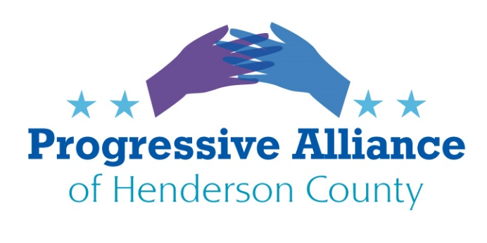
Postcard Party #180 July 3, 2020
Juneteenth Independence Day
June 19, 1865 slavery officially ended in the US.
President Lincoln issued the Emancipation Proclamation on Sept. 22, 1862, to take effect on January 1, 1863 during the middle of the Civil War, making the practice of slavery illegal in the US after hundreds of years. Even after the war was over word traveled so slowly that some states failed to comply fully for some time.
While many voices like to remind us that we cannot legislate feelings, we can write and observe laws that represent the good for all citizens of this country. In time, laws change practices which eventually help to define thoughts that can determine feelings, examples are smoking and drunk driving.
Write Congress to support the making of June 19 a National Holiday, finally recognizing the end of the shameful and extremely damaging practice of slavery in our country. From the beginning of our democracy, we hung onto the fiction that “all men were created equal,” was really only applicable if you were a white male.
US Supreme Court and Federal Judges
During this current, unfortunate administration Republicans have been attempting to alter our nation’s future by nominating ultra-conservative and sometimes completely unqualified or inappropriate candidates for the highest court as well as Federal Judgeships. By using the President, who wouldn’t know a qualified candidate from a cactus, and the Senate majority, they have rammed 200+ new justices and judges into the Federal Judiciary.
As an example, following the dismissal of the current District Attorney for the Southern District of NY, one of the most important crime stopping entities in the nation, and currently investigating many of trump’s fixers and cronies. trump announced that Jay Clayton, a lawyer for a virtual who’s who of big business and banking plus insider par excellence would assume the head of this district ASAP. Clayton currently is Securities and Exchange Commission head, nominated by trump in 2018. In itself, this is like the fox guarding the henhouse, but Clayton has no experience as a public prosecutor.
The Republicans have guided trump into packing whatever government agency, cabinet office or courtroom with individuals who are bound and determined to change the course of justice to one of cronyism, favoritism, money making or politicization. The stated goal for the government officials is to torpedo their departments’ operations from within.
Write Congress demanding that no new Justices or Judges can be nominated or approved until the 2020 election is complete and all votes are counted. The Republicans, who don’t have any recognizable concept of “fairness,” would not vote on any nominations during the last year of President Obama’s term because, “it was too close to the election” of 2016.

Children Lost in the Protests and COVID 19
It is little wonder that with the 24/7 coverage of the Pandemic and the Protests against police violence toward people of color that coverage of some very serious situations would be lost in the shuffle. By latest count there are over 100 migrant children still in custody in ICE facilities in Texas and Pennsylvania. A federal judge has ordered their release by July 17 to relatives who have been named by their parents. The situation is made worse, if that is possible, by the fact that approx. 2,500 detainees in ICE facilities have tested positive for COVID 19. ICE says they have released at least 900 people with underlying conditions to mitigate the spread of the virus.
Write Congress to highlight the plight of these human beings held in detention with little to no means of seeing freedom or even the cessation of their incarceration. The notion of swift and fair justice in this country is a cruel myth.
Republican Strategies for Restricting the Right to Vote
Chief among the methods schemed up is closing as many polling places as possible, and especially those that have majority minority voters or democrats in the majority. This is not new but has been taken up with zeal in local elections under the cover of the COVID 19 crisis.
The Republicans have managed to turn mail-in ballots, which used to be termed as “absentee ballots,” into another continuous, scaremonger’s haven, with trumped-up fears about voter fraud, etc. The Attorney General of the United States, Bob Barr, no less, has suggested that voting by mail is dangerous and subject to foreign intervention in the form of fake ballots. What we are witnessing is the lunatic fringe invading the most important offices in our government.
Write Congress demanding that adequate polling places being accessible to every voter is a basic right of our democracy and voting by mail be safeguarded and encouraged, especially in this time of pandemic. We must ensure that every person who wants to vote can do it safely and conveniently.
Projected Educator Losses Following the Pandemic
The National Education Association projects that nearly 2 million educator jobs will be lost in the next 3 years due to state revenue shortfalls caused by the COVID 19 pandemic and subsequent recession. That translates to 1 in 5 jobs gone. Every community will be affected. Students of color will be disproportionately impacted because they are much more likely to be attending a school supported by Federal Title 1 funding.
The projection for North Carolina is 79,568 jobs lost. The effect on class sizes will be enormous, which is accepted as automatically lowering the quality of education. As any interested individual understands, education quality and availability have a direct bearing on every aspect of our economy and our nation’s health and wellbeing.
Write our Senators encouraging them that this cannot be allowed to happen. If they can’t figure out what to do about this looming crisis, then we don’t need them.

