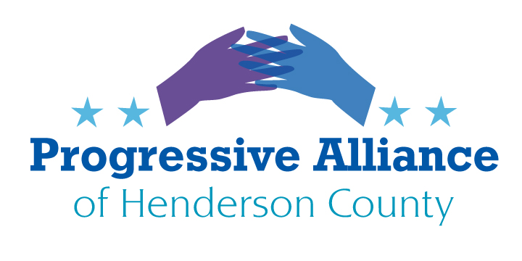
Post Card Party # 258 February 1, 2022
As we are still in the early stages of 2023, this newsletter’s suggestion sheet will focus on the damage that the NCGA will attempt to inflict on its most vulnerable citizens during the upcoming session. The two commentaries are “borrowed” a political reporter in Fayetteville, and a recent bulletin from the ACLU.
It is in your hands...contact your State senator and assembly rep (as well as Governor Cooper) with your opinion on any or all of these issues.
From The Fayetteville Observer, January 25, by Paul Woolverton

Abortion, gambling, marijuana and shot-up power stations — new NC laws on the horizon

The window for abortion services could drop to 13 weeks from 20 weeks. Meanwhile, medical marijuana and gambling on professional sports could be legalized.
North Carolina may loosen its laws on gambling and marijuana this year, but toughen abortion restrictions.
And following the attack on the power transmission stations in Moore County in December that knocked out electricity for tens of thousands of people for days, lawmakers will consider new laws to crack down on anyone who causes such damage, and whether to impose laws to have power companies increase the security of these facilities.
Those are some of the big topics the North Carolina General Assembly is expected to take up in 2023, according to interviews with Republican Sen. Tom McInnis of Moore County and Democratic Rep. Marvin Lucas of Cumberland County.
The lawmaking gets started on Wednesday when the legislature convenes to get down to business following its election of its officers two weeks ago.

Here are some things to look for:
Abortion — how much will it be curtailed?
20th week of fetal gestation. The 20-week limit was unenforceable until last summer when the U.S. Supreme Court issued the Dobbs decision that overturned its 1973 Roe v. Wade ruling that had legalized abortion nationwide.
Now lawmakers in the legislature’s Republican majority want to crack down.
How far will they go?
The Associated Press has reported that a ban after the first trimester of pregnancy, about 12 to 13 weeks, has been discussed by legislative leaders. This would have exceptions allowed later for incidents of rape or incest, or if the pregnancy threatens the mother’s life.
Any new restriction is likely to be vetoed by Democratic Gov. Roy Cooper.
The veto would be followed by veto-override votes. The Republicans have a veto-overriding supermajority in the Senate. In the House, the GOP is one vote short of the minimum needed to override, but Republicans could override if one persuadable Democrat joins them, or if at least two Democrats are absent while all Republicans are present.
Medical marijuana
A Republican-sponsored to legalize the use of marijuana for medicinal purposes passed the state Senate last year. But the bill, called the Compassionate Care Act, got no hearings in the House.
Look for lawmakers to try again.
Meanwhile, the Cherokee Indians in the North Carolina mountains are in the process of offering legal sales and use of medical marijuana within their tribe’s sovereign territory.
Sports gambling — what are the odds?
Outside of the western North Carolina casinos operated by American Indian tribes, betting on professional sports is illegal in this state.
The legislature came close to legalizing betting on professional sports events statewide this past June, but the bill failed 50-51 in the House. The topic is expected to return.
Protection for electrical power stations
Saboteurs shot up two electric substations in Moore County in December, heavily damaging the equipment and knocking out power for more than 40,000 homes, businesses and other locations. It took four days for Duke Energy to restore power — and even then, not all the equipment had been replaced or repaired.
The attack outraged McInnis.
He said he will run bills to toughen the penalties for people who damage substations and to increase the security of the substations.
Medicaid expansion — health care for lower income people
Republican lawmakers used to oppose offering the government-funded Medicaid health insurance to several hundred thousand North Carolinians who don’t have health insurance.
These residents earn too much money under current laws to receive Medicaid, yet at the same time are considered by law to be too poor to be allowed to buy health insurance at a low cost via the Affordable Care Act (which is commonly called Obamacare).
This “Medicaid gap” was created by the U.S. Supreme Court in a 2012 ruling that canceled part of the Obamacare law that had required the states to provide Medicaid to that group of people.
Republican leaders now say they want to expand Medicaid, but they have not been able to work out details among GOP lawmakers and the Democrats.
The debate on how to make it happen is expected to continue this year.

From ACLU North Carolina December 5, 2022
As election season comes to a close and we contend with the outcomes on a state and local level, we turn our attention to the 2023 legislative session, which will begin in January. In 2022, the ACLU of NC faced a tumultuous session, with both significant wins and difficult challenges. From the strategies legislators used to attempt to curtail civil liberties, we can make some predictions for legislative fights we may see in 2023.
First and foremost, anti-choice legislators have promised to attempt to further restrict abortion access. Reproductive rights were a major oppositional front in 2022. Lawmakers attempted to push through multiple anti-abortion bills. One of them, HB 453, passed in both the House and the Senate, but Governor Cooper vetoed it. Thanks in part to our determined advocacy and that of our partners, anti-choice lawmakers did not have enough votes to override his veto.
In a July interview with the News & Observer, Senate leader Phil Berger said that he remains “committed to protecting the unborn and upholding the sanctity of life.” According to the same article, House speaker Tim Moore said “his personal stance is that when there is a heartbeat, that’s a child.” Based on these statements and others, we know that lawmakers will push for further restrictions on abortion. Additionally, due to election outcomes, anti-abortion legislators may be able to override a veto if they play their cards right.
We may also see a renewed push for anti-LGBTQ legislation in 2023. States across the country have seen an upswing in these types of bills over the last several years, including restricting trans students’ participation in sports, limiting access to gender-affirming health care, and targeting LGBTQ students in education. We saw two of these bills last session here in NC. While neither became law, legislators used this opportunity to stir up homophobic and transphobic rhetoric. We may see further attempts to target LGBTQ youth in 2023.
Particularly in light of the recent anti-LGBTQ shooting in Colorado Springs, Colorado, we are well aware of the real-world violence that furthering this kind of hate and discrimination can lead to. Along with working to prevent harmful bills from passing the legislature, we will work on all fronts to counter misinformation and anti-LGBTQ narratives.
With the rise of discussions around censorship and school curricula, we expect to see another push for legislation restricting classroom subjects and targeting critical race theory. In 2022, Governor Cooper vetoed a bill that would have limited educators’ ability to discuss topics related to racism, sexism, white supremacy, diversity, and equity with their students. Since it received such support in the legislature, we expect to see more of this conversation in the spring.
Additionally, last session we saw a tough fight against anti-immigration legislation. The General Assembly introduced a bill that would have allowed people to sue “sanctuary” municipalities for allegedly obstructing federal immigration laws, which did not pass. They did pass SB 101, which would have required local law enforcement to cooperate with Immigration and Customs Enforcement (ICE). Governor Cooper vetoed the bill, but we expect to see similar legislation come up in the 2023 session.
Finally, in the wake of the 2022 election, in which people with past felony convictions were eligible to vote for the first time in North Carolina, we expect to see attempts to curtail voting rights. The legislature introduced several bills last session targeting election access, one of which (SB 326) was passed and vetoed by Governor Cooper.

