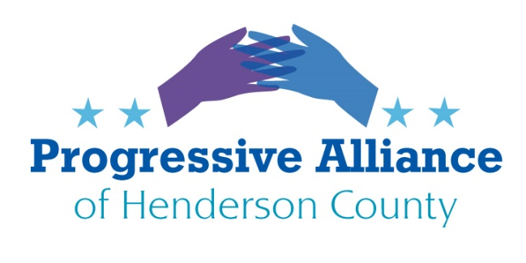
POSTCARD PARTY #151 December 13, 2019

National:

Write any and all. Where are our statesmen? Our largest national deficit:
Statesman: a wise, skillful, and respected political leader. A political leader whose wisdom, integrity, win great respect.
Write: Secretary of the Navy
Re: Captain Richard V. Spencer
1000 Navy Pentagon, Room 4D652
Washington DC 20350
“I cannot in good conscience obey an order that I believe violates the sacred oath I took.”
Thank you for your service to our country and for your courage to stand up to an incompetent tweet of a president. We need principled people.

Write all Senators and Cabinet members:
When did loyalty to a corrupt, incompetent president exceed loyalty to our nation and democracy? Shame on you if you remain cowardly silent.

Whistleblower Protection Program:
Write Department of Labor Eugene Scalia, and Senators Burr and Tillis and Representative Meadows: Whistleblower laws are enforced by OSHA. OSHA has not had a leader since trump took office. His last nominee, Scott Mugno, withdrew. Protect whistleblowers fully, any leak of an identity will reflect badly on anyone who cannot protect a whistleblower. Do your job.

Write all and all Republican Senators: Trump’s toadies. A disgraceful legacy beside your name. Protect the Constitution. Read and understand the facts for a change.

Betsy DeVos contempt of court:
Write US Senators and Representatives: Betsy DeVos, Secretary of the Department of Education, has been held in contempt of court for not stopping to collect on loans of 16,000 borrowers who attended Corinthian College, a for-profit college. The lie of diligently working to correct the errors did not fly. The fine will be paid by the government (that is us the taxpayers) to the lawyers. Instead consider impeachment proceedings against Sec. DeVos.
Colorado Sanctuary state:
Write Governor of Colorado and North Carolina, NC Senator and Representatives. resident trump: Thank Governor Jared Polis who signed HB19-1124 (Protect Colorado Residents from Federal Government Overreach) act in an effort to become a sanctuary state for immigrants. Ask our state legislators to pass similar bills. P.S. Tell trump, Colorado teaches geography in kindergarten.

Build bridges, NOT Walls.

Flights to Cuba :
Write Mike Pompeo, Secretary of State, Elaine Chao, Transportation Secretary, US Senators and Representatives: Pompeo wrote Chao to ban all flights to Cuba except to Havana because of Cuba’s repression of its people and support for Venezuela’s President Maduro. Flights aren’t being banned to China (Chao’s birthplace) or Turkey (Erdogan’s home), Saudi Arabia (bin Salam strongman) or Russia (Putin’s palace) which all take the same stand. Quit picking on our neighbor Cuba.
State:
Ban Fracking:
Write State Senators and Representatives and Governor Cooper: Trump is determined to reverse all of the clean environment initiatives. Demand a state wide ban on Fracking. Fracking is a top polluter of both air and drinking water. The waste water contains toxic chemicals such as methane, which contaminates drinking water. Earthquakes are linked to states with high fracking. Current laws and regulations do not protect us. Ban all fracking in North Carolina.

Net Neutrality:
Urge our State legislators to adopt a NC net neutrality law, recently made feasible by a Federal court decision overturning FCC’s preemptive rule. California has enacted an excellent state-level example.

