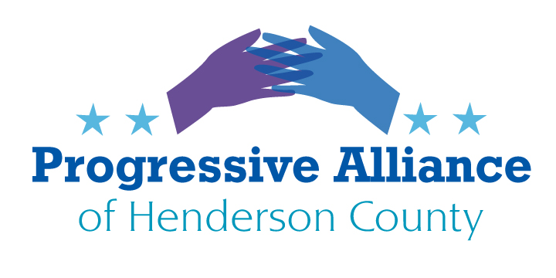

**July 21, 2023**

* We have three goals in today’s postcard party:

- education regarding issues of period products

- express support for menstruating teens and women

- encourage our legislators to address menstrual issues

Appropriate phrases of support to write on **anonymous** postcards are elsewhere in this gathering.

**Here are some appropriate facts regarding period issues in NC:**

- One in five low-income women reports missing work, school or similar events due to lack of access to period supplies.

- In the U.S. about [16.9 million](https://journals.lww.com/greenjournal/Abstract/2020/05001/Period_Poverty_and_the_Menstrual_Product_Tax_in.234.aspx) people with [periods](https://greatist.com/health/irregular-period-home-remedies) live in poverty. And like poverty in general, period poverty stems from income disparities and lack of access to much-needed resources. Not to mention, periods have become expensive.

- A 2021 Statista survey found [16 percent](https://www.statista.com/statistics/1242985/us-period-poverty-teenage-students/) of teens reported having to choose between buying period products and food or clothes.

- Campaigners have long pushed to abolish the “tampon tax” — an additional sales tax added to period products. While removing this tax won’t make menstrual products free, this cost- saving could make a difference.

- In NC, 1 in 6 women and girls from the ages of 12 to 44 live on incomes below the Federal poverty line. This equates to almost 400,000 individuals.

- Sales taxes on period supplies place an unequal burden on individuals who menstruate. In NC, period supplies are taxed.

- One third of low income women report missing work, school, or similar events due to lack of access to period supplies.

- In NC, nearly 60,000 women participate in the WIC program. While this helps provide nutritious food, it does not cover many other basic necessities.

**What can you do?**

**Write** to your NC legislators (House 117: Jennifer Balkcom, House 113: Jake Johnson; Senate Timothy Moffitt). Use the facts above to ask them to

- exempt period products from NC sales taxes

- provide free period products in all NC public schools

**Write** to NC-11 Rep. Charles Edwards to urge him to:

- include free period products in the next Federal funding authorization for public schools

-require menstrual instruction starting at age 10 for any school receiving Federal monies