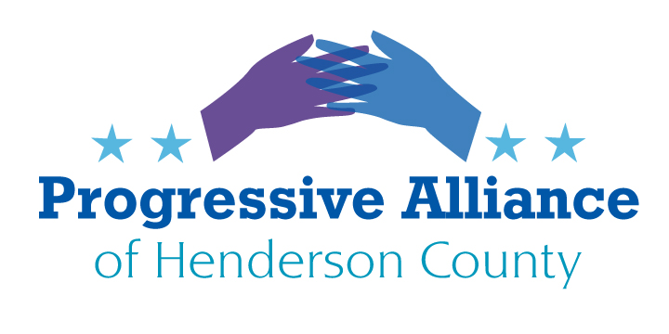
Postcard Virtual Party # 187 August 21, 2020
The Post Office Debacle
Let us be clear about this. Donald Trump is doing everything he can to win this election, even if he must sabotage the USPS to prevent mail balloting, He is purposely doing what he can do to retain his seat. He fears the American people. He fears losing. No mail in ballots=less chance of winning the election. He has already said if he loses, it will be because the election was rigged. This is obstructive, manipulative, criminal behavior and it must be stopped.
The GOP named Louis De Joy, a political operative, with deep pockets planted in Trumps’ campaign, having no USPS experience became Postmaster General. All this in May, right before the 2020 election. He took no time to institute sweeping changes:
33 staffers were reassigned in the restructuring. A hiring freeze was implemented while coaxing veterans of the Service into early retirements, realigning the Service into three “operating units” — retail and delivery, logistics and processing, and commerce and business solutions — and scaling down seven regions into four. In addition, he quickly began removing city postal boxes as well as removing sorting machines from major city service centers.
He had his reasons. His personal holdings include between $30.1 million and $75.3 million in assets in USPS competitors or contractors. The proverbial fox in the hen’s den scenario. Once again, we have another self-serving individual looking not out for the American people and its treasured institutions, but a man only looking out for his own selfish and greedy interests in the faith of a desperate president.
Benjamin Franklin invented the Postal Service for “The Common Good of America”. To this day, the PO has delivered trillions of pieces of mail across this country. Now more than ever, we need the postal service. Veterans and the elderly need their prescriptions, voters need their ballots, Americans need to receive and pay their bills, small businesses need to market and sell their products. Eliminating the PO without a replacement program, with no notice is unconscionable, especially at this time.
DeJoy, committed to Trump, has committed a Federal crime and is being sued by Attorney Generals in many states. He must be held accountable.
Write legislators to urge them to fund the Post Office, allow personnel to return to their jobs, reinstall confiscated sorting machines, and replace post office boxes that were dumped in trash yards. Citizens need to vote by mail.
NOTE: As I write this, Tuesday 8/18, there is new bipartisan support for restoring the above changes made in haste as the Postmaster General is now required to appear before Oversight committees next Monday. It’s election year folks and the GOP candidates are drowning and need some lifelines. This is one.

TRUMP ADMINISTRATION CATERING TO FOSSiL FUEL POLLUTERS
Trumps EPA Administrator, Andrew Wheeler, former coal lobbyist, announced last week that the EPA has deregulated regulations for greenhouse gas emissions, effective next week. These regulations were put in effect by the Obama Administration, and we are now at a time when research shows that fossil fuel companies have released over two times more methane that the EPA’s stated estimates. Andrew Wheeler announced the removal of these “burdensome and ineffective regulations” on the oil and gas industry which will remove their responsibilities to detect and remove methane leaks. Robert Holworth, scientist and system analyst at Cornell University, states that, “25 percent of human caused warming over the last twenty five years is due to methane.”
The EPA and Trump’s Administration needs to be held accountable. Their job is to protect citizens’ health, not free polluters from oversight and even basic regulatory rules of operation.
Action: Our Senators Burr and Tillis
Senate Committee on Environment and Public Works has oversite of EPA
Jim Inhofe R-OK
205 Russell SOB
Washington, DC 20510

Committee on Public Lands and Forests
Ron Wyden D-OR
221 Dirksen SOB
Washington, DC 20510

