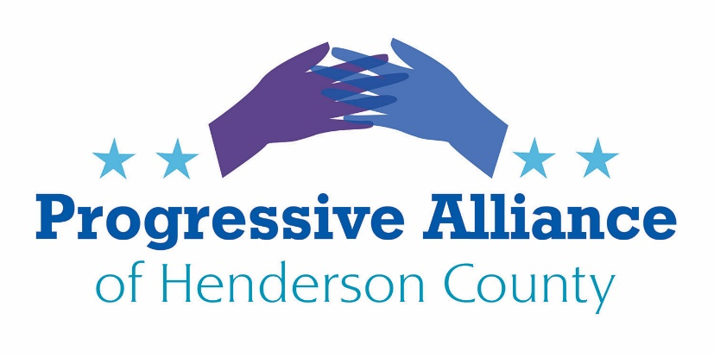

Postcard Party # 143 October 18, 2019

“When we’re dancing with the angels, the question will be asked, in 2019, what did we do to make sure we kept our democracy intact?” — Rep. Elijah Cummings (1951-2019)

Syrian Border Debacle
Hasty removal of U.S. forces from a 20-mile strip of this border benefits Bashir al-Assad of Syria, and his allies in Russia and Iran; it abandons and decimates U.S. cooperating Kurdish forces and civilians; and furthers Turkish ambitions. It strongly increases odds of resurgence by ISIS or spinoff groups in that area. House Foreign Affairs Chair Eliot Engel (D-NY) and Ranking Member Michael McCaul (R-TX) introduced a ‘Protect Against Conflict with Turkey’ (PACT) Act, HR 4695, to sanction Turkey. This is a weak response to 1 nation, for a failure that affects those 5 nations/ethnicities/factions, and that creates thousands more casualties, refugees and internally displaced persons. Senate Foreign Relations chair James Risch (R-ID) and ranking member Robert Menendez (D-NJ) are working to introduce a bill. Let’s ask the House Foreign Affairs oversight subcommittee to locate truth-tellers to bring to hearings, in a search for better options. Representative Ami Bera, MD (D-CA) is oversight chair, and his subcommittee includes progressive members Ilhan Omar (D-MN) and Ted Lieu (D-CA).

Wildlife Corridors
The House of Representatives held a hearing on Thursday on a bill that would have tremendous benefit for plants, fish, and wildlife if it becomes law.
The Wildlife Corridors Conservation Act would help to safeguard species by connecting habitats and allowing wildlife to migrate and travel freely between spaces. Eliminating barriers to safe passage and bringing fragmented habitats together will help hundreds of species–mammals, fish, amphibians, plants, and even insects like monarch butterflies would benefit from this legislation.
All of these species need room to roam and to grow. The Wildlife Corridors Conservation Act, HR 2795, would help to make that possible. Please write Representative Meadows to support this proposal.

The Equality Act
21 states currently offer some protection for employees against discharge or adverse personnel actions based on their sexual orientation. The Equality Act (H.R. 5, S. 788) would provide consistent and explicit non-discrimination protections for LGBTQ people nationally across key areas of life, including employment, housing, credit, education, public spaces and services, federally funded programs, and jury service.
The Equality Act would amend existing civil rights law—including the Civil Rights Act of 1964, the Fair Housing Act, the Equal Credit Opportunity Act, the Jury Selection and Services Act, and several laws regarding employment with the federal government—to explicitly include sexual orientation and gender identity as protected characteristics. The legislation also amends the Civil Rights Act of 1964 to prohibit discrimination in public spaces and services and federally funded programs on the basis of sex. Additionally, the Equality Act would update the public spaces and services covered in current law to include retail stores, services such as banks and legal services, and transportation services. These important updates would strengthen existing protections for everyone.
The Equality Act has passed the U.S. House and is in the Senate Judiciary Committee. Let’s write to Sen. Thom Tillis (on the Judiciary Committee and its Federal Rights subcommittee) to push for a hearing on this complex legislation. Sen. Ben Sasse (R-NE) as subcommittee chair on Federal Rights is also worth contacting on this.

EPA Proposes Rollback of Methane Controls
The U.S. oil and gas industry releases 13 million metric tons of methane from its operations each year--nearly 60 percent more than EPA had estimated. Without strong methane pollution standards, the climate impacts could be enormous. Please oppose the new EPA proposal, which would:
- basically remove regulation of methane, a super-powerful greenhouse gas;
- shelter an entire segment of the oil and natural gas sector from necessary regulation;
- allow more methane and VOCs to escape into the atmosphere;
- endanger the health and, ultimately, the lives of Americans and people around the world.
Please write to: U.S. Environmental Protection Agency, EPA Docket Center, Docket ID No. EPA-HQ-OAR-2017-0757, Mail Code 28221T, 1200 Pennsylvania Avenue NW, Washington, DC 20460.

NC Clean Energy Plan
Duke University Earth Sciences professor Drew Shindell, a UN Intergovernmental Panel on Climate Change participant and lead author, has written Governor Cooper, saying "The time is now to stop building more fossil fuel construction." His letter, backed by two dozen former EPA officials, argues that all natural gas infrastructure will now disrupt the renewable-energy goals we will need to control climate change, and thus will be wasted effort at ratepayer expense. They tell Cooper "Unless the Clean Energy Plan can envision a future without any new gas plants, it will not be a plan that protects North Carolina from the serious impacts of climate change as you intended." Please write Governor Cooper to support environmentalists’ demand that Cooper ‘continue to push his agencies and the legislature’, even in the face of Duke Energy's plans in North Carolina for the next several decades. The company, one of the country's largest electricity producers, is relying on natural gas to retire coal plants and plans to pump the gas into North Carolina through the Atlantic Coast Pipeline.
NC Electricity Regulation
Senate Bill 559 could allow electric monopolies to gouge customers for billions in bogus charges and get a single regulatory approval for five-year blocks of annual rate increases – all with even less public and regulatory oversight than exists under the current system. Every stakeholder group opposes the bill – business big and small, consumer, clean energy and environmental justice groups. Only Duke and its political cronies are promoting it. Governor Cooper vetoed this, but the NC Senate has overridden. Please write Representatives Chuck McGrady and Jake Johnson to sustain the veto.

