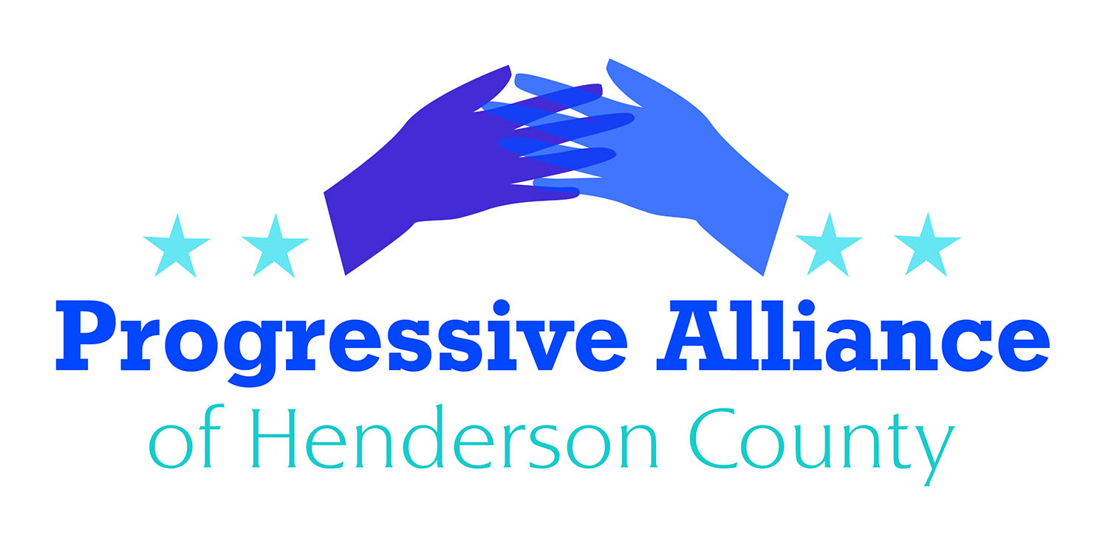

Postcard Party # 126 June 21, 2019

National

WAR AGAINST IRAN
Over the last few months, the Trump administration has escalated its hawkish rhetoric about Iran, prompting concerns that the White House is now trying to push Iran into war.
- In early May, Bolton inexplicably announced he was deploying a carrier strike group and a bomber task force to the Middle East to send Iran a "clear and unmistakable message."
- Saudi Arabia - who is already engaged in a US-subsidized proxy war with Iran in Yemen - announced two of their oil tankers had been sabotaged, raising tensions in the region.
- The US ordered all of its “non-emergency U.S. government employees” from Iraq, citing heightened threats in the Middle East.
- Acting Defense Secretary Patrick Shanahan has developed a plan with Bolton to send 120,000 troops to the Middle East, a deployment nearly the size of the American force that invaded Iraq in 2003.
- In late May, Trump ordered an additional 1500 troops to the Middle East for what he called "mostly protective" purposes.
Contact Senators Tillis and Burr, and Rep. Meadows, with your thoughts on this matter.

FREE ELEC TIONS
With Trump publicly stating he would accept foreign interference in our elections, he has opened the door and asked for outside players to act on his behalf in 2020. The Mueller report cited at least 140 contacts between the 2016 Trump campaign and Russian nationals or Wikileaks, making this explosive admission by Trump a tangible threat to our democracy.
To require campaigns report contact with foreign nationals, Senator Mark Warner (D-VA) has introduced S. 1562, the Foreign Influence Reporting in Elections Act (FIRE Act). The legislation would require campaigns to report any contacts with foreign nationals who are attempting to make campaign donations or otherwise coordinate with the campaign within a week of the contact. It would also require the preservation of any relevant documents or records regarding the contact.
It is time for both Republicans and Democrats to take concrete steps to secure our 2020 elections. Without doing so, we run the risk of delegitimizing our elections and democracy.

Contact Senators Tillis and Burr asking them to support S. 1562. Ask Rep. Mark Meadows to sponsor legislation similar to S. 1562.
State

ICE
Despite widespread opposition from the immigrant community and even several county sheriffs, the North Carolina Sheriff’s Association has flip-flopped to support the controversial House Bill 370, which forces local sheriffs to be part of Trump's deportation machine, ripping children from their parents and separating families.
- Enforcing federal immigration laws is the federal government’s responsibility. Local authorities should be free to decide how to ensure the safety of their communities without interference from anti-immigrant politicians in Raleigh.
- Fear and distrust of local law enforcement officers makes immigrants less likely to contact or speak to local officials. When victims and witnesses refuse to speak to law enforcement, it makes it more difficult for police to both identify issues and seek assistance in addressing them.
- New sheriffs in North Carolina’s largest counties won election in 2018 after making high-profile promises not to work with federal immigration agents. Local authorities, who know their communities best and are accountable to those communities, should be the ones to make the decision on how to ensure their public safety.

Bottom Line: Requiring local law enforcement agencies to pose as immigration agents will make our communities less safe, not more so.
Contact Senator Edwards and Rep. McGrady to express your concerns.

Local
287g AGREEMENT
(excerpts from a Guest Column by George Pappas in the Times-Citizen)
At the last Henderson County Board of Commissioners meeting held on June 3, 2019, together with other residents, many people spoke out against funding the 287g Agreement with Immigration Customs Enforcement (”ICE”).
Perhaps the most damning comment witnessed at the last Henderson County Commission meeting was County Commissioner Chairman Grady Hawkins’ comment suggesting that so called “illegal’s” have no right of protection under the U.S. Constitution. “Certainly, there’s a lot of information about 287(g) that I don’t particularly understand,” Hawkins said, “However, I’m not sure if you’re here illegally why you’re privy to the Constitution that the rest of the American people are. But that’s a question for the courts to deal with.” There are two problems with Chair Hawkins’ statement.
First, he is on record from the March Commissioner’s meeting as stating to Sheriff Lowell Griffin “The board is committed to the program that keeps criminals out of our society. Whatever funding you think you need as we work through the budget process, this board will find it because of the impact on the safety of our community... Again, as we work through the budget process, if you need additional funding, we will find it.”
Yet on June 3rd, Chair Hawkins states “there’s a lot of information about 287(g) that I don’t particularly understand.” Making financial commitments with taxpayers’ funds, in this instance around $250,000 for a program that Chair Hawkins does not understand, is fiscally irresponsible.
Chair Hawkins, by publicly stating that so called “illegal’s” may not be privy under the U.S. Constitution, demonstrates ignorance of the law and violates his oath of office. To fail to protect the due process rights of all “persons” and “people” under the 4th, 5th and 14th Amendments of the U.S. Constitution is a serious dereliction of public trust through constitutional ignorance. This issue has been well settled by the U.S.
Contact members of the County Board of Commissioners. (J. Michael Edney, Grady Hawkins, William Lapsley, Rebecca McCall, Charles Messer-1 Historic Courthouse Sq, Hendersonville, NC 28792)

