Postcard Party – July 25, 2025
Suggestion Sheet
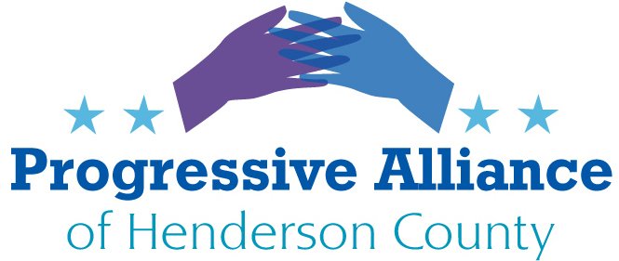

There are MANY items to detest with regard to actions the GOP has taken under the tRump47 regime. One major umbrella which will adversely affect all of us is health care. Summaries of some of the most devastating impacts are below.

Think you won’t be impacted because you are covered by private health insurance? Sorry, but your premiums and co-pays will go up because many will need to forego or delay care, thus needing more treatment when they actually do seek medical help. Covered by Medicare because you are 65+? More, younger people will convert to Medicare at earlier ages, adding to the burden faced by too-scarce doctors and hospitals willing to accept Medicare. Covered by Medicaid? You will soon see higher co pays, reduced access to medical outlets, and the need to recertify your need every six months. Not covered by insurance? Well, let’s not even go there!

Here is what is coming, and why you need to take action today (and every day).

July 10, 2025 Asheville Watchdog: Andrew R. Jones

State’s rural hospitals will lose $3.7 billion in Medicaid and SNAP could end, legislative document states

North Carolina’s rural hospitals will face $3.7 billion in Medicaid cuts and the state could be forced to end its Supplemental Nutrition Assistance Program (SNAP) following passage of President Trump’s One Big Beautiful Bill, according to a state General Assembly briefing document obtained by Asheville Watchdog.

Altogether, the state will lose $49.9 billion in Medicaid funding over 10 years, with more than 70 percent of the loss coming from cuts to hospital expenditures, according to the document, which was assembled by subject matter experts and top NCDHHS officials. The document was presented online by four of those officials Wednesday to legislators and staff.

“Hundreds of thousands of North Carolinians are expected to lose health coverage,” the document states. “In addition, without a statutory change, the new administrative costs for work requirements will likely trigger the NC law that ends Medicaid expansion, resulting in coverage loss for 671,476 people.”

Federal changes to Medicaid mandated in the bill will also force the state to pay an extra $420 million to fund the full benefits of SNAP or end the program. More than 1.4 million North Carolinians, including 600,000 children, rely on SNAP for basic food and nutrition, according to the document.

Progress NC Action Matt Schlosser, July 11

Still eligible for Medicaid? Your co pays will be higher

Trump’s legislation requires states that have expanded Medicaid, including North Carolina, to charge enrollees up to $35 for some services. Medicaid enrollees often don’t pay anything when seeking medical services because studies have shown charging even small co payments prompts low-income people to forgo needed care. That’s about to change.
NC Newsline July 15 2025 Rob Schofield
The North Carolinians that the “big, beautiful bill” will terrify, bankrupt, and kill
Nearly 12 million people across the nation and hundreds of thousands in North Carolina are projected to lose their health insurance over the coming years. Meanwhile, as North Carolina’s food banks explained in a recent urgent plea, the SNAP food assistance that will be cut by almost $200 billion over the next decade provides more than two billion meals each year to the 1.2 million North Carolinians classified as “food insecure”.
The proponents of the legislation allege that it will merely root our “waste, fraud and abuse” in these programs, but as even North Carolina’s Republican senior senator, Thom Tillis, has made plain, that’s just not so. A report from his office estimates North Carolina will lose $32 billion in Medicaid funds over the next decade and the notion that the state’s health care system could somehow absorb such a hit without dramatically reducing coverage and care is beyond absurd. As the senator said prior to voting against the bill, “So what do I tell 663,000 people [people who’ve gained Medicaid coverage in recent years as the result of the bipartisan expansion law passed in 2023] in two years or three years, when President Trump breaks his promise by pushing them off of Medicaid because the funding is not there anymore?”

What to Do?
These can be reversed or changed. Remember - Republicans have to stand for (re)election before many of the cuts take place in 2027 and beyond. Nothing scares a legislator more than being voted out of office.
For any postcards you write, whether on these or other topics, just put the recipient’s name in the address box. PAHC will take care of slapping on the appropriate address label and postage.

Work on communicating with Sen. Thom Tillis, and ask him to lead an initiative to reverse these cuts. Urge him to vote his conscience during his final 17 months in office.

Contact your County Commissioners and urge them to ensure funding for Health Dept., Pardee, and others to fill future gaps. William Lapsley, J. Michael Edney, Rebecca McCall, Jay Egolf, & Sheila Franklin.

Write to Gov. Stein to propose State initiatives to assist in closing coming care gaps, such as: perhaps our NCGA can be persuaded to defer/delay tax cuts for the uber-wealthy to cover costs for the especially needy in NC. Be sure to include Reps. Balkcom/Johnson and Sen. Moffitt in your communications.

