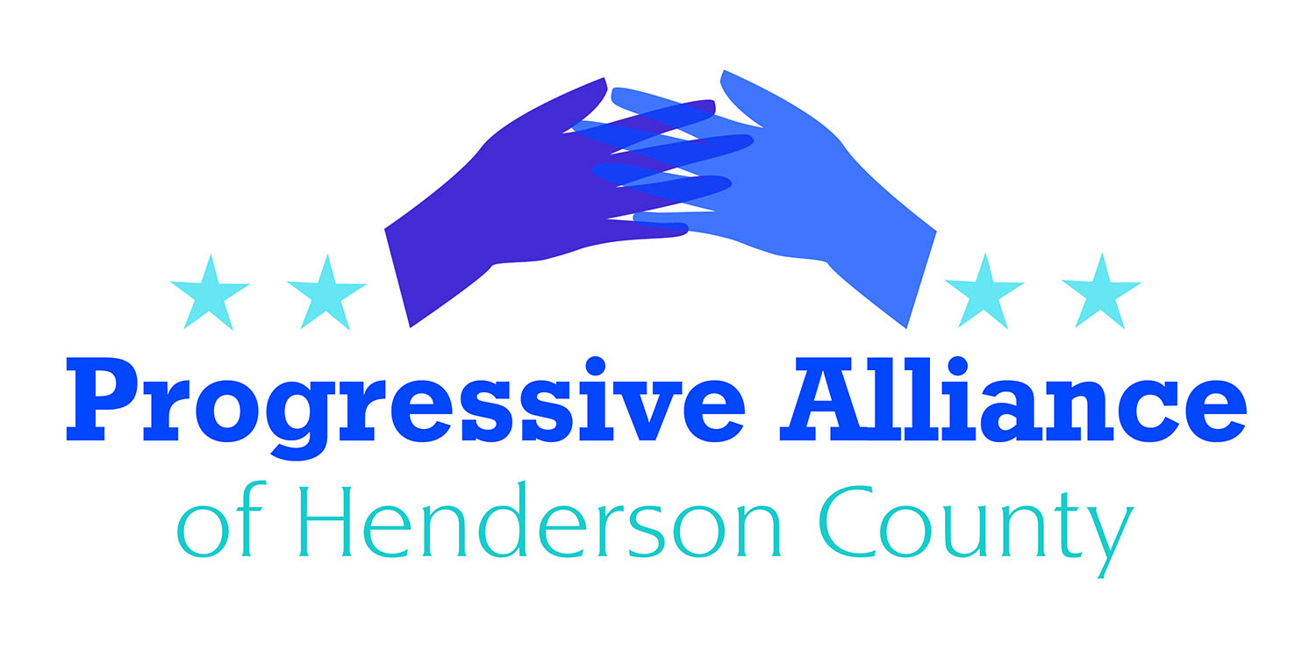

Postcard Party # 119 May 3, 2019

National

MEDICARE FOR ALL
Earlier this week, the House Rules Committee held the first-ever congressional hearing about a bill to establish a single-payer, ‘Medicare for All’ healthcare system.
While Rules Committee hearings are typically the last destination for legislation before it reaches the House floor, that won’t be the case for the Medicare for All Act (H.R. 1384) as Tuesday’s hearing was an “original jurisdiction” hearing to give members an opportunity to learn about the policy.
Chairman James McGovern (D-MA), a cosponsor of the bill, called it “a serious proposal that deserves serious consideration on Capitol Hill as we work toward universal coverage.”
Contact Mark Meadows to express your opinion on this concept.

ASYLUM FEE
President Donald Trump has outlined a new series of hardline immigration measures that he hopes will stem illegal immigration to the U.S., including imposing “fees for asylum applications and work permit applications."
The presidential memorandum, signed on Monday, would also require asylum claims to be processed within 180 days and bar unauthorized immigrants from working in the U.S. if they entered the country illegally. The memo did not indicate how much unauthorized immigrants would be charged to claim asylum.
“This strategic exploitation of our Nation's humanitarian programs undermines our Nation's security and sovereignty,” Trump said in the memo. “The purpose of this memorandum is to strengthen asylum procedures to safeguard our system against rampant abuse of our asylum process.”
Eleanor Acer, director of the refugee protection program at Human Rights First, called the proposal "a disgraceful continuation of his years-long campaign to punish refugees for seeking asylum."
Contact Senators Burr and Tillis, Congressman Meadows, as well as The Honorable Kevin K. McAleenan, Acting Secretary of Homeland Security, Washington, D.C. 20528

BOOTS ON THE BORDER
The Pentagon has approved a Department of Homeland Security request to send about 320 additional troops to the U.S.-Mexico border to provide support to Customs and Border Protection officials.
The Department of Defense has also approved expanded authorities that allow troops to come into direct contact with unauthorized immigrants, including driving CBP transport vehicles.
"In any situation that requires [Department of Defense] personnel to be in proximity to migrants, DHS law enforcement personnel will be present to conduct all custodial and law enforcement functions, and provide force protection of military personnel,” said Pentagon spokesman Lt. Col. Jamie Davis.
The Posse Comitatus Act prohibits the use of active-duty service members for law enforcement within the U.S.—unless they are specifically authorized by Congress. The recent order states that troops won’t perform law-enforcement duties.
Contact Senators Burr and Tillis, Congressman Meadows, as well as The Honorable Kevin K. McAleenan., Acting Secretary of Homeland Security, Washington, D.C. 20528

State
SAFER ROADS AND COMMUNITIES ACT OF 2019
This legislation would authorize the Division of Motor Vehicles to issue restricted driver's licenses for our newest immigrant neighbors with limited or no status.
FaithAction International House and the FaithAction ID Network, a collection of nonprofits, faith communities, and community partners (law enforcement, health centers, schools, and businesses) throughout North Carolina have provided over 20,000 community issued ID cards in NC and other states.
After consulting with numerous partners and community members, the network partnered with Representatives Harrison, Fisher, Meyer and Morey to submit the Safer Roads and Communities Act of 2019. After its first reading, it now also has the support of Representatives Autry, Dahle, Garrison, Gill, Insko and Terry. This act would increase the safety of state roads and communities in NC by authorizing the Division of Motor Vehicles to issue restricted driver's licenses to immigrants with limited or no status.
Many law enforcement agencies throughout NC have consistently stated that they feel their roads would be much safer if everyone passed the same driving tests and had insurance. Immigration reform has stalled in Congress for the last two decades, and in the meantime, states are taking action - driver's licenses or driving rights cards exist in a dozen other states. North Carolina once had a driver's license option for those with limited or no status, and our diverse communities are ready for it to return.
Write Representative McGrady/Henson to let them know how you feel about this act.

ELECTION INTEGRITY BILL
For years, Republican lawmakers in North Carolina claimed they wanted to protect the integrity of elections, but pushed voter ID bills designed to protect their party’s majorities. Those bills dealt with in-person voter fraud, which is rare in our state and across the country.

Last year’s NC-09 U.S. House election was tainted by widespread absentee ballot fraud in Bladen and Robeson counties. Now, lawmakers are poised to provide North Carolina with a bipartisan bill that comes close, although not close enough, to dealing with a real election problem.

House Bill 944 would make it a crime to sell or pay for absentee ballot request forms, a tactic allegedly used by Bladen County operative McCrae Dowless to help swing the NC-09 election to Republican Mark Harris. The bill also would require counties to keep a register of absentee ballots requested and issued, which some but not all NC counties already have.

Contact Chuck McGrady/Cody Henson to express your opinion on these efforts.

