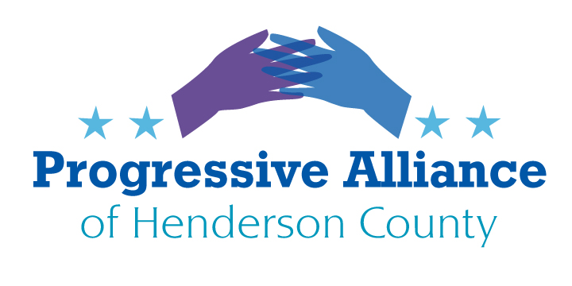
POSTCARD PARTY #198 November 6, 2020

Henderson C0. Flooding

In the last couple of years, there has been serious flooding in Henderson County. There are several roads around the county that you can count on having to be barricaded when we get heavy rains. Of particular concern is the flooding where Main, Church and King split and become Greenville and Spartanburg Highways. Mud Creek and Wash Creek merge right at that point and it is a flood plain.

We can blame climate change for severe storms and developments that don’t’ account for storm water run-off.

I wish to add poor maintenance of creeks allowing debris to clog the much needed capacity. It is the responsibility of a home owners to keep streams clear on private property. It is the responsibility of city or county or state properties (i.e. parks) to keep their streams clear. This does not mean digging a stream deeper. Look up “Riparian methods”. Yes, we all need to be good stewards of our environment. The quickest remediation is to clear the streams of limbs and downed trees. If you property contains a streams, keep it clear, and offer to help a neighbor clear their stream. There are also private and non-profit groups, sometimes funded with grants, which could use our help. A few are listed here:
Mountain True
https://mountaintrue.org/waters/
Mills River Partnership
https://www.millsriverwater.org/
Conserving Carolinas
https://conservingcarolina.org/americorps/
RiverLink
https://riverlink.org/about/

And city and county departments that issue building permits, and developers building and paving need to not build in flood plains and need to prepare for heavy rainfalls. The shopping center where fresh Market, PetSmart, Stein Mart (going out) and the new bank construction probably predate flood plain delineation. Publix did get a permit, but it maybe should not have been granted as it has clearly aggravated this area.

Trump’s great infrastructure promise has come to nothing, unless building oil and gas pipelines and allow mining, drilling and deforestation in national parks “infrastructure”. I digress.

One consideration would be to build a bridge from where King, Church, and Main converge over the flood plain and tie in to feeder access to Greenville and Spartanburg Highways. Then remove the lower roads, bridges and edges of parking lots that restrict water flow.

For example, Buncombe County requested a plan from the US Army Corp of Engineers to help with the catastrophic flooding of Swannanoa River in 2014. Plan presented and nothing ever done.

The attached report is from June 2003 about water quality:
https://files.nc.gov/ncdeq/Water%20Quality/Planning/BPU/BPU/French_Broad/Mud_Creek_June_2003.pdf

All of this costs money. Maybe think about how we can use a few million dollars more wisely that putting fake turf on high school football fields.

Write the City County and County Commissioners to be part of the solution.
Funding should be available through North Carolina Land and Water Fund, about a million and a half has already been allocated to Henderson Co.
https://nclwf.nc.gov/

Daylight Saving Time

A little background, the idea of daylight saving goes back to 1784 and Benjamin Franklin.
The Standard Time Act in 1918 created time zones and daylight saving. It was repealed in 1919 but some states continued the idea.
The Uniform Time Act of 1966 established a Daylight Saving Time for the entire United States. States could exempt themselves from participating.
The Energy Policy Act of 2005 changed the date of the switch overs.
Hawaii and most of Arizona do not recognize DLS. About 70 countries also use DLS.

This is Wikipedia’s synopsis of the Energy Policy Act. So much of it needs to be overturned, including the Daylight Saving portion.
https://en.wikipedia.org/wiki/Energy_Policy_Act_of_2005

Revoking this Act or writing a new one requires the US House and Senate.

