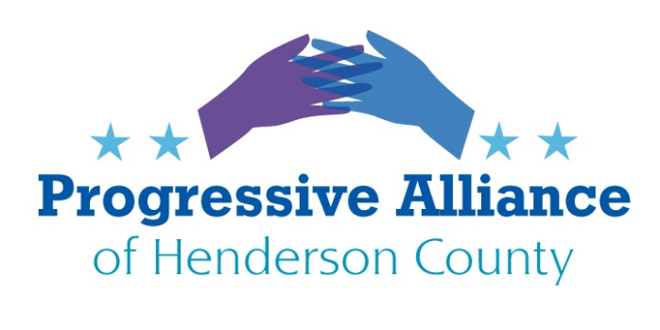

VIRTUAL POSTCARD PARTY #190 September 11, 2020

Issues from September 4, 2020 that still may need additional attention:
- Update on USPS
- Big Pharma vs. public options for pharmaceuticals
- Who is protecting our data????
FEDERAL / STATE / LOCAL
New addresses at the end of this Suggestion Sheet
SUPPORT THE HEROES ACT - AGAIN
All of our state and local governments have lost hundreds of billions in tax revenues because of the Coronavirus Pandemic Recession. Having already laid off many thousands of workers, our governments are now laying off hundreds of thousands more, and have cut back on many basic and essential services. The Heroes Act passed the House of Representatives in May, therefore, with at least $375 billion for state and local governments to be able to serve us and help save our economy.
Moscow Mitch McConnell and Leningrad President Trump firmly proposed to include exactly $0 for state and local governments in a new pandemic relief program, even as both red and blue states suffer the same perilous conditions. The federal government can print money to vastly grow the deficit in order to pay for necessary pandemic relief. State and local governments must now depend on relief from the federal government because they must balance their budgets and are very limited in how much they can issue in bonds to raise money.

Congress returned this week from its August recess and will soon depart again for a long campaigning recess. Congress must act now to pass the Heroes Act with veto-proof majorities.
Contact Sen. Burr and Sen. Tillis to demand they break with McConnell and Trump by advocating for passage of the Heroes Act. Contact Republican candidates Cawthorn (U.S. House), Sen. Edwards (NC Senate), and Moffitt (NC House), to tell them to advocate for passage of the Heroes Act. Write Democratic candidates Davis (U.S. House), Caskey (NC Senate), and Remillard (NC House) to thank them for advocating for North Carolina.

REMEMBER SEPTEMBER 11, 2001 AND ACT ON THE LESSONS WE SHOULD HAVE LEARNED
Three thousand people were murdered on September 11, 2001. The victims were American citizens, documented immigrants, international visitors, and undocumented residents. The vulnerabilities that were exploited by terrorists that day were the result of carelessness, hubris, penny-pinching, and failures of imagination. But it was clear that Americans did not invite the 9/11 hijackers to attack us. Somehow in 2016 Donald J. Trump won the Electoral College despite having openly invited the Russian government to attack our elections through toxic propaganda and multiple cybercrimes.

Meanwhile, our individual and national security is still being undermined by the Trump administration’s failed response to the coronavirus pandemic in which more than 60 times as many Americans have already died as perished on September 11, 2001. These two tragedies should not be compared, since there is no conceivable scale on which the weight of sorrows can be measured. But we must observe that the Republicans apparently only mourn publicly when it is in their political interests.
Contact Sen. Tillis, Sen. Burr, U.S. Rep. candidate Cawthorn, NC Sen. Edwards, and NC Rep. candidate Moffitt to ask them how they can continue to support Donald Trump on the 19th anniversary of the September 11 attacks.

REMIND THE CANDIDATES FOR THE NORTH CAROLINA GENERAL ASSEMBLY AND FOR THE U.S. CONGRESS THAT WE OWE VETERANS DEBTS OF GRATITUDE, NOT DENIGRATION

The Atlantic magazine has reliably reported that Bone Spurs Donald J. Trump has referred to members of the U.S. Armed Forces as “losers” and “suckers”, in particular when referring to service members who have died or been wounded while defending our country. In some cases, particularly in his boorish and disgusting statements about the late Sen. John McCain, such comments are in the public record on videotape or Twitter.

Whatever our opinions and feelings may be about the politicians who got us involved in one war or another, we all still owe debts of gratitude and honor for people who serve and have served in the U.S. Armed Forces.

Contact Sen. Tillis, Sen. Burr, U.S. Rep. candidate Cawthorn, NC Sen. Edwards, and NC Rep. candidate Moffitt to ask how they can continue to support Donald Trump following this reminder of his disrespect and hypocrisy in these comments about people in the military. Remind them that Trump’s giddy preference is to use soldiers and armaments as Soviet-style props in show parades, even as he expresses cowardly disgust about interactions with wounded veterans.
NEW ADDRESSES:

Moe Davis (D)
P.O. Box 18584
Asheville, NC 28814

Madison Cawthorn (R)
638 Spartanburg Hwy Ste. 70 #362
Hendersonville, NC 28792

Tim Moffitt (R)
3182 Sweeten Creek Rd
Asheville, NC 28803

Josh Remillard (D)
P.O. Box 746
Etowah, NC 28729

Brian Caskey (D)
P.O. Box 598
Horse Shoe, NC 28742

