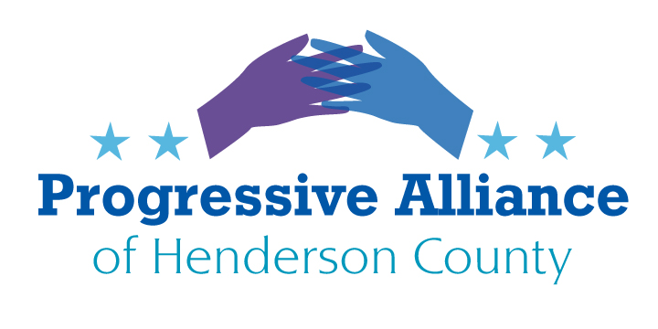

Virtual Postcard Party #172 May 8, 2020

National

Assault Weapons Ban
Canadian Prime Minister Justin Trudeau announced a ban on all assault-style firearms last Friday. The ban includes "1,500 models and variants," including the AR-15 rifle. It will prohibit those firearms, as well as some components, from being used, sold or imported.

According to a release from the Canadian government, the ban will not take full effect for another two years in order "to protect owners of newly prohibited firearms from criminal liability while they take steps to comply with these new rules." There are also exceptions until April 30, 2022, for people in indigenous communities and for those who hunt to sustain themselves or their families. But ultimately all items on the list will be banned.

Folks, if Canada can do it, why can't we? Contact the usual suspects, but concentrate on Sen Tillis and Rep. McGrady – since each is in the final few months of their terms (we HOPE, in Tillis' case), perhaps they will be amenable to something sensible. In addition, you might want to drop a line to these five freshman House members who are endorsed by the GiffordsPAC for their efforts in supporting sensible firearms regulations: Abby Finkenauer (IA-01), Cindy Axne (IA-03), Sean Casten (IL-06), Chris Pappas (NH-01), and Andy Kim (NJ-03).

Confirmation of Unqualified Judges (from MoveOn)
Donald Trump and Mitch McConnell's attempts to pack the courts with lifetime appointees who are unqualified to serve the American people may restart as early as next week. We cannot allow the American judicial system to descend even further because of their partisan politicking.
McConnell is calling the Senate back into session during a global pandemic, but instead of focusing on helping the people who are struggling during this public health crisis, he is working to install his political crony, Justin Walker, into a powerful lifetime role on the federal bench. As he is only 37 years old now, Walker could sit on the D.C. Circuit Court of Appeals for decades to come. Tell our Senators to reject Justin Walker's nomination.
Eliminating Presidential Oversight (Washington Post, May 2)
President Trump moved to replace the top watchdog at the Department of Health and Human Services after her office released a report on the shortages in testing and personal protective gear at hospitals.
In a Friday night announcement, the White House nominated a permanent inspector general to take the reins from Christi A. Grimm, the principal deputy inspector general who has run the office since January.
The White House nominated Jason Weida, an assistant United States attorney in Boston, as permanent inspector general. The announcement said Weida was chosen because he has overseen “numerous complex investigations in healthcare and other sectors.” He must be confirmed by the Senate.
Grimm’s removal follows a purge of high-profile federal officials and inspectors general whose work has been critical of the president. Inspectors general at large agencies serve at the pleasure of the president, but they are considered independent monitors for waste, fraud and abuse.
Contact our Senators to urge them turn down nominated replacements for deposed IGs. Contact Speaker Pelosi to insist that all future funding bills contain strong provisions for oversight.
Limiting Employer Liability (Washington Post, May 3)
Congressional leaders are girding for a huge fight over the reentry of millions of Americans to the workplace, with Senate Majority Leader Mitch McConnell (R-Ky.) insisting that employers be shielded from liability if their workers contract the coronavirus. He appears to have the backing of top White House officials.
Democratic leaders have declared they will oppose such blanket protections, putting Washington’s power brokers on opposite sides of a major issue that could have sweeping implications for health care and the economy in the coming months. The battle has unleashed a frenzy of lobbying, with major industry groups, technology firms, insurers, manufacturers, labor unions, and plaintiffs lawyers all squaring off.The clash is a sharp departure from the past six weeks, when lawmakers from both parties came together to swiftly approve nearly $3 trillion in emergency funds as Americans hunkered down during the pandemic. Now, lawmakers are warring over what the rules should be when millions of Americans return to the workplace. Contact U.S. Senators and Reps. to halt this attack on workers.

North Carolina

COVID-19 Relief (From ProgressNC Action, May 4)
After waiting a month to respond to the pandemic, the legislature still failed to address two important issues out of the relief package; improving unemployment benefits and health insurance for the working poor.
- The Senate, led by Phil Berger, declined a partial Medicaid expansion proposed by the House to cover COVID-19 treatment costs for people under a certain income threshold -- the final bill contains increased funding for Medicaid in general.
- Despite unemployment claims over one million in NC, a proposal to increase the state's weekly maximum on unemployment benefits was also cut.
- Lawmakers also declined a series of election policy changes and funding requests from the State Board of Elections, including efforts to make voting safer for North Carolinians.
The two latest bills are backed by an abundance of federal money but the legislature retained its unwillingness to help jobless workers or low-income North Carolinians, regardless of the pandemic.
Another session is expected later this month as the legislature must decide on how to allocate the $3.5 billion in federal funding from the Congress' stimulus bills. Contact Sen. Edwards and Rep. McGrady to demand that each of these three issues is adequately addressed during the upcoming short session.

Local

Reopening Henderson County
In their third meeting on reopening the county for business post-coronavirus, business owners pushed back on a phased plan they said was too rigid and time-consuming. The Post-Covid Task Force is co-chaired by commissioners Bill Lapsley and Rebecca McCall, But during the hour and 20-minute meeting, Lapsley and McCall listened as business owners from a cross-section of sectors — services, shops, dining, lodging — implored them to accelerate the reopening timeline as much as they could.

Henderson County Commissioners are debating how rapidly the County should reopen restaurants, stores, parks, and other establishments. So far, the only organized stream of comments has been from restaurants and merchants. Public comment has NOT been solicited. So, folks, it is time to write your commissioners (toss in the Chamber of Commerce and downtown business association, as well) and tell them exactly, and under what circumstances and restrictions, you would be willing to visit restaurants and retail establishments again. Be firm, be polite, be specific. The businesses need to know whether or not there will be consumers willing to buy upon reopening.

Quarantine Isolation – An Exercise in Contemplation
A short article in the April 25th issue of The Economist, “Protection Racket”, addressed the unconstitutional actions taken by various autocrats (Hungary, Russia, Serbia, China, India et. al.) to cement power in 2020 while all attention is diverted to COVID-19.

Readers, we have a docile Senate and compliant federal court system to encourage 45 to do anything and everything to stay in the WH. Ten years ago, most voters would have said they would be marching in the streets if a president did a tenth of the inane actions that Trump has finessed.

So, what is the limit of your tolerance? And, just what are you willing to do when that line is crossed?

