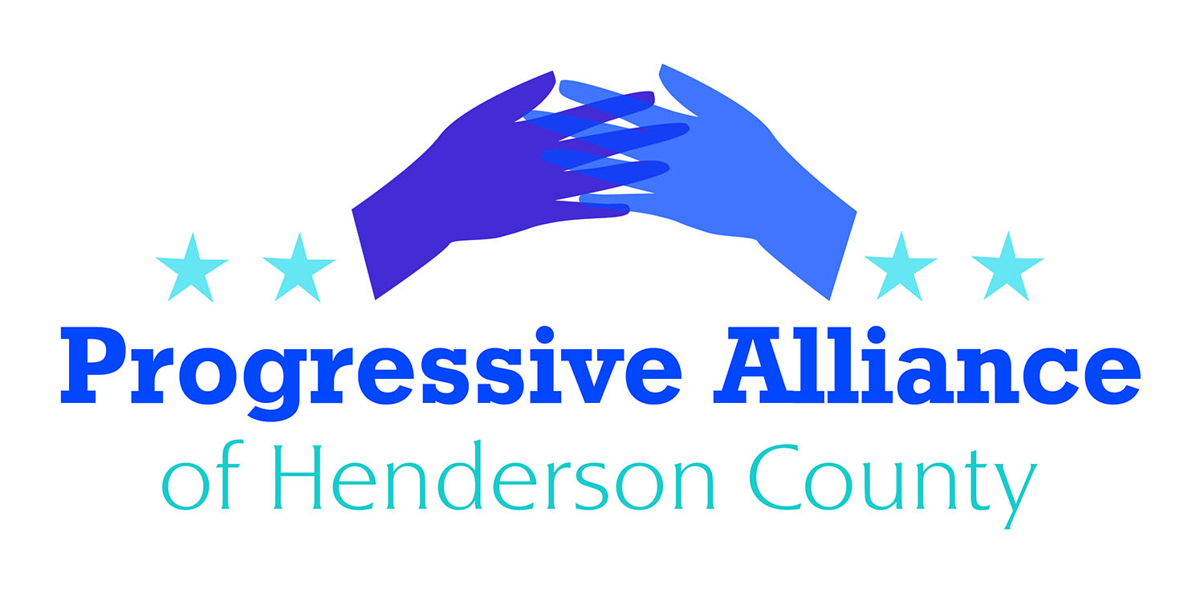
Postcard Party # 128 July 5, 2019

National

MIGRANT DETENTION
A new report by the Homeland Security Inspector General describes appalling conditions and wretched overcrowding at migrant detention centers in Texas with a top manager at one of the facilities saying he fears for the security of his staff, calling the situation a ‘ticking time bomb.’ The report released Tuesday includes numerous pictures of people behind cages lying on bare cement floors with nothing to do, men in a room with standing room only, men and women wearing surgical masks appearing to be reaching out to the photographers for attention. The inspector general called on the DHS to ‘take immediate steps to alleviate dangerous overcrowding and prolonged detention of children and adults in the Rio Grande Valley.'”

Write to Senators Tillis and Burr and Congressman Meadows, as well as the head of Homeland Security. (The Honorable Kevin K. McAleenan, Acting Secretary of Homeland Security, Washington, D.C. 20528)

FORCED ARBITRATION IN BANKING
Americans for Financial Reform reports that “JPMorgan Chase recently sent its 47 million customers an email. Buried almost 2,000 words into that email were details of how it will begin to take away customers’ legal rights.
“Chase is putting many of its credit card holders into forced arbitration “rip-off clauses”. The clauses prevent consumers from taking Chase to court, or joining class action lawsuits if the bank harms them or breaks the law.
“Forced arbitration is a secretive, privatized system that takes away an individual’s rights to seek justice when they are cheated, discriminated against or defrauded.”
If Chase is successful in forcing arbitration onto its customers, every large bank in the country will surely follow.

Write to Senators Tillis and Burr and Congressman Meadows, as well as the Comptroller of the Currency (Joseph M. Otting, Comptroller of the Currency, Office of the Comptroller of the Currency, 400 7th Street, SW, Washington, D.C. 20219), to demand legislation that will prevent banks from forcing arbitration onto their customers.

State

U.S. SUPREME COURT HANDS A VICTORY TO GERRYMANDERING
Last week, the Supreme Court ruled on Rucho v. Common Cause - explicitly approving the blatant partisan gerrymandering which North Carolina Republicans have used to turn a purple state into a sea of red districts. While the ruling is disappointing, it makes it even more important to push for nonpartisan redistricting reform so that our state can have fair maps no matter who’s in charge of drawing them.
- North Carolina can’t afford another decade of elections using maps that were drawn by the same lawmakers and GOP consultants using the same software as the previous racially gerrymandered maps which were ruled unconstitutional.
- The Supreme Court banned racial gerrymandering, but does not prohibit partisan gerrymandering. But when African-American voters almost exclusively support Democrats, what is the difference between racial and partisan gerrymandering?
- The only way to truly ensure fair maps is to take partisan politics out of the redistricting process so that no party can draw an unfair advantage for themselves, as the current Republican majority has done.
Contact Sen. Edwards, and Rep. McGrady or Henson.

STATE BUDGET
Gov. Cooper vetoed the Republican budget (HB966) last Friday, but that won’t stop the GOP from once again trying to ram through a budget which does not address the concerns of hard-working North Carolina families or our valued educators. Instead of expanding Medicaid and investing in our schools and our students, the politicians are trying to give even more of their misguided tax cuts to big corporations and the ultra-wealthy.
Although the GOP lost its supermajorities in 2018, several Democratic lawmakers stood with the GOP to vote for this budget and its misguided priorities. Some may vote differently on a veto override, but Republicans will be doing their best to encourage Democratic lawmakers to break ranks.
Contact Rep. McGrady or Henson, to encourage them to vote against overriding Cooper's veto of HB966. In addition, contacting these Democratic members of the NCGA would be worthwhile.
Democrats Voting “Yes” (siding with Republicans): Hunter
Democrats Absent with Authorization: Alexander; Brockman; Floyd; Gailliard; Graham
(North Carolina General Assembly, Legislative Building, 16 West Jones Street, Raleigh. NC 27601)

Local

MIGRANT FAMILY DETENTION
Many families prepared for a holiday weekend spent celebrating our nation’s birthday with friends. The awful truth is that while we’re celebrating, thousands of migrant children will be huddling under aluminum blankets on concrete floors, separated from their parents. The Fourth of July is supposed to be a celebration of our nation’s highest ideals: life, liberty and the pursuit of happiness. That’s why this holiday weekend, I’m urging my friends and family to bear witness to the family separation at our border which is so antithetical to our American values. I’m grateful to People’s Action and the dozens of other groups who are stepping up at this crucial moment. Join a vigil among the hundreds planned on July 12th or start your own, volunteer at a local organization or donate to a refugee assistance organization such as HIAS or the International Rescue Committee, and talk to your friends, families and neighbors about how to get involved. Children and families are counting on us. Don’t fall silent. Don’t look away. We’ve got work to do.
Action: Write postcards today to two friends, and encourage then to join us on Friday, July 12, during our candlelight vigil at the ICE building at 6th and Justice.

