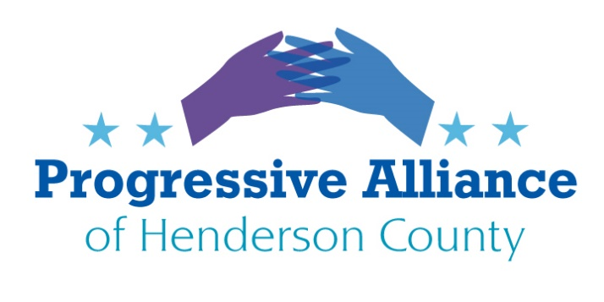

**POSTCARD PARTY 160 FEBRUARY 14, 2020**

**GUN SAFETY LEGISLATION**

***Write Henderson County Board of Commissioners***

FOR IMMEDIATE RELEASE  
February 12, 2020   
**“Second Amendment Sanctuaries” Opposed by NCGV**

NCGV (North Carolinians Against Gun Violence) today reiterated its opposition to “Second Amendment Sanctuaries after over half of North Caorlina’s 100 counties have passed some form of the resolution. These resolutions declare or imply that state gun safety laws do not apply in their communities, with some going as far as refusing to enforce and dedicate tax-funded resources to the implementation of state gun safety measures. These resolutions jeopardize public safety by interfering with the implementation of life-saving laws.

"It's extremely troubling that over half of North Carolina counties have passed these resolutions," said Becky Ceartas, Executive Director of NCGV.  "They are reckless and potentially dangerous."

The constitutionality of laws is decided by courts, not local governments and courts have overwhelmingly upheld gun safety laws as fully compatible with the Second Amendment. Most notably, in the Supreme Court’s *District of Columbia v Heller* (2008) majority opinion, Justice Scalia wrote that the Second Amendment was not unlimited and that a range of gun regulations are fully consistent with it.

These resolutions put victims of domestic violence most directly at risk. According to the American Journal of Public Health, the presence of a firearm makes it nearly five times more likely that a domestic violence victim will become a homicide victim. In a county that has passed a resolution, a local sheriff might take an extreme stance on not enforcing a gun law with which they disagree. For example, they might not use county resources, like staff time, to remove weapons from domestic abusers who make credible threats to harm a partner or child. This risks a tragic outcome for no good reason.

In addition, refusing to enforce a state law opens a county up to lawsuits. Would a victim of gun violence sue a county for not enforcing a state law that might have prevented an incident? Also, a Second Amendment Sanctuary resolution risks harming a county’s economy as corporations and individuals might be repelled by such a resolution and avoid investing there.

That sad truth is that 1,430 North Carolinians were shot and killed in 2017, the most since 1999. This number will likely grow if “sanctuaries” stop enforcing our gun laws.

 For more information on Second Amendment Sanctuary resolutions please go to [www.ncgv.org](http://www.ncgv.org?e=d58bcd31d72b21527de0e5db75d458ef2199a765&utm_source=ncgv&utm_medium=email&utm_campaign=release_about_2a_sanctuary&n=1&test_email=1).

*North Carolinians Against Gun Violence (NCGV) is a non-profit organization that has been working for more than 26 years to reduce the number of incidents of gun-related deaths in our state each year. NCGV’s mission is to make North Carolina safe from gun violence through public education on gun violence prevention, the enforcement of current gun laws, and the enactment of new legislation.*

*______________________________________________________________________________*

***To NC House Speaker Tim Moore and Henderson County Reps. McGrady & J. Johnson***

**Fifty members of the Republican House caucus, including Speaker Tim Moore, signed a letter that supports those who want “Second Amendment sanctuaries”. The letter says the Republican caucus “stands with Virginia, the Counties and Cities who have declared themselves 2nd Amendment Sanctuaries that will not permit a tyrannical government to restrict or infringe on those or any other rights.”**

**These resolutions spurred extremists who want to encourage local militias to engage in armed rebellion against the state — action that isn’t just dangerous but that also runs counter to the Constitution. The right secured by the Second Amendment is not unlimited. As the Supreme Court made clear in Justice Antonin Scalia’s 2008 majority opinion in**[***District of Columbia v. Heller***](http://r20.rs6.net/tn.jsp?f=001l-drueVwID86VPYBfl4wRvtY8PrlSq35sHikZ3DOxoSNHubODjNkJl-g-EUhDbvufJGncF3--v1fw43QbPknYUHcX2ar2Jln8ldymDhtg1w4PT-kNjghF48EAEWQ31xk6kdU0dP5lXCZi_MseBMq9cpW1EVkE5mBF-zVZSXoj_o=&c=YVq9YfMkyNZpABIYWgRyJ4XI6xE9eOXl5JNxfR-pwi5qyXjcg-4skQ==&ch=zygoGaBDi3GKtOtWWtJYyKZKuybA1MDJ0OIiWB5Xmx9jNOENY0eWDg==)**, it is “not a right to keep and carry any weapon whatsoever in any manner whatsoever and for whatever purpose.”**

**______________________________________________________________________________**

***To any federal Senators, and especially Senators Burr & Tillis***

**Universal Background Checks**

**House of Representatives passed broad legislation last year (H.R. 8, Bipartisan Background Checks Act of 2019) but it is stalled in the Senate.** It has not been referred to any committees.

Senator Chris Murphy (D-CT) has obtained 41 cosponsors for S. 42, the **Background Check Expansion Act** (Summary: This bill establishes new background check requirements for firearm transfers between private parties (i.e., unlicensed individuals). Specifically, it prohibits a firearm transfer between private parties unless a licensed gun dealer, manufacturer, or importer first takes possession of the firearm to conduct a background check. The prohibition does not apply to certain firearm transfers, such as a gift between spouses in good faith.) This bill is in the Judiciary Committee, but has not earned hearings or been on an agenda to discuss. Senator Tillis (R-NC) is on the committee.

**Join the majority of Americans who support Background Check legislation for all gun sales including private and online transactions. This legislation deserves a vote!**