WE’VE LISTED MOST* CANDIDATES AND THE OFFICES THEY ARE SEEKING ON NOVEMBER 5, 2024. THEY WANT YOUR VOTE, SO THIS IS AN OPPORTUNITY TO:
Advise candidates of your expectations!
NOTE: Because many candidates’ official NC Board of Elections snail mail addresses happen to be their private residences, we are not providing those. If no address appears here WE WILL ADDRESS CARDS FOR YOU to respect candidates’ privacy.
Postcard Party # 269
March 15, 2024 GREETINGS TO CANDIDATES 2024!
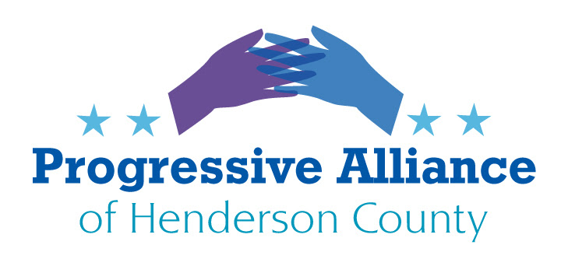
OFFICE |  | CANDIDATE |  |  | CANDIDATE
Henderson County Commissioner  District #2 | D | Erik Weber |  | R | Sheila Franklin
Henderson County Commissioner  District #5 | D | none |  | R | Jay Egolf  PO Box 2530  Hendersonville NC 28793
Henderson County School Board  (4 seats open) | D | Leslie Carey  1216 6th Ave. W #600  Hendersonville NC 28739  Crystal Felicia Cauley  PO Box 1  Hendersonville NC 28739  Mary Ellen Kustin  PO Box 1911  Hendersonville NC 28793  Rhonda Mountain |  | R | Robert Bridges  Beth Campbell  Amy Lynn Holt  Kathy Revis
Hendersonville City Council  (2 seats open)  (non-partisan) |  | Lyndsey Simpson |  |  | DJ Harrington  PO Box 661  Hendersonville NC 28783  Jennifer Hensley
Hendersonville City Council  (1 unexpired term seat open)  (non-partisan) |  | Gina Baxter  PO Box 2791  Hendersonville NC 28793 |  |  | Colby Coren  Lynne Elizabeth Williams
U.S. Congress  District 11 | D | Caleb Rudow  PO Box 18475  Asheville NC 28814 |  | R | Chuck Edwards  337 N. Main St.  Hendersonville NC28792
NC Senate  District 48 | D | Chris Walters |  | R | Tim Moffitt  PO Box 768  Hendersonville NC 28793
NC House  District 117 | D | Steve Martinez  PO Box 714  Horse Shoe NC 28742 |  | R | Jennifer Balkcom  PO Box 97275  Raleigh NC 27624
NC House  District 113 | D | Michelle Antalec  1216 6th Ave W #600  Hendersonville NC 28739 |  | R | Jake Johnson  PO Box 681  Columbus NC 28722
NC Governor | D | Josh Stein  301 Hillsborough St. #950  Raleigh NC 27805 |  | R | Mark Robinson  PO Box 473967  Charlotte NC 28247
NC Lt. Governor | D | Rachel Hunt  PO Box 6104  Charlotte NC 27628 |  | R | Hal Weatherman  pending possible runoff
NC Attorney General | D | Jeff Jackson  PO Box 470882  Charlotte NC 28226 |  | R | Dan Bishop  PO Box 1285  Waxahaw NC 28173
NC Superintendent of Public Instruction | D | Maurice “Mo” Green  1001 Wade Ave #323  Raleigh NC 27605 |  | R | Michele Morrow  PO Box 1761  Cary NC 27512
NC Supreme Court Judge Seat 6 | D | Allison Riggs  1001 Wade Ave #323  Raleigh NC 27605 |  | R | Jefferson Griffin  PO Box 99780  Raleigh NC 27624
NC District Court Judge Seat 3 | U | Lora Baker |  | R | Monica Gillett
*ADDITIONAL RACES WILL APPEAR ON THE NOVEMBER BALLOT, INCLUDING MUNICIPAL OFFICES IN MILLS RIVER AND FLETCHER, AND OTHER STATEWIDE ADMINISTRATIVE POSITIONS. BE SURE TO DOWNLOAD
THE GENERAL ELECTION BALLOT ONCE IT IS FINALIZED, THEN BEGIN YOUR RESEARCH!

