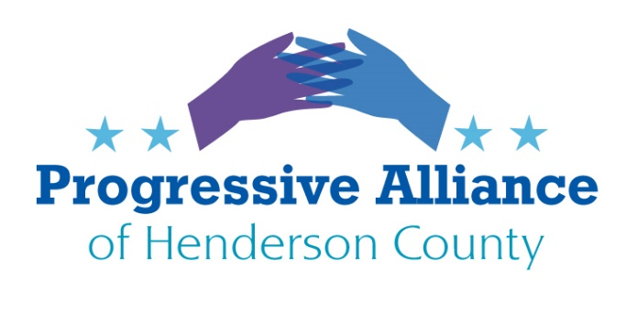
Postcard Party #155 January 10, 2020

Impeachment Trial

From NY Times, January 6:
After “careful consideration and study,” John Bolton, President Trump’s former national security adviser, said in a statement today that he would be willing to testify in a Senate impeachment trial, potentially delivering Democrats a crucial witness who spoke directly to Mr. Trump about his Ukraine dealings. Mr. Bolton’s lawyer said in November that Mr. Bolton knew about “many relevant meetings and conversations” connected to the Ukraine matter that had not been shared with impeachment investigators. Witnesses testified that Mr. Bolton, who left the White House unceremoniously in September, was deeply troubled by the campaign to get Ukraine to investigate Democrats.
Contact Sen. Burr & Tillis to tell them to support a fair, open trial of Trump...WITH witnesses.

Congress To Vote on Limiting Trump’s War Powers
Pelosi announces war powers resolution as tensions with Iran escalate. NBC: “House Speaker Nancy Pelosi, D-Calif., announced the House will vote soon on a war powers resolution to limit President Donald Trump’s military actions after he ordered the killing of a top Iranian general last week, escalating tensions with Tehran. ‘Last week, the Trump administration conducted a provocative and disproportionate military airstrike targeting high-level Iranian military officials,’ Pelosi said in a letter to colleagues Sunday. ‘This action endangered our service members, diplomats and others by risking a serious escalation of tensions with Iran.’ ‘As members of Congress, our first responsibility is to keep the American people safe,’ she continued. ‘For this reason, we are concerned that the administration took this action without the consultation of Congress and without respect for Congress’s war powers granted to it by the Constitution.'” Action: If the House has not yet voted on this, contact Rep. Meadows. Regardless, contact Sens. Burr and Tillis.

From socialsecurityworks.org
As the calendar turned to January 2020, our Social Security benefits saw a 1.6% increase over last year’s, due to the automatic cost-of-living adjustment (COLA). That amounts to just an average of $24 a month—a very modest bump that sadly doesn’t even cover one trip to the grocery store.
But, many seniors will see even less than that, because Medicare Part B’s standard monthly premium, which is automatically deducted from Social Security checks, is increasing by $9.10 a month.
Americans need more than a measly $15 per month increase in our modest Social Security benefits. We need to fix the formula used to calculate Social Security’s COLA. The Social Security 2100 Act does just that, by updating the formula to reflect the real expenses that Social Security beneficiaries face. This issue deserves the attention of Rep. Meadows and Sen. Burr & Tillis.

North Carolina

Headline: "Consultant says NC didn’t provide enough education funding. How big is the price tag?" "Twenty-five years after school districts first took the case to court, an independent consultant says North Carolina needs to sharply increase school funding — $8 billion more over the next 8 years — to help provide students a sound basic education. The report from WestEd, a nonprofit research group, says that state funding has not kept up with needs, leaving North Carolina near the bottom in the nation in spending on education. The result, the report says, is that academic performance has lagged in the state’s public schools. “The state is further away from meeting its constitutional obligation to provide every child with the opportunity for a sound basic education than it was when the Supreme Court of North Carolina issued the Leandro decision more than 20 years ago,” the WestEd report says."
The decline in per-pupil spending in North Carolina since 2009-10 when adjusted to 2018 dollars, according to WestEd. The group contends that average teachers' salaries were lower in 2017 than in 2003 and 2009, when adjusted for inflation.
This issue deserves the immediate and full attention of Sen. Edwards, Rep. McGrady, Johnson, and Gov. Cooper when the NCGA reconvenes next week.

From progressnc.org
Settlement forces Duke Energy to clean up coal ash ponds -- but who will pay for it?
After years of Duke Energy trying to shirk its responsibility to clean up its coal ash ponds, a new settlement means the energy giant will finally have to clean up these polluted ponds which have leaked countless tons of toxic chemicals into North Carolina waterways.
But who will pay for the estimated $9 billion cleanup? Obviously, Duke Energy should have to pay to clean up its own mess. But the company wants to pass those costs on to ratepayers -- many of whom have been dealing with the effects of toxic coal ash pollution for years.
- Last year, the state Utilities Commission authorized Duke Energy to charge state customers to recover hundreds of millions of dollars the energy giant has spent on closing ash sites around the state. This is unacceptable
- Duke Energy’s negligence allowed tons of toxic chemicals to seep into our rivers and groundwater. And they’re the ones who should pay for the cleanup, not blameless ratepayers.
- For years, Duke Energy has used its influence and profit-driven agenda to try to shirk its responsibility. They even donated heavily during the 2018 elections in order to gain support for a highly controversial bill that would have made it easier to pass cleanup costs on to customers.
Bottom Line: Lawmakers should be looking out for taxpayers and electricity ratepayers, not corporate polluters and their Wall Street shareholders. It’s good that Duke Energy must finally clean up its toxic coal ash pits, but we must continue to stay vigilant to ensure the energy giant does not try to pass cleanup costs on to consumers. Write to McGrady, Johnson, and Edwards with your opinion.

