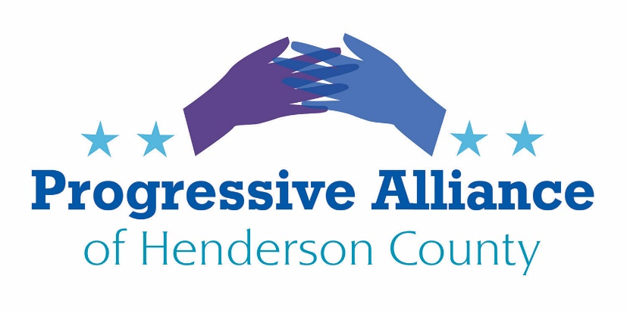

Postcard [Virtual Party] Writing & Sending # 165 March 20, 2020

National

ASK OUR SENATORS TO STOP DELAYING AND PASS THE HOUSE “FAMILIES FIRST” BILL NOW, TO HELP THE MOST VULNERABLE AND MOST AFFECTED IN OUR SOCIETY
The Families First Coronavirus Act (H.R. 6201) was passed by the U.S. House of Representatives in the early hours of March 14, 2020. The bipartisan legislation would extend employee sick leave benefits, expand access to free testing, support affected small businesses, and provide $1 billion in food aid to vulnerable Americans. Reactionary Republican senators oppose mandatory sick leave benefits for employees, based on the fig leaf of concern for small businesses when they are actually trying to prevent the (to them) slippery slope of mandatory employee sick leave from eventually becoming the law of the land after this crisis is over. Note that most R policies heavily favor powerful businesses and buy-and-milk hedge fund managers, and neglect most startups and small operations.
Action: Contact Senators Thom Tillis and Richard Burr to tell them to smooth passage of H.R. 6201, not slow it down.

AIRLINES HAVE BEEN BENEFICIARIES OF MULTIPLE BAILOUTS. WHILE THEIR PROFITS HAVE THRIVED IN THE PAST DECADE, SERVICE HAS DECLINED PRECIPITOUSLY WHILE TICKET PRICES HAVE SOARED
The Trump Administration intends to propose a $50 billion bailout of U.S. airlines. The airlines, along with many other travel-related industries, are indeed at great risk during the Covid-19 crisis. No monies, however, should go to the airlines without very firm and broad conditions that will improve conditions for the flying public when the airlines recover and again earn incredible profits. Equity (stock) should go to the public for any such favored industry (that’s how General Motors survived 2008-9), so recovery after the crisis has a clearer, more equitably shared path, consistent with the shifted risk.
Action: Contact Senators Thom Tillis and Richard Burr to tell them to oppose any bailout for the airlines unless it includes very firm and broad conditions, including public ownership features, that will improve conditions for the flying public in the future.

FIRE THE TRUMP ADMINISTRATION’S BUDGET DIRECTOR AND HIS JUNTA
The Trump Administration’s Office of Management and Budget director and the OMB leadership have year after year called for deeply cutting the budgets of the Centers for Disease Control and Prevention and the National Institutes of Health. If we hadn’t already known we are now painfully aware that Trump & his OMB have the worst possible priorities and the most delusional understanding of what government needs to be able to do to protect the American people.
Action: Contact Senators Thom Tillis and Richard Burr to tell them to vocally call for the firing of everyone in leadership at the OMB who has ever had any role in pushing for cuts to the CDC and the NIH. Contact the White House to make the same demand.

THE TRUMP ADMINISTRATION’S TRUE CORONAVIRUS CRISIS GRADE
Donald J. Trump claims he deserves a grade of 10 out of 10 for his “wonderful” response to the Covid-19 crisis. That is sheer fakery. The pandemic response units were disbanded in 2018. We face dreadful shortages of ICU beds, masks/respirators, ventilators, testing swabs (!) and serious questions about drug supply/ingredient supplies that the Federal authorities do not have information systems set up to collect. There are indications of intent to manipulate the situation to benefit a company headed by Jared Kushner’s brother.
Action: Contact Senators Thom Tillis and Richard Burr to tell them to denounce Pres. Trump’s off-the-cuff Covid-19 statements and policies. Strongly recommend using defense funds to purchase needed items under the Defense Production Act. Recommend directives to the Army Corps of Engineers to ramp up for installation of temporary hospital sites as needed and as done in Wuhan/Hubei. Contact the White House to offer your own evaluation.

State
MEDICAID TRANSFORMATION AND MEDICAID EXPANSION
It is unknown when and whether the General Assembly will reconvene. It is time, however, for the roadblocks to expand Medicaid in North Carolina in accordance with the Affordable Care Act to be removed by whatever means necessary to vote on the facilitating legislation.
Action: Contact Sen. Chuck Edwards, Reps. Chuck McGrady & Jake Johnson, and Gov. Roy Cooper to tell each one that the Covid-19 crisis must impel them to work with all our legislators to find a pathway to accept Medicaid expansion through the Affordable Care Act. Ask legislators to contact Sen. Berger and Speaker Moore to arrange for a prompt special session to reinforce medical staffs, facilities, and supply chains, using Medicaid and any targeted components of COVID-19 Federal stimulus resources.

Watch out for elderly neighbors, family and friends.
Support our local businesses as best as you can.

