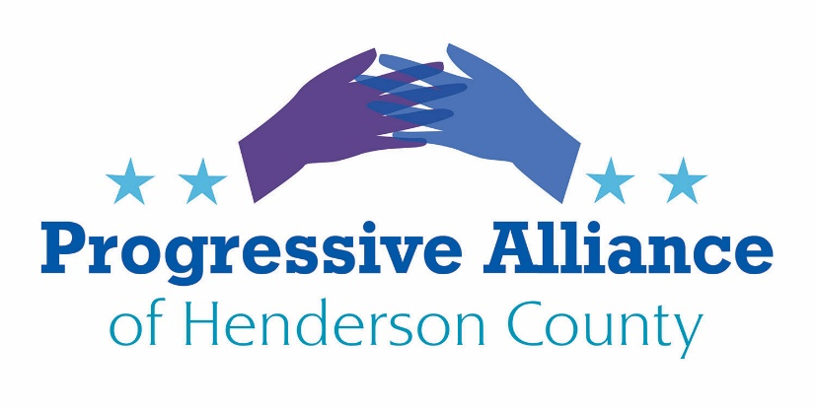

Postcard Party # 153 Dec. 27, 2019

National

KEEP UP THE PRESSURE FOR REPUBLICAN SENATORS TO VOTE FOR FOUR KEY FACT WITNESSES AT IMPEACHMENT TRIAL
The Senate has the sobering responsibility to try Pres. Trump on the two articles of impeachment passed by the House. The Senators must show their commitment to the Constitution by calling at least 4 key first hand fact witnesses whom Pres. Trump has so far blocked from testifying: John Bolton, Mick Mulvaney, Robert Blair, and Michael Duffey.
Action: Contact Senators Thom Tillis and Richard Burr to tell them to vote to call these 4 fact witnesses, and to maintain an open mind to impartially review all of the evidence.

ASK OUR SENATORS & REPRESENTATIVE WHETHER THEY COMPREHEND THE MEANING OF A COMMITMENT TO FIGHT CORRUPTION
Pres. Trump and his spokespeople claim that he was deeply committed to fighting corruption in Ukraine. Pres. Trump has not taken a single voluntary action to condemn and fight corruption and human rights violations in Russia, Turkey, Saudi Arabia, India, Hungary, Poland, the People’s Republic of Korea, and the Philippines.
Action: Contact Senators Thom Tillis and Richard Burr and Rep. Meadows to ask them how anyone can credit Pres. Trump’s commitment to fighting corruption when he gives outspoken support to corrupt, autocratic regimes in Russia, Turkey, Saudi Arabia, India, Hungary, Poland, Brasil, the People’s Republic of Korea, and the Philippines. Pres. Trump showed an extremely selective concern about corruption in Ukraine and has only been concerned about corruption and human rights violations in countries that he agrees are adversaries, such as Iran and Venezuela.

ASK OUR SENATORS AND REPRESENTATIVE TO CALL FOR WHITE SUPREMACIST STEPHEN MILLER TO RESIGN OR FIRED BY THE PRESIDENT
White House adviser (and let’s face it, policy maker) Stephen Miller’s trafficking in white supremacist websites and ideology has been exposed by diligent media.
Action: Contact Senators Thom Tillis and Richard Burr and Representative Meadows to tell them to call for Stephen Miller to resign or to be fired by Pres. Trump.

State
MEDICAID TRANSFORMATION AND MEDICAID EXPANSION
The General Assembly will reconvene in less than a month. The budgetary steps to sustainably transform Medicaid in North Carolina and to expand Medicaid in accordance with the Affordable Care Act are trapped in gridlock.
Action: Contact Sen. Chuck Edwards, Reps. Chuck McGrady & Jake Johnson, and Gov. Roy Cooper to tell each one to work with all our legislators to find a pathway to use the upcoming legislative session to sustain regular Medicaid and to accept Medicaid expansion through the Affordable Care Act.

PRIMARY AND SECONDARY EDUCTION IN NORTH CAROLINA IS IN CRISIS, WITH ACHIEVEMENT FAR BELOW WHAT VOTERS SHOULD EXPECT.
The General Assembly has been unwilling to adequately fund primary and secondary education.
Action: Contact Sen. Chuck Edwards and Reps. Chuck McGrady and Jake Johnson to tell them to work during the upcoming legislative session on increasing funding for primary and secondary education.
Our legislators should be asked to address inequities in educational practices and opportunity in North Carolina. Over 80% of state teachers are white. We should take steps to increase the attractiveness of NC schools to minority teachers. Gov. Cooper recently issued an executive order on this subject. Do they support his efforts? The 1994 Leandro school inequity case recently saw a follow-up report recommending investment of $8 billion over eight years to rectify the historic funding inequities in our public schools. There is no good reason that an economically healthy state should not begin to take on this failure to live up to the ideals of our state Constitution.

PLEASE REMEMBER: Any of these topics can be slightly expanded upon in a letter to the editor to any of the media organizations listed in the December PAHC newsletter.

