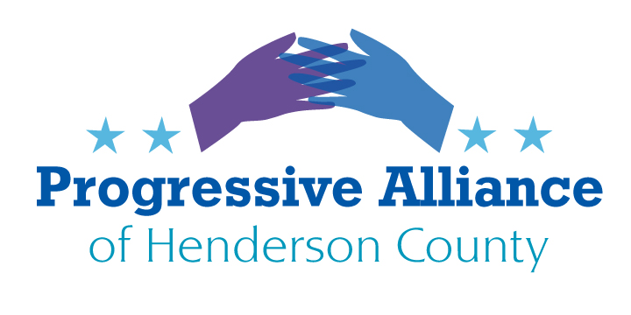
VIRTUAL POST CARD PARTY #194 OCTOBER 9, 2020
State & Local

Asphalt Plant- New Update
In the Wednesday, September 30, edition of the Times-News paper, it was reported that the zoning change request by Southeastern Asphalt was being withdrawn. The zoning request would have allowed construction of an asphalt plant in East Flat Rock near neighborhoods.
Although this may seem like a victory, it is likely only short-lived.
It has been reported that the owner of Southeastern Asphalt may once again file for a zoning change as he has now secured a toxicologist to address concerns by local citizens. Southeastern has six months to refile for the zoning change.
It is up to us to continue the vigilance and voice we have to stop this plant from being built once and for all. Facilities in other states have proven that disastrous, toxic environmental effects on the local population have occurred with plants of this nature.
If there are hearings, attend them. To reach out by postcard please contact County Commissioners: Mike Edney, Grady Hawkins, William Lapsley, Rebecca McCall, Teresa Wilson, Charlie Messer at this address:
Henderson County Board of Commissioners
1 Historic Courthouse Square Suite 1
Hendersonville NC 28792

ELECTION SECURITY

Election security has certainly become a prominent issue this election year. How do we physically stay safe when voting in person? How will we be safe when there is promise of local interference by agitators? Local counties have developed reassurance guidelines for overall protection from COVID 19 for both workers and voters at poll sites such as: the wearing of protective masks and gloves, face shields, social distancing, single use pens, cotton swabs for touch screen surfaces, sanitary wipe-downs of equipment after each use, curbside voting with privacy sleeves, self-screening of poll workers, etc.
The other issue is safety around the exterior of a polling site. Buncombe County announced 10/8 that in case agitators show up at polling sites on election day, the Asheville Police Department and the Buncombe County Sheriff's Office will have extra officers on duty, but only on election day November 3. On the other hand, Hendersonville Board of Elections has derided the notion that law enforcement is necessary and has not committed to offering police or sheriff assistance on any day of voting including election day, citing they will only respond if called.
As we have seen and heard on the news and web, the vigilantes supporting Trump have proclaimed they will disrupt the polling process by means of intimidation which can and has resulted in violence. They have already begun, as we have seen in blue states. NC law requires anyone protesting to stay at least 50 feet away from a polling site. Is that enough? This kind of intimidation goes way beyond a third finger or cracking a throttle to spew black smoke. Henderson County voters could be reassured by seeing law enforcement checking each poll site on their rotations.
If concerned, then contact the Board of Elections and request at minimum, that each polling site be placed under law enforcement surveillance on November 3 for everyone’s safety and peace of mind.
Board of Elections – Board Contacts:
Charlese Medd- Chair, Christian Stolz, William Cutler, Linda Rebuck- Members, Karen Webb, Dir.
Address: Henderson County Bord of Elections 75 E. Central St. Hendersonville, NC 28792
NATIONAL

HEROES ACT- 2
The House Democrats' revised stimulus bill estimated at $3T would restore many programs that were devised to help families manage the coronavirus pandemic such as the $1,200 per adult stimulus checks targeted to middle- and low-income families. Nancy Pelosi said the bill is $1.2 trillion less than the Democrats' original HEROES Act put forth in May, which failed to advance amid opposition from Republicans. The new bill is called the updated HEROES Act. The new bill would restore $600 in extra weekly jobless benefits to tens of millions of adults who lost their jobs when the pandemic crippled the economy in March.
The bill also provides additional coronavirus funding across the entire government spectrum. Especially meaningful to us are the Title V clauses that include tax credits, increased state and local, tribal and territory funding, increased funding to support elections, $50 billion for small businesses, $15 billion for the USPS, public emergency funds and would provide broadband to rural areas.
Pelosi says the two parties are still far apart on issues because there is “a stark difference not just of dollars, but of values.” The House passed the relief bill last Thursday. It is unlikely to move forward in its current form through the Republican-led Senate. Mitch McConnell has indicated that he would not support any legislation that costs more than $2 trillion.
What can we do? Urge any and all Republican Senators, (beginning with Tillis and Burr) to support the expedient passage of a bill that helps the US recover from this pandemic.
Tom Tillis US Senate Class II 185 Dirksen SOB Washington, DC 20510
Richard Burr US Senate Class III 217 Russell SOB Washington, DC 20510
SCOTUS- Overturning Same Sex Marriage

Justices Clarence Thomas and Samuel Alito, two conservatives on the Supreme Court have spoken out this week in defense of Kim Davis, the Kentucky marriage license clerk whose religious beliefs prevented her from granting a license to a gay couple. Davis was sued by the couple and she took her case to the Supreme Court who has refused to hear it. However, both Justices in the wake of RBG’s passing, seem to be more vocal on this issue as the confirmation of another conservative judge is underway. It seems very likely that the future plan may be to overturn the 2015 legal decision that allows same sex marriages.

Separation of church and state is in the 1st Amendment of the Constitution. “It is appalling that five years after the historic decision in Obergefell, two justices still consider same-sex couples less worthy of marriage than other couples,” said James Esseks, director of the ACLU’s LGBT & HIV Project. “When you do a job on behalf of the government — as an employee or a contractor — there is no license to discriminate or turn people away because they do not meet religious criteria. Our government could not function if everyone doing the government’s business got to pick their own rules.”

Continue to write the Supreme Court Justices to express your views on equality.

- John G. Roberts, Jr., Chief Justice of the United States, ...
- Clarence Thomas, Associate Justice
- Stephen G. Breyer, Associate Justice
- Samuel A. Alito, Jr., Associate Justice
- Sonia Sotomayor, Associate Justice
- Elena Kagan, Associate Justice
- Neil M. Gorsuch, Associate Justice
- Brett Kavanaugh, Associate Justice

Address:
Supreme Court of the United States
1 First Street, NE
Washington, DC 20543

