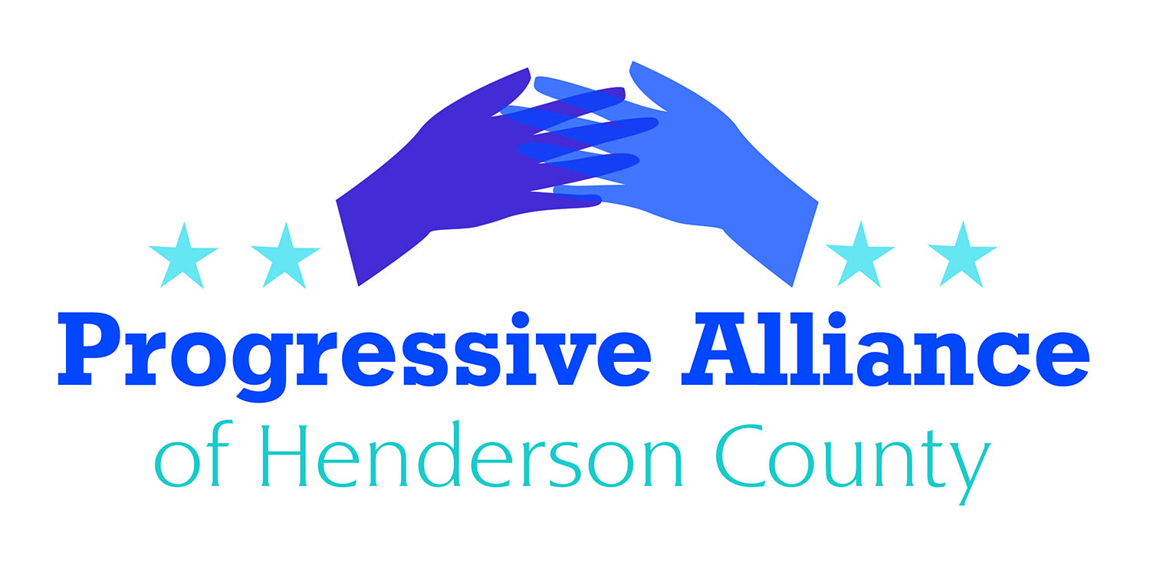

Postcard Party # 116 April 12, 2019

National

URGE CONGRESS TO ACT ON THE CLIMATE CHANGE CRISIS

In late November of 2018, a federally mandated report was prepared by the US Global Change Research Program, a team of 13 federal agencies assisted by over 300 government and non-government scientists. The document clearly states that without significant changes in greenhouse emissions, the average annual global temperature could increase by 9 degrees Fahrenheit or more by the end of the century.

The report conveys alarming warnings on the impact of climate change on our economy, food systems and health. Without course correction, the report predicts the US economy will lose up to 10% of its GDP by the end of the century. It also found a deterioration of our food systems associated with increased global temperatures - forecasting drought, flooding, crop failures, a decrease in dairy production, and a decline in fish populations.

Write Senators Burr and Tillis and Congressman Meadows about the report and urge them to work on policies and programs that will face climate change head on.

PREVENT TRUMP FROM UNILATERALLY WITHDRAWING FROM NATO

The North Atlantic Treaty Organization (NATO) was formed after World War II as an alliance between the US and multiple Allied European countries against retaliatory attack by Germany or the Soviet Union, and has continued to serve as a deterrent to Russian aggression ever since. President Trump has been consistently critical of our country’s continued participation in NATO and has repeatedly threatened to unilaterally withdraw the US from NATO.

In anticipation of this move, Senator Tim Kaine (D-VA) has introduced a bipartisan joint resolution that requires either Senate approval or an approved act of Congress before the President may withdraw the US from NATO.

Contact Senators Burr and Tillis to express your views on S.J.Res.4.

SUPPORT LGBTQ RIGHTS WITH THE EQUALITY ACT OF 2019

The Civil Rights Act of 1964 protects people from discrimination based on race, skin color, sex, religion, and national origin. However, the Act's crucial anti-discrimination provisions do not protect against discrimination based on sexual orientation or gender identity. Thus, in the 30 states without robust LGBTQ anti-discrimination laws, LGBTQ people can legally be fired, harassed at work, barred from businesses, denied housing, and more because of their sexual orientation and/or gender identity. The Equality Act would provide necessary national-level protections for LGBTQ people by updating existing laws, like the Civil Rights Act of 1964, to explicitly ban discrimination based on gender identity and sexual orientation. The law would also revise the Civil Rights Act to ban sex-based discrimination in public spaces and services, such as retail stores, pharmacies, and transit, as well as in federally funded programs.

Write Senators Burr and Tillis and Congressman Meadows asking them to support the Equality Act of 2019.

State
NC HOUSE DEMOCRATS FILE BILL TO BLOCK DUKE FROM PASSING COAL ASH COSTS TO CUSTOMERS
The Cooper Administration last week ordered Duke Energy to dig up and remove all toxic coal ash at six power plants. Democrats in the NC House have filed a bill to prevent Duke from charging customers for a coal ash rate hike.
Duke would like the NC Utilities Commission to decide if the company can raise electricity rates on customers to pay for coal ash clean up. Duke made $2.7 BILLION in profits in 2018 alone. Duke shareholders can absolutely afford to shoulder all of the cost of coal ash clean-up.
Write Chuck McGrady/Cody Henson to express your views on HB567.
NC HOUSE BILL WOULD REQUIRE SHERIFFS TO WORK WITH ICE
The controversial House Bill 370 states that for anyone who is detained for any period of time under a criminal offense or an impaired driving charge, the person responsible for the facility must determine the prisoner’s residency status through questioning or through an examination of documents. Immigration officials can ask to have criminal suspects held in county jails up to 48 hours on belief they are in the country unlawfully so agents have time to take them into custody. Under the bill, sheriffs who don't comply with detainers or other state immigration laws could face litigation by private citizens, with potential fines of up to $25,500 a day for repeat offenses.
The North Carolina Sheriffs’ Association released a statement in opposition to HB370 stating that “the bill is not the appropriate method to address this very important issue” and have labelled their position OPPOSE-HIGH PRIORITY.
What had looked like a bill that was sure to pass has now become a bit iffy.
Contact Representatives McGrady and Henson and Senator Edwards to share your thoughts on HB 370.

