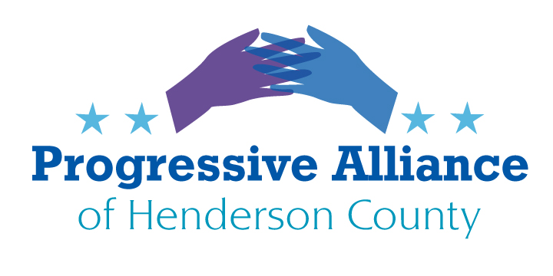

**Post Card Party # 268 February 16, 2023**

Today’s postcard party focus is on the unaffordable costs and unavailability of child care and youth mental health resources in NC. Many of the following statistics have been generously provided by Jamie Weiner and Paula Roberts of the Family & Children’s Resource Center. BUT, before writing legislative postcards, c**onsider congratulating the Center for being a Living Wage Certified Employer in our community,** putting their principles to work to ensure that their employees can afford to live and thrive here. Direct your “Congrats and Thanks” wishes to **Ms. Jessica Knox, President of the Board of Directors, 851 Case St., Hendersonville 28792.**

**State Level**

Now, on to our legislative nudges for the month. Let’s start with some stats on **the state of child care and youth mental health in NC:**

**Child care -**

* Low-income families and families with more than one child have to pay a high percentage of their income for care. A single mother with one child earning $39,445 or less per year can receive child care subsidy as funds are available. If funds are unavailable or if this parent’s earnings exceed the income eligibility limit, a parent would pay 27% of her gross income for child care offered at the county rate. Little is left in the family’s budget for food, medical, clothing, travel or other basic living expenses. Due to the high cost of child care, parents often make difficult choices. Some may be forced to seek TANF. Others may seek cheaper, often inadequate child care or leave their children unattended.
* Approximately 1,815 infants/toddlers in Henderson County live in families where their sole or both parents work.
* **67.3** percent of children under 6 in **NC** have both parents in the work force. We must ensure that they all have access to high-quality & affordable care.
* Average annual child care tuition for an infant in center-based care in NC is **$11,833.00**
* The average child care worker in **Henderson County** makes only $**12**/hour. It’s time to raise wages for the dedicated workers taking care of our children.
* 18% of children under the age of 6 live in poverty in NC, that is 128,240 children.

**Youth Mental Health –**

* Mental Health America ranks states by mental health. States with low rankings have lower prevalence of mental illness and higher rates of access to care for youth. NC ranks 42.
* Henderson County ranks 69th out of 100 NC counties for the suicide rate.
* Henderson County ranks 85th out of 100 NC counties for the student-counselor ratio.

What to do? **Contact your NCGA representatives (Rep. Jennifer Balkcom or Jake Johnson; Senator Tim Moffitt) to encourage them to use parts of the State budget surplus to increase subsidies for child care, and child care workers, so that working families can afford to continue to work.**

**North Carolina faces a child care cliff. Will state lawmakers step up as federal support ends?**

Pandemic-era subsidies at the federal level are ending just as other family-support costs are soaring. A bill in the NCGA, the Working Families Act, can help with funding to assist with purchasing a first house, access to paid family and medical leave, and an increase in the State minimum wage to $15 per hour (vs. the current $7.25). **Contact your NC Rep and encourage them to get behind and support HB569.**

**Local Level**

County Commissioner Rebecca McCall serves on the Center’s Early Childhood Task Force. Endeavors such as Universal Pre-K and a multi-unit child care center are in discussion. Lend your voice to the discussion by **writing McCall at 1 Historic Courthouse Sq., Suite 1, Hendersonville 28792.**

**Federal Level**

A bipartisan bill has passed the U.S. House to increase child care tax credits for some 16 million children in low income households, 552,000 of whom are in NC. The trade-off is that the bill would also extend some corporate tax breaks through 2025, but the benefit to individual families would seem to outweigh the negative parts of the bill. It is currently being stonewalled by Senate Republicans, so perhaps **writing to Sen. Tillis and Budd is a worthwhile use of your time.** Refer to the Tax Relief for American Families and Workers Act.