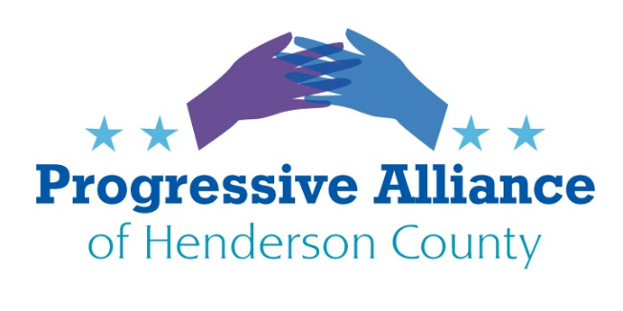
Postcard Party May 29, 2020

Sen. Richard Burr
The case of Sen. Richard Burr of North Carolina is somewhat curious. He is being investigated by the FBI for possible insider stock trading after he, along with some other members of Congress, were advised at the first of the year of the true situation and potential of the corona virus in China. Burr is accused of quickly selling approx. $1.6 million of stocks which would logically be weakened by any serious health threat that a pandemic would pose.
Under the rules of the Senate, the prospects for any substantial legal action of a sitting US Senator are remote.

Write Sen. Burr encouraging him to do the right thing and resign. This would allow Gov. Cooper to appoint a replacement, albeit from Burr’s party.

Environmental Concerns in North Carolina
A series of bills, HB 1108, 1109 and 1110, SB 735 and SB744 are to be presented in the current legislature session that concern GenX (not the generation) and other PFAS chemicals that have been secretly polluting large parts of North Carolina for decades. These Democrat-sponsored bills are attempting to address the actions needed on these little-recognized threats. There is general agreement within both parties in the legislature that the threats exist but no consensus on what to do.

GenX is the trade name used by an offshoot of DuPont Chemical, Chemours. PFAS chemicals are used in the manufacture of Teflon-like products and chemicals used to treat clothing, like Gortex. Teflon was produced using the chemical PFOA, also known as C8, which is part of the same chemical family PFAS. These chemicals have been conclusively linked to serious health conditions. Many chemicals are not regulated by the EPA despite their danger to all organisms on the planet.

(For a dramatic illustration of the seriousness of the pollution of this chemical family watch the film “Dark Waters” available via Netflix.)

A bipartisan bill, SB 746, refers to the concerns over cancer clusters within the state. While not directly related to pollution this bill would revamp the state’s efforts to uncovering the truth about the clusters.
Write our legislators in support of these bills. We need more awareness and knowledge about these chemicals and the dangers they present.

Reinstate Captain Crozier
Col. Moe Davis: I have always said that it is always the right time to do the right thing, regardless of whether or not it’s the easy thing to do and regardless of the political considerations.
That’s what Navy Captain Brett Crozier did when he went above his chain of command to save the lives of the women and men aboard the USS Roosevelt, the aircraft carrier he commanded.
It was the right thing to do: Morally and legally.
The USS Roosevelt had one of the largest initial COVID-19 clusters in the United States with hundreds of positive cases among the crew and a shortage of protective gear available. Crozier’s superiors refused to act on his recommendations, which if implemented, would slow the spread and protect the others on board.
Many of his staff wanted to join him when he approached the public about the outbreak to force the Navy to act. But Captain Crozier wouldn’t let them because he knew it could cost them their career.
His actions likely saved dozens if not hundreds of lives of the service members and civilian contractors on board. But he was fired as an act of retaliation by the Trump administration, with one of Trump’s personal appointees slandering him to his own crew, referring to him as “too stupid” to be their Captain.
It’s always the right time to do the right thing: Join me in calling on the Navy to reinstate Captain Brett Crozier as Captain of the USS Roosevelt.
PAHC editor’s opinion: the investigation needs to be into Thomas Modley, who fired Captain crozier and subsequently resigned as acting Navy secretary) and Rear Admiral Stuart P. Baker for not listening to Captain Crozier.
Write Congress, Secretary of the Navy reports to Department of Defense Mark Esper.

- PITHY POSTCARDS

Quit approving trump’s incompetent or destructive nominations. You are not honoring your oath of office. Shameful.

Lives are sacred- until keeping people alive interferes with you making a buck. Hypocrites – disgusting.

If you give all power to trump, we don’t need you. Go home.

Hate thrives amid silence. Speak up.

Trump pardons a war criminal and punishes a decorated war vet for personal vendettas. That is abuse of power.

Write appropriate members of U.S. Congress and U.S. Cabinet:

