**Postcard Party-Gun Violence**

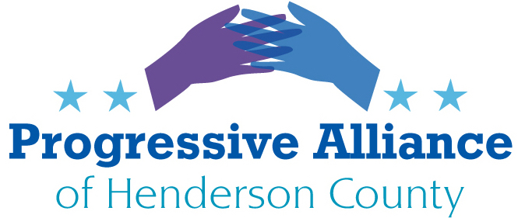

SUBJECT: Tell North Carolina state lawmakers to reject **HB 5 permitless carry legislation,** allowing anyone of adult age to carry a concealed ﬁrearm in public without a license, training, or background check. If passed (probable), tell Josh Stein to veto the bill

ADDRESS TO:

NC State Legislatures (Johnson, Balkcom)

Gov. Josh Stein

MESSAGE

Extremists in the state legislature are considering legislation that would eliminate the requirement for a permit to carry a gun in our communities. This policy would endanger North Carolinians who deserve to feel safe in their homes, at the supermarket, in public, and in their everyday lives. North Carolina Sheriﬀs Association opposed permitless carry in 2023. Most Americans support concealed carry permitting systems that help ensure that only responsible gun owners can carry concealed guns in public. 88 percent of Americans think you should get a permit before carrying a concealed gun in public. Recent research found that states with permitless carry have nearly triple the rate of firearm road rage shootings than states with the most protective standards – loosening this key safeguard will only increase the chances of dangerous ripple eﬀects across the state. For over a century, states have recognized the public safety beneﬁts of requiring a permit to carry concealed guns. Over 80 percent of gun owners, non-gun owners, Republicans, Democrats, and Independents agree that high safety standards are critical in issuing concealed carry permits.

SUBJECT: SUPPORT NC SENATE BILL 161-"Jenesis Firearm Accountability Act,"

ADDRESS TO: NC SENATOR TIM MOFFITT

MESSAGE

A new bill in the North Carolina General Assembly aims to address a problem that has been a growing concern: stolen guns used in crimes. Senate Bill 161 would require gun owners to report a stolen or lost gun within 48 hours. The bill was inspired by the tragic death of Jenesis Dockery in Fayetteville in 2023. Investigators say she was shot and killed by her 12-year-old cousin, who stole his grandfather's gun. On average, at least one gun is stolen from a car every nine minutes in the United States. The rate of gun thefts from cars is triple what it was a decade ago. Every year, hundreds of thousands of guns are lost or stolen in America, with one gun stolen from an individual owner every two minutes. Stolen guns can be diverted to the illegal gun market, where they are used to fuel crime across the country. Lost and stolen reporting laws help reduce gun trafficking by requiring individuals to report loss or theft to law enforcement shortly after discovering it.

**SUBJECT: Oppose H.R.38 - Constitutional Concealed Carry Reciprocity Act**

ADDRESS TO: TILLIS (Bill hasn’t reached the Senate), EDWARDS (Chuck is co-sponsor of the bill)

MESSAGE

Federal legislation creating a concealed carry mandate would gut state standards for who may carry hidden, loaded handguns in public. It would force each state to recognize the concealed carry standards of every other state, even those that have dramatically weaker standards—and those that don’t have any standards at all. A Federal Concealed Carry Mandate would force states to allow violent offenders and people with no firearm safety training to carry hidden, loaded handguns within its borders—even if those people could not otherwise legally carry a concealed weapon, let alone buy a gun, in that state. States that removed concealed carry permit requirements between 1999 and 2021 saw, on average, a 27 percent increase in gun homicides.

**SUBJECT: Support S 726- Ethan’s Law**

ADDRESS TO: TILLIS BUDD

Please support Ethan’s Law to promote safe gun storage and save lives.

Ethan’s Law, named in honor of 15-year-old Ethan Song, who was unintentionally shot and killed with a firearm found in his best friend's home, would create federal requirements for safe gun storage when there is a reasonable belief that children or other prohibited individuals would be able to access them.

Every day, eight children and teens are unintentionally injured or killed due to family fire — a shooting that results from someone misusing an unsecured firearm from the home. Unintentional shootings, firearm suicide, and many intentional shootings are all forms of family fire. If just 20% of gun-owning parents locked all household firearms, we could prevent a third of youth firearm suicides and unintentional shooting deaths.

Already, 4.6 million children live in homes with access to an unlocked or unsupervised gun. Additionally, 76% of school shootings are facilitated by kids having access to unsecured or unsupervised guns found in their home, or the home of a relative or friend.

We can help prevent such incidents by passing Ethan’s Law. This common-sense safe gun storage measure, which is supported by gun owners and non-gun owners alike, would help end preventable tragedies nationwide.