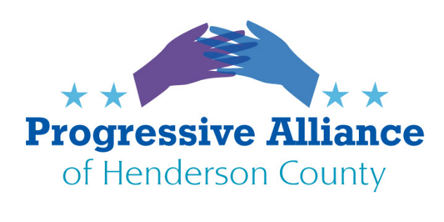

**Let’s Acknowledge Public Education Champions** *Henderson County Board of Education* – voted unanimously at Sept. 2023 meeting to fund breakfasts and lunches for all HCPS pupils for this school year. **414 4th Avenue West Hendersonville, NC 28739** (Mr. Robert Bridges, Mrs. Stacey Caskey, Ms. Shelia Dale, Mr. Blair Craven (Chair), Mr. Jay Egolf, Ms. Alyssa Norman, Dr. Kathy Revis)

*Gov. Roy Cooper* – declared aState of Emergency for Public Education (May, 2023) outlining the devastating impacts of Republican legislature’s schemes to give vouchers to millionaires, defund public schools and push culture wars into the classroom and urged North Carolinians to contact their legislators to protect public schools. **203001 Mail Service Ctr. Raleigh NC 27699**  
  
*Atty. Gen. Josh Stein* –NC Dept. of Justice has filed suit against the effort to re-litigate the decades-old Leandro case, in which conservatives are attempting to bring Leandro decision once again before the (now-conservative-leaning) NC Supreme Court. ( Oct. 2023, PENDING) **9001 Mail Service Ctr. Raleigh NC 27699**  
  
*League of Women Voters (NC and Henderson County) –* Maintain published positions insupport secure, well-funded, equitable public education for all. (See: <https://my.lwv.org/north-carolina-state/position/public-education> ) LWVHC conducts voter registrations in all county high schools and also sponsors mock elections (all levels) during presidential election years.   
**League of Women Voters of Henderson County, P.O. Box 1163, Flat Rock NC 28731  
  
*Public School Strong***

We know that our public schools are amazing, and they would be even better with more resources. Unfortunately, there are small groups of loud extremists distracting us from the real issues. Public School Strong is the best way for us to refocus attention on the thing that matters most: making sure all children in North Carolina have access to honest, accurate, safe, and fully funded public education. Henderson County contacts are Judy Bonner  <[judybonner1@outlook.com](imap://ndbrown1701%40gmail%2Ecom@imap.gmail.com:993/fetch%3EUID%3E/INBOX%3E552755mailto:judybonner1@outlook.com) > or Alex Ramirez <[alan23alex15@gmail.com](imap://ndbrown1701%40gmail%2Ecom@imap.gmail.com:993/fetch%3EUID%3E/INBOX%3E552755mailto:alan23alex15@gmail.com)>

**Thank Individual HCPS staff members** for their dedication and professionalism in delivering for our community every day of the school year.  **No address necessary on the card - just the name, and drop off at office to direct via interoffice mail?**

# **NC charter school enrollment keeps growing while school districts stay flat**

# **From WFAE, November 2** By [**Ann Doss Helms**](https://www.wfae.org/people/ann-doss-helms)

# Once again, North Carolina’s total charter-school enrollment has climbed while most districts were virtually flat or declined slightly.

# That’s based on a new first-month report**for the current school year. It shows enrollment for charter and lab schools, which don’t report to local school boards, grew almost 5% compared with the same time last year, to 147,436. Charter schools are run by independent nonprofit boards. Lab schools, which are less common, are run by universities.**

Meanwhile the state’s 115 districts lost a total of 4,872 students, down 0.4%. Districts have almost 1.4 million students, while combined enrollment in all types of public schools tops 1.5 million. Enrollment affects state funding for teachers, local money channeled to charter schools and plans for school construction.

**Contact your NCGA representatives to request (demand?) an end to the incessant expansion of charters that are bleeding our public schools dry.**

# **‘Parents’ Bill of Rights’ puts a halt on decades-long child sexual abuse prevention program**

# **From NCNewsline Nov. 1, 2023** BY: [**SINCLAIR HOLIAN**](https://ncnewsline.com/author/sholian/)

With the passage of Senate Bill 49 — The Parents’ Bill of Rights - on Aug. 16, school administrators across North Carolina are grappling with how to best comply with new requirements for their classrooms.

For Safe Touch, this means a pause on a mission decades in the making.

**What is Safe Touch?**

Established in the 1980s, Safe Touch was developed in response to requests from local guidance counselors seeking support for addressing an influx of student sexual abuse disclosures.

Children across the country are abused at a staggering rate. According to the Center for Disease Control and Prevention, about 1 in 4 girls and 1 in 13 boys in the United States experience child sexual abuse.

At Safe Touch, statistics like these inform the curriculum in order to reach children at every age and grade level. Students learn to differentiate between safe, unsafe and confusing touches, and they practice strategies of seeking help if they’re touched in an unsafe way.

**Once again, contact your NCGA reps and point out the damage that SB49 is already exacting, and request that it be repealed.**