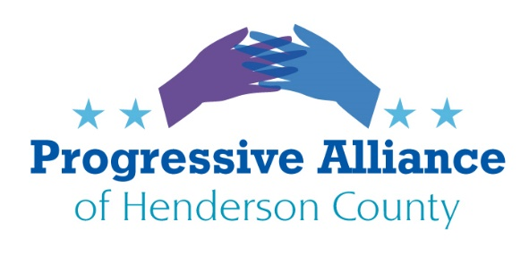
Virtual Post Card Party #209
Cawthorn… Again
I don’t know about you, but I am very concerned, very uncomfortable with Cawthorn’s use of the media platform “Telegraph Messenger” for his online communications and here is why:
- Telegraph is a Dubai based, Russian owned social media platform
- Foreign terrorists are known to use it including ISIS
- It is a major hub for far-right QAnon conspirators
- Users freely share nonconsensual pornographic images on the platform
Cawthorn has made it very clear to his Republican colleagues he intends to use this method of communication, and I quote, “I have built my staff around comms rather than legislation. It’s not about legislating or fixing problems, it’s about the show.” According to the Citizen Times Asheville Watchdog media, “Cawthorn’s channel has become a gathering place for conspiracy theorists, 2020 election deniers, Trump backers, gun-rights advocates, Capitol insurrection apologists, and fans who urge the young congressman onward and rightward.”
His attitude towards government is cavalier, self-centered, and partisan to a fault for starters. He is not representing anyone in WNC other than his right-wing conspirators. He is eschewing what he was voted to do, engage in legislative efforts.
People have called for him to resign, we should continue those efforts. In using a questionable foreign, social media tool to communicate to his “constituents and colleagues,” he could easily be snared as a pawn for terrorist groups. Telegram does not have end-to-end encryption. We should demand he cease using Telegraph not only for appearance sake, but rightfully, for US security concerns.
Suggest writing to Nancy Pelosi (https://pelosi.house.gov/contact-me) and Homeland Security and ask them to investigate Cawthorns use of a foreign internet service that may be violating national security protocols.
The Honorable Chad F. Wolf
Acting Secretary of Homeland Security
Washington, DC 20528

Voter Suppression
Currently there are over 100 bills in Congress and over 2,000 bills moving through state legislatures addressing election-related issues. Most of them make it harder for voters to cast ballots in future elections mainly because the majority of states are controlled by right-wing legislators. We may have experienced a well-run November election locally, but statewide and nationally, we have a lot to be concerned about. Such as:

Gerrymandering, re-districting, manipulating maps to keep black and brown populations from voting
Limiting mail-in voting systems, especially “no excuse mail voting”
Overriding state certification of the electoral ballot by appointing electors of their own choice
Purging voter rolls by preventing infrequent voters from receiving ballots
Mandating voter ID requirements
Eliminating drop box receptacles
Ending same-day and automatic voter registration

This year, 2021, the NC General Assembly will be redrawing congressional and state legislative districts. The goal is to ensure that the process is fair and that all stakeholders are represented.
Contact your state representatives in the General Assembly and let them know that you will not tolerate gerrymandering and will be watching them closely.
https://www.ncleg.gov/FindYourLegislators

Keep in touch with your local precinct representatives by letting them know you demand transparency and equitable division of map re-districting. Be aware and protest any use of undemocratic methods GOP uses to suppress the vote.

Eliminating the Filibuster

With over 500 bills sitting on McConnell’s desk that never saw the light of day, not much was accomplished in the last four years of the Senate. He blocked them from ever coming to the floor for debate. Now that the tide has turned, this Minority leader who historically has had a penchant for filibustering, (blocking the opposing party’s agenda) will once again use this tool to stop bills from progressing through the voting legislative process. This could set us back another four years of inertia in the Senate.

Time to call an end to this madness. We are all tired of the gridlock and dysfunction of our representatives, and consequently, our nation. How? Contact your Senators, especially Democrats at the moment, and demand that the filibuster be restricted from use on the House floor. We need to get back to the time and place where legislators debate and pass bills for the good of all of us.
Link to US Senators, can be sorted by state or name:
https://www.senate.gov/general/contact_information/senators_cfm.cfm

