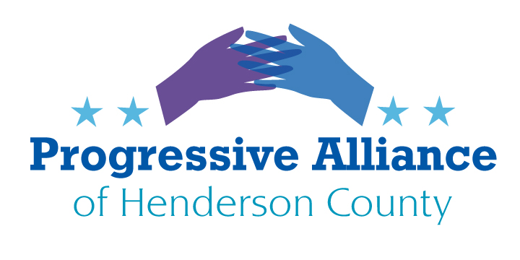

POSTCARD PARTY VIRTUAL #185 August 7, 2020

National

Headline: "Worries about 2020 census' accuracy grow with cut schedule" "The U.S. Census Bureau is cutting its schedule for data collection for the 2020 census a month short as legislation that would have extended the national head count's deadlines stalls in the U.S. Senate. The move is worrying researchers, politicians and others who say the change will miss hard-to-count communities, including minorities and immigrants, and produce less trustworthy data. The Census Bureau said late Monday that the door-knocking and ability for households to respond either online, by phone or by mail to the questionnaire will stop at the end of September instead of the end of October so that it can meet an end-of-the-year deadline to turn in numbers used for redrawing congressional districts. Census experts and civil rights activists worry the sped-up count could hurt its thoroughness and produce inaccurate data that will have lasting effects through the next decade since it determines how $1.5 trillion in federal spending is distributed and how many congressional districts each state gets." (AP, 8/4/20) Folks...contact the usual suspects in DC, but only AFTER making sure that YOU have already responded to the Census.

The COVID-19 pandemic response has been a DISASTER under Trump’s leadership. Now, he’s trying to cover up future data in order to downplay the actual emergency. The Trump administration stripped the CDC of its ability to share coronavirus data as the pandemic continues to kill Americans.
The absence of the data will make it harder for health and public officials, as well as the general public, to understand how the virus is spreading. This is extremely disturbing! Most importantly, suppressed data for this pandemic will significantly harm our ability to respond to the next worldwide disease. Make sure Sen. Tillis, in a fight for his political life, knows of your concerns.

Urge Congress to Support Direct Assistance to Cities and Towns
The U.S. Senate has released its proposal for a new round of COVID-19 relief, and the package DOES NOT include additional funds for state and local government. Instead, the plan leaves cities and towns to fend for themselves when it comes to pandemic-caused budget shortfalls.
Please contact your members of Congress now to urge them to provide direct assistance to cities and towns. Let them know that sales tax and utility revenue streams have been harmed by the economic effects of the pandemic and must be addressed for the economy to recover.
With the U.S. House already approving a relief package that does include funding for municipalities, it is important to encourage those congressional supporters to continue to stand strong with municipalities as negotiations begin. It is also crucial to let your U.S. senators know that flexibility for previously approved CARES Act dollars is not enough, as the pandemic’s effects continue and economic uncertainty remains.

North Carolina

Broadband - From NC Policy Watch, 8/3

Millions of children will begin the new school year learning from home due to the COVID-19 pandemic.
The pivot to remote learning for U.S. schools has exposed a troubling digital divide between children from low-income families, mostly Black and Latinx students, and their peers from wealthier zip codes. Education experts fear that the lack of high-speed internet connections and electronic devices needed to access remote instruction will lead to the widening of the achievement gap that has bedeviled school districts for decades.
The Boston Consulting Group, a global management consulting firm in partnership with Common Sense, a nonprofit organization that focuses on how media and technology impact children, released a report recently titled “Closing the K-12 Digital Divide in the Age of Distance Learning” that closely examines the nation’s digital divide.
Here’s what they found:
50 million – the number of K-12 students who will have to learn remotely this school year
15 million to 16 million – the number of students who lack adequate internet or devices to sustain effective distance learning at home.
9 million – the number of students who lack both adequate internet and devices
21% – the percentage of students in urban communities who lack an adequate internet connection to receive instruction remotely
25% – the percentage of students in suburban communities who lack an adequate internet connection to receive instruction remotely
Readers, regardless of when in-person K-12 classes will be able to resume, broadband access for homework and research will be a continuing problem. Make sure your NC reps, senator, and Gov. Cooper know that this is a relatively easy was to reduce the education and equality gap statewide. We need statewide broadband yesterday!

