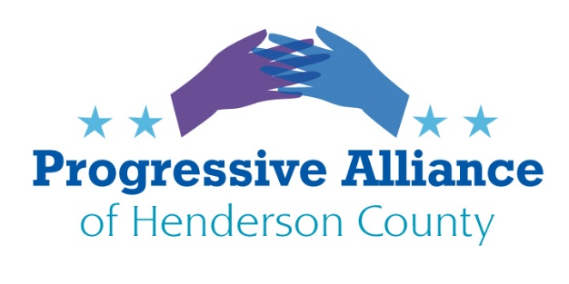
Postcard Virtual Party #171 May 1, 2020
PRESIDENTIAL ELECTION
Write all your friends and family – do not let anyone think that voting in the Presidential Election is not important. Especially those who supported Bernie or those in traditionally Democratic states like California. Every Vote Counts. When we beat trump it has to be yuuuuge. He will not go quietly into the night. Do not let anyone throw away their vote by thinking they are making a statement by not voting or voting for a third party. Granted, if someone spectacular shows up third party, we can think about all this. But if it is trump and Biden, then everyone has to make the popular vote and the Electoral College vote significantly against trump. Vote Him Out!

NO TIPPING

Minimum wage for Tipped Employees in North Carolina is $2.13 an hour if they make at least $20 in tips a month. Enough of these slave wages. End all tipping. Pay all employees a livable wage. In most of the advanced world, tipping is optional and recognizes outstanding service. Tipping to augment minimum wage was never the intent.

Write Governor Cooper, McGrady, Jake Johnson, Chuck Edwards for state laws. Write Senators Burr and Tillis for Federal laws.

STOP THE GREED

There are now numerous committees supposedly with oversight of the trillions of dollars being disbursed because of COVID-19. Yet multiple companies listed on stock exchanges received millions. We just came off a long bull market that trump has described as “terrific” and “the greatest in the history of the country”. Compensation for upper management and buying back stock to make the stock look like it is trading higher is not fiscal responsibility. For example TSR, Inc. (NASDAQ: TSRI) showed a market cap of $6 million and received a PPP loan of $6.7 million. Their financial reports show that they have a net loss on average of a million dollars each of the last 4 year. Wave Life Sciences (www.wavelifesciences.com) is registered in Singapore. They have a market cap of $286 million and received a loan for $7.2 million. Hallador has four coal mines in Indiana and started 2020 with 915 full-time employees. Their lobbyist is Scott Pruitt. Their market cap was $22 million and received loans for $10 million.

The appointed committees need to do their oversight job and the Small Business Administration needs to get loans returned that are not the intent of our tax dollars. When we think small businesses we think of our hair dresser, local restaurants, small garden shops and florists, local breweries. The SBA defines small businesses as less than 500 employees. Yikes, that is big manufacturing and similarly, better-resource companies.

Write for well thought rules and regulations that are realistic and meet the needs of small businesses. Not rushed bills during a pandemic.

Write the Small Business Administration and Senators Tillis and Burr, and Speaker of the House Pelosi.

FAILING SYSTEMS

When ACA was rolled out, the Republicans and trump trashed the system for “failing”. The IRS program for citizens to see when their “Coronavirus -Get My Payment” is an unmitigated disaster. The IRS said the system was running smoothly and efficiently. That is a desperate mis-portrayal given so many recipients’ accounts are lacking entirely or are managed by tax preparations firms.

Write your Federal Representatives and Secretary of the Treasury Mnuchin to reconsider before they trash failures “from the other side”. The shoe is now on this foot and it needs to be fixed now!

TRUMP ORGANIZATION

Trump owns and operates the Trump International Hotel located in the Washington DC Old Post office building, a federally owned property. The General Services Administration has reported the lease is $268,000 a month with a 60-year lease agreement. The Trump organization has asked the GSA for changes to the terms of the lease to lower future monthly payments. Once trump became president he should have been held in violation of the Emoluments clause in the Constitution.

Another example of trump and his family not caring about anyone: Last year they fired all of their undocumented workers, some of whom had been working for them for years. This year, they laid off or furloughed about 2,000 employees in the United States and Canada. These so-called billionaires could have kept paying these people who were probably low paid workers at their hotels and restaurants.

The Trump Organization is also in touch with Deutsche Bank about postponing payments on its loans. Reportedly the loans are more than $300 million dollars. Deutsche Bank knew trump was a terrible credit risk as many American banks would no longer lend him money. Maybe it is time to call trump’s bluff and hold him to his debts.

In addition: the Trump Organization is asking Palm Beach County to renegotiate and lower their lease on the Trump International Golf Club in West Palm Beach, Florida.

Hold him to his obligations like so many Americans will be held to payrolls, leases, rent, and other bills.

Write GSA, congress, Palm Beach County, Deutsche Bank. Shame the trump organization, which is still owned and operated by Donald J. Trump.
GSA Deutsche Bank P. Beach Co. Commissioners Trump Organization
1800 F Street NW 60 Wall St 301 N Olive Ave. 725 Fifth Ave
Washington DC 20004 NY, NY 10005 West Palm Bch, FL 33401 NY, NY 10022

PANDEMIC RELIEF and VALUES

Public Citizen claims the Senate Leadership is interested in pursuing only one of the following:
- Making sure our nation’s health workers have the personal protective equipment and medical supplies they need to care for the rest of us throughout this pandemic.
- Providing struggling Americans additional financial relief they literally can’t live without.
- Getting serious about containing the coronavirus with a 21st century Marshall Plan for testing and contact tracing.
- Making sure every American — regardless of employment status — has access to health care during a global crisis unlike anything humanity has faced for at least a century.
- Giving businesses immunity from liability even if they fail to take reasonable steps to keep workers, patients and consumers from getting sick.
News reports says the only favored relief is for business’ legal liability. This is not pro-health or pro-life. Please object to it.

Write your Congress representatives.

