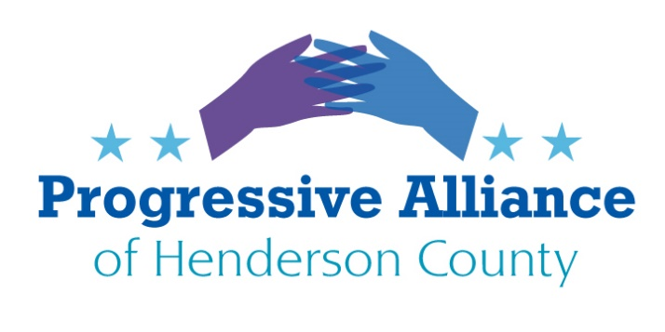

**Postcard Party # 144 October 25, 2019**

**National**

**Close Loopholes Allowing Foreign Interference and Deceptive Practices in U.S. Elections**The SHIELD Act of 2019 (HR 4617)— would combat foreign interference in U.S. elections by closing loopholes that allow foreign spending in U.S. elections, boosting disclosure and transparency requirements, and creating a duty to report illicit offers of campaign assistance from foreign nations.

The Act creates a duty to report illicit offers of campaign assistance from foreign governments and their agents. The SHIELD Act requires political campaigns, parties, and political committees like PACs and Super PACs to report attempts by foreign governments, foreign political parties, and their agents to influence our elections to authorities at the Federal Election Commission (FEC) and Federal Bureau of Investigation (FBI). This ensures violations can incur criminal or civil liability. The SHIELD Act also requires campaigns to establish compliance mechanisms.

**Contact NC-11 Rep. Mark Meadows to express your opinion regarding the SHIELD Act of 2019.**

**HUD Intentionally Stalled Puerto Rico Disaster Aid**

Two top officials with the Department of Housing and Urban Development admitted at a congressional hearing this week that the agency knowingly missed a legally required deadline that would have made desperately needed hurricane relief funding available to Puerto Rico after Hurricane Maria devastated the island in 2017. ‘HUD did fail to comply with the law,’ said Rep. David Price, D-N.C., said at the hearing. The housing agency was supposed to issue funding notices to 18 states affected by disasters on Sept. 4. They published all the notices except Puerto Rico’s. The publication of the notice would have allowed Puerto Rico to start drafting a plan that would create the structures needed to manage the much-needed funds.”

**Write to NC Senators Burr and Tillis to let them know your feelings and ask them to pass supplemental legislation to immediately provide the funds that Puerto Rico desperately needs. Ben Carson is Secretary of HUD.**

**Congressmen interrupt Impeachment Testimony**

The planned impeachment testimony from a Pentagon official responsible for Ukraine policy resumed Wednesday afternoon after congressmen staged a demonstration against the probe and barged into a secure facility on Capitol Hill, causing a more than five-hour delay.

Deputy Assistant Secretary of Defense Laura Cooper was due to speak at 10 a.m. in closed testimony focused on the mechanics of U.S. security assistance for Ukraine and fallout from the White House’s decision to withhold it for several months. But conservative lawmakers disrupted her session as it was about to begin, refusing to leave the secure room where impeachment witnesses have met with lawmakers.

**Rep. Mark Meadows was a prime instigator of this demonstration. Write to Meadows and demand that he abide by the rule of law.**

**State / Local**

**Saturday Early Voting**

In 2018, lawmakers passed Senate Bill 325, a law that, among other things, eliminated voting on the popular final Saturday before Election Day. Facing litigation, lawmakers restored the final Saturday for 2018 ONLY. But under current law North Carolinians will NOT be able to vote on the heavily-used last Saturday in 2020, when voters will need it most.

Lawmakers are considering restoring Saturday for 2020 through Senate Bill 683 which is being considered in a conference committee now.

**Write to Sen. Edwards, and Rep. McGrady to ask them to restore Saturday Early Voting for 2020.**

**Budget Standoff**The budget standoff has dragged past its 100th day, and although lawmakers are back in session this week, a resolution is not expected before the state Senate adjourns for the year at the end of the month.

On the other hand, it is possible that a budget veto override may go through before leaving town if the Democrats aren’t able to hold all 21 members together. So really, anything could happen.

Which is why, in the meantime, it’s worth revisiting why this fight is so important.

* As North Carolinians, we believe in the values of fairness, opportunity, and equality for all. We believe in a society that works for everyone and puts people over profits; where a child’s ability to obtain a quality education, affordable health care, and eventually a good job isn’t determined by their zip code, their family’s income, or their skin color.
* No matter what we look like or where we live, we all want to give our children the opportunity to earn a quality education and succeed in life. Unfortunately, wealthy special interests and the politicians they control are trying to dismantle public schools so they can turn education into a business -- deciding who receives an education and who doesn’t based on what’s profitable.
* School funding is slashed while burdening students and teachers with extra testing. Then the overburdened schools, particularly in low-income districts and communities of color, are labeled as failing..
* Politicians use these “failing” schools as an excuse to slash classroom funding even further. The only way to reverse this cycle is through unity and collective action, as we’ve seen through teacher walkouts throughout the country - including right here in North Carolina.

**Write to Sen. Edwards, and Rep. McGrady and Jake Johnson, all are on Education Committees, to ask them to negotiate a true budget that addresses the needs of all NC citizens.**

The Progressive Alliance of Henderson County’s individual members have their own opinions and positions on many varied, important issues. We respect and appreciate fact-based opinions and encourage open-minded critical analysis. As an entity, we endorse no specific political candidates.