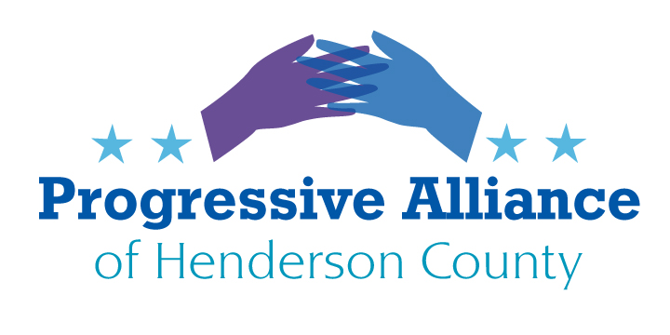

VIRTUAL POSTCARD PARTY #196 October 23, 2020

Issues from October 16, 2020 that still may need additional attention:
- 30, 30, 30: the truth about labor and the U.S. economy
- The Supreme Court and the Constitution
- Our future beyond trump
Note: The prior and current topics can be addressed by postcards and emails to the officials and candidates. It is typically too late now for election-related letters to the editor to be accepted for publication. Mountain Xpress, for instance, had an October 20 deadline. But, to the degree that you are comfortable doing so, one may post issues and suggestions on social media platforms.
FEDERAL, STATE, LOCAL

TERRORIST THREATS AGAINST MICHIGAN GOVERNOR GRETCHEN WHITMER
At his rallies Donald J. Trump, Sr. brazenly and extra-legally threatens the safety of Michigan Governor Gretchen Whitmer and, therefore, everyone around her.
Challenge Sen. Tillis, Sen. Burr, NC Sen. Edwards, NC House member Johnson and Moffitt, and candidates Dan Forest and Madison Cawthorn to condemn the desperate and unacceptable threats made by the terrorist in chief at the top of their ticket.

DELUSIONAL CONSPIRACY THEORIES ARE NEITHER AMUSING NOR HARMLESS
Donald J. Trump Jr. winks at QAnon’s delusional conspiracy theories because he is the “hero” at their center. QAnon pushes the more than one thousand year old blood libel at the core of its deliberate lies, for purposes of extreme social and political disruption. The blood libel is an incitement against Jews and Muslims, as well as against anyone else QAnon decides to label as impure. The blood libel was the rallying cry at countless pogroms that murdered many thousands of Jews over these many centuries.
Challenge Sen. Tillis, Sen. Burr, NC Sen. Edwards, NC House member Johnson and Moffitt, and candidates Dan Forest and Madison Cawthorn to condemn QAnon.

FAR RIGHT LAWYERS PROMOTE “FREEDOMS” THAT HARM PEOPLE
Republican Congressional candidate Madison Cawthorn has made a big deal about how he detests “liberal” lawyers in Congress who defy what he claims, without foundation, to be the will of the people. His full-page newspaper ads extol freedom as though he is the champion of the positive freedoms that are our pride and protection.
Cawthorn, however, is extolling a very different set of freedoms that far right lawyers have insinuated and packed into our laws and judicial decisions. The freedoms to swindle, exploit, pollute, underpay, discriminate against, redline, regressively tax, undermine elections, suppress the vote, and cocoon the powerful against the consequences of their actions.
Challenge Congressional candidate Madison Cawthorn about why he loves those freedoms so much while he despises the four freedoms in Pres. Franklin Delano Roosevelt’s famous speech. [Freedom of speech, freedom of worship, freedom from want, and freedom from fear.]

LOCAL
VETERANS FOR WHOM?
NC House candidate Tim Moffitt has signs out saying Veterans For Moffitt. Which veterans groups prefer Moffitt to an actual veteran, Josh Remillard?
Contact Tim Moffitt to ask him when he is going to excoriate Donald J. Trump, Sr. for calling our veterans “losers” and “suckers”.

NEW ADDRESSES:

Dan Forest (R)
P.O. Box 471845
Charlotte, NC 28247

Madison Cawthorn (R)
638 Spartanburg Hwy Ste. 70 #362
Hendersonville, NC 28792

