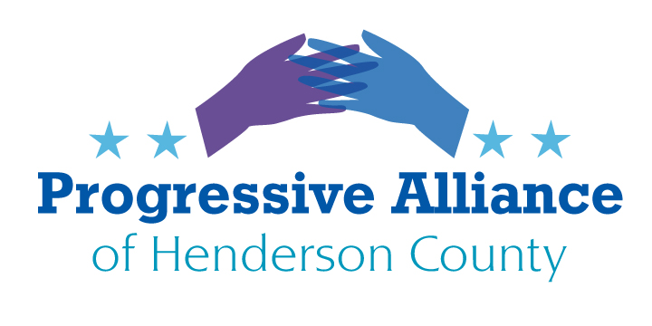
Virtual Post Card Party # 247 August 19, 2022
WE ALL LIVE IN KANSAS NOW #1
In Kansas on August 2 voters chose personal freedom and autonomy over absolutist oppression, affirming the Kansas constitution’s protection of women’s access to abortion, with the kinds of restrictions that had become very common nationwide following the U.S. Supreme Court’s Casey decision in 1992. Since the U.S. Supreme Court overturned the Roe and Casey decisions, abortion is becoming a motivating political issue in localities throughout the country.
Ask Sharon Brooks, the Chair of the Henderson County Republican Party why anyone in our county should vote for Edwards, Moffitt, Balkcom, or Johnson to let them try to impose their hatred of women and their extremist sectarian beliefs on all of us.
Reproductive choice and freedom are on the ballot throughout America this November. In North Carolina, our task is to elect Democrats to prevent the Republicans from winning a super-majority in the legislature. Gov. Cooper’s veto must be preserved, because the alternative will be the end of reproductive choice in North Carolina if our Governor cannot veto abusive, indiscriminate, and physically dangerous abortion bans that the Republicans have promised their base that they will pass. If you sometimes vote for Republicans, that is not a pro-choice option this year.
Choice and freedom are likely to bring out a large number of voters who might otherwise have not voted in the midterms. As the Republicans say, however, steep inflation is on the ballot, and they will pretend they need say nothing about abortion. Please understand that today’s struggle is against the anti-choice minority’s goals of inflated repression and criminalization to essentially drag our county back to the era of the Salem witch trials.
Express your concerns to both Republican and Democratic candidates.

Jake Johnson [Republican for NC House 113]  300 N. Salisbury Street, Rm. 306B1  Raleigh, NC 27603-5925  https://www.jakefornc.com/contact/ | Chuck Edwards [Republican for US Congress – NC 11]  300 N. Salisbury Street, Rm. 628  Raleigh, NC 27603  https://www.chuckedwardsforcongress.com/
Timothy Moffitt [Republican for NC Senate 48]  PO Box 768, Hendersonville, NC 28793 | J. Michael Edney [Republican for Henderson County Commissioner]  1 Historic Courthouse Sq. Suite 1  Hendersonville, NC 28792
Andrew Murray [Republican for 3-County District Attorney]  Henderson County Courthouse  200 N. Grove St., Suite 223  Hendersonville, NC 28792 | Sharon Brooks, Chair  Henderson County Republican Party  PO Box 2552, Hendersonville, NC 28793  chair@hendersoncountync.gop  https://henderson.nc.gop/contact_us
Jennifer Balkcom [Republican for NC House 117]  Balkcom4House@gmail.com  https://www.votebalkcom.com/ | Ted Budd [Republican for US Senate]  PO Box 97127, Raleigh, NC 27624  https://tedbudd.com/  info@tedbudd.com
Jay Carey [Democrat for NC Senate 48]  P.O. Box 307  Horse Shoe, NC 28742  https://www.electjaycarey.com/  jay@electjaycarey.com | Michael O'Shea [Democrat for NC House District 117]  43 N Meadow View Dr.  Mills River, NC 28759  osheafornc@gmail.com
Jasmine Beach Ferrara [Democrat for US Congress – NC 11]  PO Box 7553 Asheville, NC, 28802  info@jasmineforcongress.com  https://www.jasmineforcongress.com/ | Cheri Beasley [Democrat for US Senate]  PO Box 28778, Raleigh, NC 27611  https://cheribeasley.com/  info@cheribeasley.com
WE ALL LIVE IN KANSAS NOW #2
For the time being, Americans need to grapple with the specious, sub-juvenile reasoning in Justice Alito’s masterpiece of malpractice Dobbs decision. We all need to be aware that “women” appears nowhere in the U.S. constitution. Indeed, the word “slavery” does not appear in the original 1787 constitution, despite having significant clauses concerning the slave trade.
The deep history of our country ignores and marginalizes the rights and freedoms due to women, people of color, Native Americans, and anyone else not worthy of the attention of white, male, Christian, property-owning adults.
It is equally noteworthy that the words “fetus” and “unborn” still have not appeared in the U.S. constitution. Justices Alito, Barrett, Gorsuch, Kavanaugh, and Thomas---as well as Roberts in his own peculiar way---have continued to make “women” disappear from the equal protection of the laws while ratifying an unwritten right to give an unborn fetus (essentially from the moment of conception) a right to life that trumps any rights women have to preserve their bodily integrity.
Please write to the six misbegotten justices to have them know that when people, as in the August election 2 in Kansas, have the access to vote on these transcendent issues, they will reject the justices’ irrational sophistry over and over. Perhaps we should be concerned that they will find another outlandish way to disqualify Kansas’s voters and let their legislature ignore the Kansas constitution.
Or if you write to the Public Information Officer, you might inquire when we should expect impeachment proceedings regarding Justices, Barrett, Gorsuch, and Kavanaugh’s Senate testimony, or regarding Justice Thomas’s manifest conflicts of interest.
Justice (so and so), Supreme Court of the United States. 1 First Street, NE. Washington, DC 20543
Public Information Officer, Supreme Court of the United States, 1 First Street, NE,
Washington, DC 20543 or https://www.supremecourt.gov/contact/contact_pio.aspx

LETTERS TO THE EDITOR: WHY WRITE THEM AND HOW TO DO SO
There are many personal reasons to write letters to the editor. They give you the opportunity to express yourself thoroughly, eloquently, and personally about an issue that is very important to you. The Natural Resources Defense Council provides a good guide. Searching the web you can find many other good approaches; this one https://www.nrdc.org/stories/how-write-successful-letter-editor is not very wordy and is relevant to any letter to the editor you might write. In a postcard you can express in a direct way what you want a public official to do, but with a Call To Action in a letter to the editor you may be able to substantially multiply the number of people who will second your point of view and participate in actions you suggest.

REAL SOLUTIONS OR MORE OF THE OLD & TIRED REPUBLICAN PLAYBOOK?
Participating in postcard parties, demonstrations, and political organizing are not elitist, “woke”, insular, and off-putting activities. Don’t let yourself be dismissed by the pseudo-conservative, right-wing politicians and commentators who demean the things in which you believe.
Every postcard and letter to the editor can have a call to action that you understand to be a real solution to the problem that you are addressing. The converse is true of the policies that pseudo-conservative, right-wingers propose when they deign to propose anything at all. Most are firmly aimed at rewarding the elites whom Republicans favor: those with the biggest incomes, largest wealth, richest neighborhoods, easy rides into the most prestigious and costly private schools and universities, and the greatest power to which they try to add the permanent disenfranchisement of the rest of the world.
In a postcard you can include a “got ya” to an official or candidate to criticize tired old pseudo-populist policies that only pretend to support working families and Americans who, for whatever reason, feel left out, misunderstood, and devalued. The Republican talking points are all aimed at privileging those who already “got theirs”, while making believe that their policies will empower potential voters who feel that they and their children are cut off from access to security and prosperity. A letter to the editor can say more about that disconnect, directed toward everyday people who are currently inclined to disbelieve and reject progressives.
So, use the postcard parties (in person or virtual) to try out this approach, writing to whomever you select about the issue of greatest import to you. Follow up with occasional letters to the editor. Challenge yourself. Then challenge the powerful who act like they are above any challenge from the rest of us.

