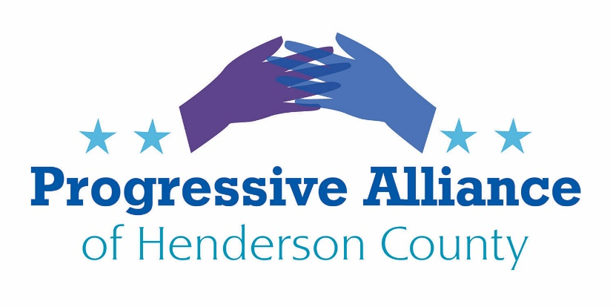

Postcard Party # 141 October 4, 2019

National

THE IMPEACHMENT INQUIRY:
1. The impeachment inquiry is the right thing to do. At the very least, Republican Senators and Representatives need to openly distance themselves from Pres. Trump. Urge them to save their souls, as former Sen. Jeff Flake has put it.
2. Pres. Trump’s behavior has been flagrantly corrupt, now with particular clarity in the illicit favors he asked from Ukraine’s new president and from other countries as well. Now is the time to break with Trump completely. Just do it.
Action: Contact Senators Thom Tillis and Richard Burr and Representative Meadows to tell them to do #1 or #2 above. Tell Tillis and Burr that silence is no virtue. Tell Meadows that his illogical contortionist defense of Trump is a disservice to the Constitution and our national security.

START DIALOGUE WITH OUR NORTH CAROLINA SENATORS:
Sen. Tillis has a regional office in Hendersonville. Sen. Burr has a regional office in Asheville. It’s time for them to meet with us, or at least have senior aides meet with us in our region.
Action: Contact Senators Thom Tillis and Richard Burr. Ask them to schedule face-to-face meetings with representatives of the PAHC before the end of 2019. Remind them that unfettered dialogue will be valuable for their decisions about how to vote on issues that affect all of his constituents. Tab stickers will be available with our web address for them to contact us to start the scheduling process.

STOP STONEWALLING CONGRESS:
The Trump Administration violates the Constitution every time it defies subpoenas and fails to cooperate with Congress’s essential oversight role. This corrupt behavior has already escalated since the impeachment inquiry began. Silence is immoral and a violation of the Constitution.
Action: Contact Senators Thom Tillis and Richard Burr and Rep. Mark Meadows to tell them to publicly condemn Trump’s corrupt defiance of Congress.

IMPEACH ATTORNEY GENERAL BILL BARR:
Attorney General Bill Barr has proven he will do anything to protect Donald Trump, even if it means breaking the law or using foreign leaders to undermine U.S. interests and attack political rivals. He is acting like Trump's private lawyer instead of the nation's top law enforcer, impartially and without fear or favor.
After special counsel Robert Mueller concluded his two-year investigation, Barr did all he could to whitewash the findings — releasing a partisan, three page "summary" that absolved Trump of charges of obstruction, which the report explicitly did not do.
And now we have learned that Barr has solicited foreign assistance to thwart our own U.S. intelligence efforts, endangering both the rule of law and our national security.
Action: Contact Representative Meadows to tell him to publicly announce support for an impeachment inquiry in the House regarding the Attorney General. Senators Thom Tillis and Richard Burr and tell them that silence is no virtue. Their announced support for initiating a fair and transparent impeachment inquiry in the House will go some distance towards redeeming the Republican Party in America.

State
THE NORTH CAROLINA CLIMATE SOLUCTIONS COALITION (NCCSC) TASK FORCE PROMOTES THE WORK OF A TEAM OF SCIENTISTS WHO HAVE DEVELOPED A PLAN TO TRANSFORM ALL OF AMERICA’S ENERGY PRODUCTION AWAY FROM FOSSIL FUELS AND TO 100% RENEWABLE RESOURCES AND TECHNOLOGIES.
The NCCSC Task Force depends on local residents’ active participation in this process.
Action: Contact Sen. Chuck Edwards and Rep. Chuck McGrady to tell them to support the coalition’s work by participating as concerned citizens (and not necessarily as government officials). They can find out more about the NCCSC Task Force at https://ncclimatesolutions.org .

THE SILENT VIGIL FOR IMMIGRATION REFORM IS A NECESSARY ACT OF SOLIDARITY WITH ALL CURRENT IMMIGRANTS AND A WAY TO RECOGNIZE THAT EVERYONE BUT NATIVE AMERICANS IS AN IMMIGRANT TO THE U.S.A.
The next vigil is Fri. October 18 from 4:00 to 4:30 PM at the historic courthouse on Main St in Hendersonville.
Action: Contact Sen. Chuck Edwards and Rep. Chuck McGrady to tell them their presence is essential at this vigil to show that they are committed to contribute locally to efforts to fix our nation’s broken immigration system.

The Progressive Alliance of Henderson County’s individual members have their own opinions and positions on many varied, important issues. We respect and appreciate fact-based opinions and encourage open-minded critical analysis. As an entity, we endorse no specific political candidates.

