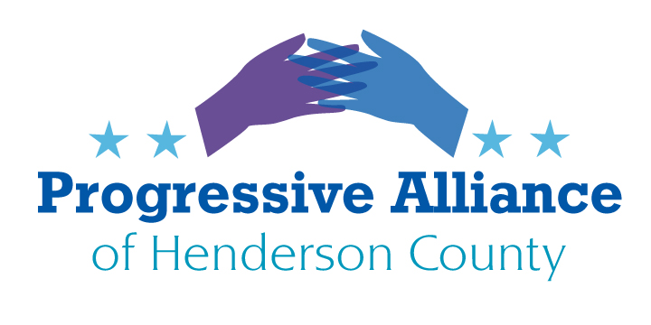
VIRTUAL POSTCARD PARTY #189 9-4-20 SUGGESTION SHEET
Update on USPS
Louis DeJoy testified that more than 600 mail sorting machines were removed by the USPS under his leadership and none will be reinstalled, including 15 in NC causing massive package backlogs here and across the country and threatening timely delivery of mail-in ballots in November.
$25 billion is slated for the USPS to replace revenues “forgone due to the corona virus pandemic.” Trump said he wouldn’t veto the bill if it includes money for the Postal Service and state election planning — but he repeated his statement about the agency being unable to handle mail-in ballots without it.
Voter suppression is a Trumpian tactic designed to eliminate the disenfranchised vote in Blue states. Since nothing is going to change, we must inform as many as possible to cast their ballots early if mailing in and encourage others to vote in-person during early voting days before the actual election day on November 3rd.
Big Pharma vs Public Options for Pharmaceuticals
Deep into our third profit-motivated opioid epidemic, we are now also facing a global pandemic without the treatments and vaccines we need to prevent further mass death. At the same time, ordinary Americans who have long struggled to afford their daily medications, such as insulin, are now face increasingly difficult choices as they lose jobs and health insurance as a consequence of COVID-19.
The problem stems from the deadly mistake of treating medicine like a business, rather than as a public service. Without a public option in pharmaceuticals, we are doomed to business as usual. Over the years, we’ve allowed the pharmaceutical industry to become highly privatized and monetized.
Since the beginning of this year, Big Pharma has hiked the prices on 245 drugs including 61 used in the treatment of COVID-19, restricting access to only those who can pay. Even though the US pumps more public dollars into pharmaceutical development than any other country, ordinary Americans are saddled with the world’s highest drug prices.
A public option in pharmaceuticals would ensure end-to-end research and development of new medications in the public interest, create sufficient production capacity for essential medicines, and provide efficient, cost-effective distribution of those medications, breaking Big Pharma’s monopoly on our medicine supply. A public option would also shift the balance of power and reduce the political influence of the industry. Without shareholders to respond to, public pharmaceutical companies would be free to focus on developing and distributing the medications most needed by our health care system, not just to bring in the highest profits.
Now is the time to support and expand that strong public tradition and ensure that medicines are available to all who need them. Write any of the members of the Subcommittee on Health Care, led by Lamar Alexander (R-TN) and Ranking Member Patty Murray (D-WA). 22 Senators, 12 Republicans and 10 Democrats are members.
Who is Protecting our Data????
As of July 10^{th,} the Trump administration directed hospitals to send COVID-19 data directly to the Health and Humans Services Administration (HHS) instead of the CDC.
HHS awarded a $10 million, no-bid contract to Palantir Technologies, a data-mining firm that works with the Pentagon and law enforcement agencies, including Immigration and Customs Enforcement (ICE). They are charged with creating a new data system that duplicates the one the CDC already has. The contract, called HHS Protect, was developed by Peter Thiel, a billionaire Trump supporter and co-founder of the company.
FEAR 1 Issue: In order to get access to data, hospitals are required to use the private data system HHS Protect instead of the CDC’s. It includes about 2.5 billion pieces of data from healthcare providers, government officials, and labs around the country about coronavirus case numbers, hospital capacity, and even supply-chain issues. Palantir will have the license and power to aggregate all incoming data. They’re working together to analyze and model more than 200 data sets from about 5,700 hospitals and report directly to White House officials, governors, and local leaders. This is not sharing of data - it is a coup, a takeover of personal information to be used for what purpose? It is dangerous and an invasion of our personal information that can easily be exploited, sold or manipulated. Not good.
FEAR 2 Issue: Since Palantir already has a track record assisting ICE in the arrests of hundreds of undocumented workers and caregivers of unaccompanied migrant children, there are now valid concerns as to whether the existing surveillance framework Palantir has created will be supplemented by the addition of personal health information contained within the HHS Protect platform. This can easily lead to misuse for political purposes.

The Congressional Hispanic Caucus, along with Senators Elizabeth Warren (D-MA) and Richard Blumenthal (D-CT), is calling for more transparency with regard to this total operation and its objectives. Join them and ask, who is protecting our data. How is it being used and for what purpose? This is really a Big Brother issue for all of us to be concerned about.

