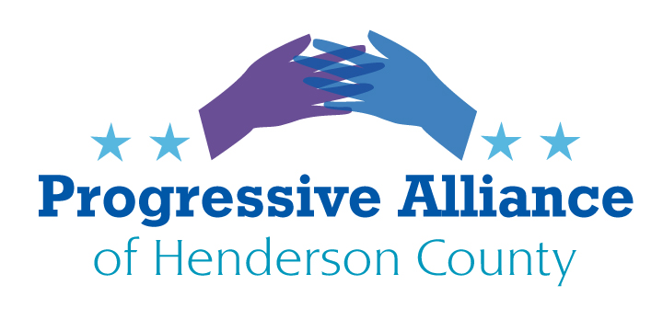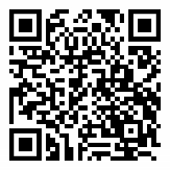
POSTCARD PARTY #167 (VIRTUAL) April 3, 2020

Pandemic Response:
Please check out coverage in online magazines: The Atlantic, The New Yorker, The American Prospect, WIRED.
www.covid19conversations.org [Public health and medicine presenters in 1.5 hr webinars] because the most effective US response is not at the White House.
www.nelp.org/publication/unemployment-insurance-provisions-coronavirus-aid-relief-economic-security-cares-act/ [Unemployment insurance and related help]
Health Weather Map: https://www.healthweather.us/?mode=Trends ...Is our county getting feverish?

Federal:

OSHA Protections for Health Care Workers

House Education and Labor Committee Chair Bobby Scott (D-VA) said, “The next package must include a requirement that OSHA issue an Emergency Temporary Standard that requires employers to implement protections for at-risk workers” in health care. As well, he continued, “we intend to expand the scope of this legislation to protect other at-risk workers, including TSA agents, direct care workers, police officers, pharmacists, grocery store workers,” and others.

Federal documents issued in response to the coronavirus provide some guidance for what emergency standards should look like. The U.S. Department of Labor and the Department of Health and Human Services jointly have issued “Guidance on Preparing Workplaces for COVID-19.” And the Centers for Disease Control and Prevention (CDC) has issued “Interim Guidance for Businesses and Employers to Plan and Respond to Coronavirus Disease 2019 (COVID-19),” as well as a release entitled “Information for Health Professionals.” Help our finest public servants get some relief!

Sens. Chris Murphy (D-Conn.) and Bryan Schatz (D-Hawaii) offer legislation to nationalize the essential medical supply chain so that doctors/clinics/hospitals could get what they need without getting gouged for it, but that idea didn’t make the Senate coronavirus bill. Neither did efforts to order companies to start actually manufacturing the stuff doctors need. Urge triggers be posted in a COVID-Relief-4 bill to correct this.

Open a special enrollment period for Obamacare
The Trump administration refuses to open a special re-enrollment period for Obamacare in the midst of COVID-19. That needs to be reversed. Over 6 million people filed have filed for unemployment in the last few weeks. Huge percentages of those folks may rely on their employers for health insurance. Leaving them uncovered right now is unconscionable.

Farm Workers Excluded from Coronavirus 3 (CARES) Relief Act

Farm workers are facing huge new economic burdens and risks. Ask your representatives to pass emergency legislation to give farm workers hazard bonuses. The COVID19 stimulus bill that President Trump signed leaves many farm workers out. At least 50% of farm workers are undocumented and while they pay taxes, they are being left out of the stimulus check others are receiving. Even their US citizen children are left out. They are told they are essential workers, but they are not receiving essential benefits. They are putting themselves at risk on a daily basis by going out to the fields tending crops and harvesting our food. Many have to arrange for childcare. Competitive grocers are rare in farmworker locales. Transportation may be newly hazardous, and alternatives pricey. Essential workers deserve essential benefits. We are depending on farm workers to keep our supermarket shelves full. We must take care of the farm workers who are keeping us fed. Congress should provide hazard pay immediately for these workers who are now working in a dangerous environment and dealing with huge additional expenses.

Aim High: Universal School Meals Program Act (S. 2609)
Sen. Bernie Sanders last fall introduced a Universal School Meals Program bill — a move that could improve school attendance and affect student health. The Universal School Meals Program Act can make school meals free to all schoolchildren. This legislation will also address lunch debt, increase funding for school meals, and improving summer and after school feeding programs.
The Universal School Meals Program Act will make breakfast, lunch, and after school snacks free for every public and nonprofit private school student, regardless of family or community income, improving student academia and ending school lunch shaming, among additional benefits directly to the schools.

Coronavirus Relief (and Recovery?) Part Four

Stay tuned to reputable sources as to what will be in this bill for additional stimulus. Some suggested provisions include:

- Relief from Evictions – at least for the duration of Stay At Home Orders
- Moritoria on all Debt Collections including Mortgages – Fed support for banks in Part Three allows this to proceed with regard to banks. The Fed is able to set up facilities to serve other types of lenders also.
- Hardship Pay for Emergency Work according to identifiable hazards.
- Reversal of Trump administration designating gun stores as essential businesses during the coronavirus pandemic.
- Support protective measures for the U.S. Postal Service. Sen. Sanders: “...employees still raise concerns over the lack of personal protective equipment (PPE), such as hand sanitizer and gloves available to employees. Postal employees who work in retail post offices or the large mail processing facilities face a different, but equally concerning, set of challenges and needs to protect both themselves and postal customers. Rigid adherence to social distancing for co-workers and customers, and PPE usages such as Plexiglas window shields at retail windows and face masks, are immediate steps the Postal Service should be taking...”
- Abate current and threatened medicine shortages: Respiratory therapy tools are especially likely to need support. Instruct the FDA to waive barriers to overseas (but not-US) approved generics. Allow Medicare to negotiate bulk prices to control costs, especially on COVID drugs. Centralize need reporting on critical drugs.
- Adequate support for State and Local budgeting.
- Make sure there are sunset provisions on any corporate tax or regulatory relief proposals.

States

Unsafe Prisons and Detention Centers. Rikers Island in NYC is a tragedy. NC prisons, CRV [‘confinement in Response to Violation’] centers and lockups need extensive depopulation, cleanliness support, PPE to avoid unconstitutional conditions and staff absences. [ncpolicywatch.com, 3/31]

Support this Proposal for Emergency Powers for the State Board of Elections (NCBOE)—Now through Monday, April 20, the NCBOE is accepting feedback on a proposal to amend election rules temporarily in order to respond to the coronavirus crisis. This would broaden the definition of a “natural disaster” to include the current public health crisis, so that the NCBOE Director can take pro-voter actions as needed. Read more about it here, and submit your support for this proposal through the NCBOE public comment portal here.

Online Support Systems

Zoom may have an issue: https://campaigns.organizefor.org/petitions/demand-that-zoom-immediately-create-a-solution-to-protect-its-users-from-racist-cyber-attacks

We are staring into the abyss, but America has been through this before. If we can manage to learn from this crisis, our industries and society will emerge from this more resilient, stronger, and more democratic. And we can hold ourselves high as an honorable country that pulled together when we most needed to. - Matt Stoller

