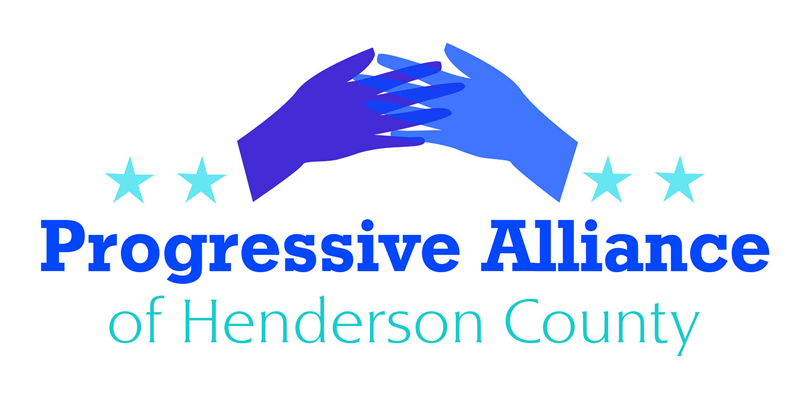
Postcard Party # 131 July 26, 2019

National
BEE-KILLING PESTICIDES
The Environmental Protection Agency (EPA) said Monday it will allow states to use a pesticide that is harmful to bees. The agency made an emergency exception for 11 states to use sulfoxafloron cotton and sorghum crops.
A study published in Nature last year found sulfoxaflor inhibited bumblebee reproduction.
Sulfoxaflor’s use was temporarily barred after a lawsuit from beekeepers in 2015, but the EPA in 2016 changed its instructions for how to use the pesticide in a way designed to reduce the impact on bees. Cotton and sorghum were not included in the directive.
The collapse of honeybee colonies can be attributed in large part to increased use of pesticides for agricultural crops. Sulfoxaflor is a bee-killing pesticide that was banned in 2015 because it was killing so many bees, but under the Trump administration, it's being used again.
Write to your MOCs, and demand that they support legislation to override the EPA's decision. Also voice your opinion directly to the EPA. (Andrew Wheeler, Administrator of the Environmental Protection Agency, 1200 Pennsylvania Ave., NW, Washington, DC 20460)

U.S. TO SPEED UP DEPORTATIONS WITHOUT COURTS

U.S. to ramp up rapid deportations with sweeping new rule. Reuters: “The Trump administration said on Monday it will expand and speed up deportations of migrants who enter the United States illegally by stripping away court oversight, enabling officials to remove people in days rather than months or years. Set to be published in the Federal Register on Tuesday, the rule will apply ‘expedited removal’ to the majority of those who enter the United States illegally; unless they can prove they have been living in the country for at least two years. Legal experts said it was a dramatic expansion of a program already used along the U.S.-Mexican border that cuts out review by an immigration judge, usually without access to an attorney. Both are available in regular proceedings. ‘The Trump administration is moving forward into converting ICE (Immigrations and Customs Enforcement) into a ‘show me your papers’ army,’ said Vanita Gupta, the president of The Leadership Conference on Civil and Human Rights.”

Contact your MOCs, as well as the acting head of Homeland Security: The Honorable Kevin K. McAleenan, Acting Secretary of Homeland Security, Washington, D.C. 20528

TRUMP USDA WANTS TO TAKE MILLIONS OFF FOOD STAMPS
Trump USDA proposes new rule to strip food stamps from over 3 million Americans. Common Dreams: “The U.S. Department of Agriculture on Tuesday proposed a new rule that would strip food stamps from more than three million Americans. USDA chief Sonny Perdue, in a call with reporters Monday, said the rule change would end automatic food stamp eligibility for those receiving other forms of federal and state assistance. The 60-day comment period on the proposal is set to begin Wednesday. Tens of millions of people suffer from hunger and food insecurity each year in the United States, and the SNAP program is widely recognized by experts as an effective way to reduce hunger-particularly among children. Policy experts, lawmakers, and commentators warned the Trump administration’s proposed rule-described by one critic as ‘unconscionable’-would increase hunger among vulnerable Americans.

Contact your MOCs, as well as the Secretary of the USDA: Sonny Perdue, Secretary of Agriculture, U.S. Department of Agriculture, 1400 Independence Ave., S.W., Washington, DC 20250

BUSES ARE NO PLACE FOR BORDER PATROL
Throughout the country, people rely on Greyhound to get to work, visit family, or to simply travel freely. But Greyhound has been letting Border Patrol board its buses to question and arrest passengers without a warrant or any suspicion of wrongdoing.
Greyhound is owned by FirstGroup plc, a multi-national transport group based in the UK, whose own Code of Ethics and Corporate Responsibility contradicts what its subsidiary has been doing to passengers. "We are committed to recognising human rights on a global basis. We have a zero-tolerance approach to any violations within our company or by business partners."
Greyhound's complicity in the Trump deportation machine is a clear violation of the human rights values that FirstGroup professes to uphold.

Make your feelings known to FirstGroup America Headquarters, 600 Vine Street, Suite 1400, Cincinnati, OH 45202

