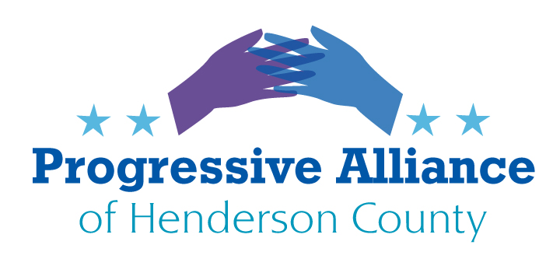

**Post Card Party # 267 January 19, 2023**

**GREETINGS TO POLITICS 2024**

**IS THE EX-PRESIDENT REVIVING THE KU KLUX KLAN?**

**NEO-NAZI / KLAN-LIKE RHETORIC FROM THE EX-PRESIDENT**  
The ex-President has been using Nazi and Klan-like rhetoric as a feature of his current campaign. He promises to rid our country of “vermin” who disagree with him, e.g. the 81 million people who voted for Joe Biden in 2020. He weaponizes his demagoguery, saying that immigrants are coming into the U.S.A. “poisoning the blood of our country”, a line straight out of Hitler’s “Mein Kampf”.

**Please write to Representative Chuck Edwards, Senator Ted Budd, Senator Thom Tillis, NC Senator Tim Moffitt, and NC Representative Jennifer Balkcom to ask that they condemn Klan attacks on Americans and that they find a better candidate for President than the ex-President.**

**PRESERVING ESSENTIAL SERVICES FOR AT RISK COMMUNITY MEMBERS**

**PISGAH LEGAL SERVICES IS LOSING ESSENTIAL FEDERAL GRANT FUNDING, HAVING TO CUT DOMESTIC VIOLENCE SURVIVOR PROGRAMMING**

FROM THE ASHEVILLE CITIZEN TIMES, 12/28/23:  
[Pisgah Legal Services] may soon make significant cuts to its domestic violence survivor programming after losing funding from several federal grants.

Pisgah Legal Services provides free civil legal aid to low income WNC residents. It consults with clients to fight evictions, arrange health insurance and find protection from domestic violence.

For the 2024 calendar year, Pisgah Legal faces a $1 million funding gap previously filled by the federal Crime Victims Fund, Violence Against Women Act and American Rescue Plan, Pisgah Legal Executive Director Jim Barrett told the Citizen Times Dec. 27.

A plurality of the funding from these programs flowed to the organization’s domestic violence prevention services, Barrett said. To bridge this gap, Pisgah Legal and other organizations unsuccessfully lobbied Raleigh legislators. Now these organizations are turning to counties and donors for help, before turning to municipalities.  
  
**Please write to Henderson County Commissioners Rebecca McCall, William Lapsley, David Hill, Daniel Andreotta, and J. Michael Edney to leverage and coordinate local funding, including from Henderson County funds, for these essential services. Address for all of the Commissioners: Henderson County Courthouse, 1 Historic Courthouse Square, Hendersonville, NC 28792.**

**THREE CHEERS FOR IMMIGRATION**

From our very own Hendersonville Times News (BlueridgeNow.com), Jan. 13, 2024:

“Today, if it weren’t for immigration, the population of the United States would be shrinking, [the Cato Institute’s David] Bier said, because of low birth rates and rising deaths due to an aging population. Population growth rates in the 2020s are the lowest of any decade in the history of the U.S., which is bad for the economy, he said.

“The Census Bureau projects the U.S. population will begin declining in the second half of this century in a low-immigration scenario. In a zero immigration scenario, the population decline would begin this year.

“’We need immigration to make up for the fact that we’re having fewer children and people are living longer and retiring,” he said. “It puts upward pressure on the cost of living if more people are consuming and fewer are producing. That puts a drag on economic growth.’”

**Please write to Representative Chuck Edwards, Senator Ted Budd, and Senator Thom Tillis to ask them why they are trying to destroy our country’s economic growth by promoting panic about immigration. Yes, there must be a comprehensive bipartisan reform of our immigration system, including adequate funding of all of the necessary agencies involved in immigration and adequate fiscal support to all areas of the U.S.A. that are affected by current and future influxes of immigrants.**

**WHY DOES CHUCK EDWARDS FAVOR ALLOWING WOMEN TO DIE?**  
In among his first acts on arriving in Washington, DC in January 2023 Chuck Edwards broke faith with his campaign promise to not vote for national anti-abortion legislation. He is a poster-child example of the ultra-right’s obsession with exercising power and control over women at all ages and in all circumstances. Chuck Edwards pretends to be “pro-life” when it is abundantly clear that, since Roe v Wade was struck down in 2022, every state that passed extreme abortion restrictions has put thousands of women at risk of severe health impairment or death when their medical condition requires abortion and miscarriage care, BECAUSE EVEN WHEN THERE ARE “EXCEPTIONS” FOR THE HEALTH OF THE PREGNANT WOMAN THOSE “EXCEPTIONS” ARE NOT OBTAINABLE AND, THEREFORE, FICTITIOUS.

**Please write to Representative Chuck Edwards to demand that he stop advocating for the negligent “manslaughter” of women throughout our country who need unrestricted access for abortion care when prescribed by their healthcare provider.**

**Please send postcards to our nearest local Planned Parenthood office at 68 McDowell St, Asheville, NC 28801, to express support for their efforts to provide abortion and other reproductive health care, despite the restrictions politicians have placed on this necessary medical care.**

**AND NEXT!!!:**

