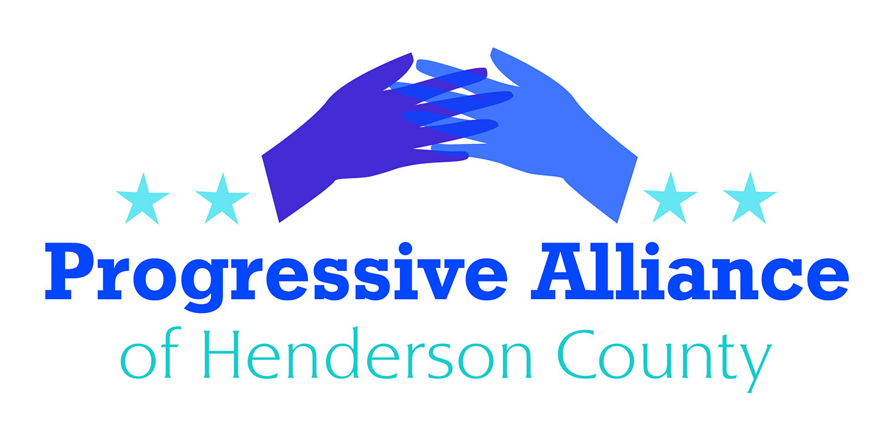
Postcard Party # 130 July 19, 2019

National

URGE CONGRESS TO HOLD BORDER PATROL AGENTS ACCOUNTABLE
On July 1, ProPublica published an expose of a secret Facebook group where 9,500 current and former Border Patrol agents mock the deaths of detained immigrants and post racist and sexist content. The three year old Facebook group is just the latest evidence of a disturbing culture of white supremacy and sexism among Customs and Border Patrol (CBP) employees.

While the Trump administration has dramatically escalated the detention and abuse of immigrants crossing the border, CBP agents’ culture of racist cruelty is longstanding. In 2014, a group of 116 unaccompanied immigrant children held in CBP detention filed a complaint alleging that agents denied them adequate food and water, blankets, and essential medical care.

Inexplicably, members of Congress, including Democrats, have approved a massive funding boost for CBP without adequate provisions to ensure the money is spent on aid rather than expanding Trump’s detention of asylum seeking immigrants. Instead of perpetuating CBP’s atrocities, Congress must demand a robust investigation of CBP and the termination of all active agents posting racist content online. Further, Congress must commit to opposing any additional funding for CBP as long as the agency continues to hold innocent people in appallingly dangerous conditions.

Contact Senators Burr and Tillis and Congressman Meadows to express your thoughts on this matter.

DEFYING CONGRESSIONAL SUBPOENA
White House Counselor Kellyanne Conway did not show up to testify at a hearing on Monday about Hatch Act violations for a second time, despite being issued a subpoena by the House Oversight and Reform Committee following her absence at the first hearing last month.
Write to Nancy Pelosi, and demand that the House Democrats start holding Administration officials in contempt of Congress when they ignore a legal demand to testify. (Congresswoman Nancy Pelosi, Speaker of the House, 1236 Longworth H.O.B., Washington, DC 20515)

TRUMP ADMINISTRATION TO END ASYLUM PROTECTIONS
The Trump administration on Monday announced it is moving to end asylum protections for most Central American migrants. The departments of Justice and Homeland Security unveiled a new rule that would require migrants fleeing their home countries to apply for asylum in the first country they reach - or become ineligible for asylum once they reach the U.S.
DHS Acting Secretary Kevin McAleenan said that the agency's "action will reduce the overwhelming burdens on our domestic system caused by asylum-seekers failing to seek urgent protection in the first available country."
But Lee Gelernt, deputy director of the Immigrants’ Rights Project at the ACLU, argued the "administration is trying to unilaterally reverse our country's legal and moral commitment to protect those fleeing danger. This new rule is patently unlawful and we will sue swiftly.”

Contact Senators Burr and Tillis and Congressman Meadows, as well as the acting head of Homeland Security: The Honorable Kevin K. McAleenan, Acting Secretary of Homeland Security, Washington, D.C. 20528

State

GOP BUDGET
The GOP budget proposal short-changes our public schools once again. The numbers are clear when you adjust for inflation and enrollment.
- Enrollment in NC’s public schools is up 5.4% over the last decade. State spending is 2.9% below pre-recession levels (inflation/enrollment adjusted) of 2008-09 before the “Great Recession”.
- In this budget, the state would fund nearly 800 fewer teachers than in 08-09.
- State would fund 7,730 fewer teaching assistants than in 08-09.
- State would spend 40% less on textbooks and classroom supplies (inflation/enrollment adjusted).
- South Carolina already spends 21% more per student than North Carolina.

Contact Sen. Edwards, and Rep. McGrady or Henson, to encourage them to vote against overriding Cooper's veto. In addition, contacting Democratic members of the NCGA would be worthwhile.

CODY HENSON GETS ANOTHER CONTINUANCE
Cody Henson’s cyberstalking case has been continued for the third time. The lawmaker’s attorney, J. Michael Edney, attributed the delay to legislative necessity. “They needed him in Raleigh,” said Edney, who is also a county commissioner in Henderson County.

Evidently the GOP leadership’s need for him in Raleigh is more important than his victim’s receiving justice in court. Instead they should be demanding Henson’s resignation.

Contact Sen. Edwards and Rep. McGrady and ask why they have not spoken up about this. Write Cody Henson to express your feelings.

