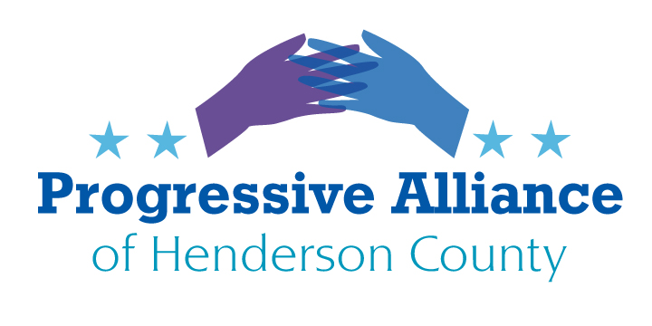
Post Card Suggestions # 188 Aug. 28, 2020

Amazon, et al
Luckily, deliveries of many things during the pandemic have been a tremendous safeguard against the vulnerabilities of going out into the world as well as a convenience.
However, considered objectively, in more ordinary times we hope will soon come, can we, as well as most of the developed world, continue to use our resources in pursuit of what, for the majority of us, is simply a luxury? Take, for instance, a typical multi-item order from Amazon or Walmart. Delivery might be by UPS, FedEx, USPS, etc. Since items are often supplied by different merchants and arrive separately this can mean a truck in your driveway for each one, no matter the size or cost. The damage to local merchants aside, the overall cost of this self-indulgence is huge in terms of the environment- more trees cut for paper, more paper waste for landfills and more pollution into the atmosphere.
Amazon, in particular, has played on the ‘freedom and privilege’ of making virtually all your purchases from them online, with extremely convenient delivery, regardless of the item. Many of our friends, relatives and neighbors brag about being members of Amazon Prime. Is delivering a single sleeve of paper cups by a driver in a truck a waste of energy and labor? What do you think?
This extravagance depends on low wages and no benefits for drivers and warehouse workers, cheap fuel and a public dependent on fewer and fewer suppliers. Do we need to encourage and support more dead-end jobs in this country?
Make your own decisions about how and who you buy from, but write Congress to express your concern that long-term we need to regulate the big tech companies before their take-over is complete.
ICE and the Detention of Children
Seemingly lost in the Pandemic and the upcoming election are 120 children ordered by a Federal judge June 26, 2020 to be released within 30 days. According to the Flores Settlement, a 23 year old class action lawsuit which laid the ground rules for children’s rights held in immigration detention, children cannot be held for more than 20 days. Many children have been detained much longer; 47 children in a Texas facility have been incarcerated for more than 300 days. Increased cases of Covid among the ICE- held children are “on fire” according to the judge.
ICE and lawyers representing the children have been unable to agree on how to safely and humanely remove children from custody, which of course, in most cases, means removal from their incarcerated families. ICE could choose to release entire families to relieve the pain and danger of detention but have chosen not to. The judge originally gave ICE two options on June 26: release the children to sponsors with parental consent or release the parents and children together. So far, ICE has refused to release families together. The judge has admonished ICE for failure to comply with the ruling and find solutions to the problem.
Write Congress and demand that ICE comply with legal rulings, and above that, act with humanity and above political pressures from uncaring politicians.
School Vouchers in NC
Children’s Law Clinic, Duke University Law School
There are differing opinions about school vouchers and charter schools, depending on one’s point of view. Those in favor of this system look for benefits from religious-based schooling and lack of governmental controls on how our youth are educated. Those opposed to the current concept of charter schools may feel that there should be a separation between church and state and/or that educational standards should be maintained through controls on curriculum and measurement of results in the classroom.
Regardless, the Duke University Law School published a study which outlined the experience in NC with its school voucher system so far. Some of the pertinent findings:
93% of the vouchers have been used to pay religious school tuition in NC
More than half the students using vouchers are performing below average in reading, language, and math. Similar public school students in NC are scoring above the national average.
Educational accountability in NC private school receiving vouchers is among the weakest in the country. The schools need not be accredited, adhere to state curricular or graduation standards, employ licensed teachers, or administer state end-of-grade tests.
Private schools receiving vouchers in NC are not required to administer state tests nor publish detailed achievement data. Therefore, we will be unable to reach valid conclusions about the success of the program at improving educational outcomes for participating students.
The NC voucher program is well designed to promote parental choice, especially for parents who prefer religious education for their children. It is poorly designed, however, to promote better academic outcomes for children and is unlikely to do so.
So, what are the costs of “freedom” from regulation?
Whatever your beliefs, write Governor Cooper and our legislators to tell them your feelings.

