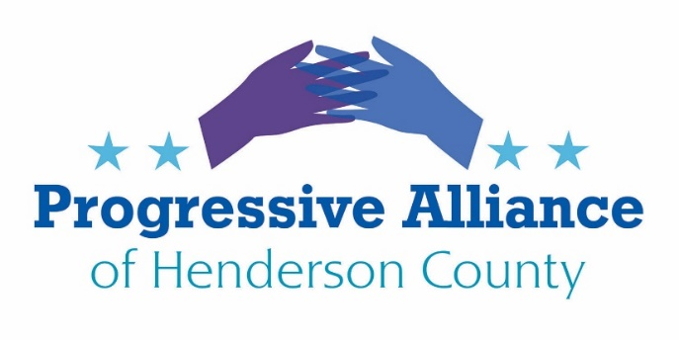

Postcard Party # 140 September 27, 2019

National

SCHOOL LUNCH RULE CHANGES
(From the Washington Post, Tuesday, Sept. 24)
About a half-million students could lose access to free school meals under a Trump administration proposal to limit the number of people who qualify for food stamps.
The change, proposed over the summer, would cut an estimated 3 million people from the Supplemental Nutritional Assistance Program. It is intended to eliminate eligibility for people who get food stamps because they have qualified for other forms of government aid, even though they may have savings or other assets. But the impact of the cuts is anticipated to go further: Children in those households could also lose access to free school lunches, since food stamp eligibility is one way students can qualify for the lunches.
Write to NC11 Rep. Meadows, and Senators Tillis and Burr, asking them to immediately introduce and support legislation to overturn this rule change.

EXTREME RISK PROTECTION ORDER
Extreme Risk Protection Orders (ERPOs)—often known as “red flag laws”—empower families and law enforcement to prevent gun tragedies by temporarily restricting access to guns for individuals at an elevated risk of harming themselves or others.
ERPO Talking points:
- They can prevent homicides and suicides, and we need them in North Carolina.
- In many shootings, including interpersonal violence and suicides, family and household members are the first to notice changes in behavior indicating that an individual may become a danger to themselves or others.
- This law will save lives while ensuring that all steps for due process are followed.
- Extreme Risk Protection Order (ERPO) legislation is a bi-partisan, common sense solution to reduce both homicides and suicides. ERPOs provide families and law enforcement a way to help ensure that people who state that they plan to hurt themselves or others have their access to guns temporarily restricted.
- 17 states plus Washington, DC have enacted ERPO legislation because it works. It addresses impulsive behavior. Shooters in Parkland, Florida; and Isla Vista, California had behaviors that would have set the ERPO process in motion, had ERPO laws been in place in those states at the time.
- These laws prevent suicides, which are almost two-thirds of all gun deaths in NC and nationally. Research from Connecticut has shown that for every 10-11 ERPO orders, one suicide has been prevented. We want the same protection for our friends, families, and communities in NC.
Write Representative McGrady, Senator Edwards, Senator Burr, Senator Tillis to express your views.

State / Local
GOP TAKES A VACATION WITHOUT PASSING TEACHER PAY RAISES
It has been at least three months since Gov. Cooper sent a compromise offer to GOP leaders with radio silence in return. But despite not passing a budget, Republican lawmakers decided to head home last week with no plans to return until September 30.
Instead of negotiating a compromise, Republican leaders have left the state without a budget that addresses education funding and health care in favor of more corporate tax breaks.
Contact State Senator Edwards and Rep. McGrady to express your views.

MEDICAID EXPANSION IS BACK ON THE TABLE AT THE NC GENERAL ASSEMBLY
The latest maddening and semi-hopeful development in this seemingly never ending saga arose in the aftermath of the September 11 budget veto override debacle when House Speaker Tim Moore announced that he would fulfill “a promise” to revive the GOP version of the proposal now that the House was “finished” with the budget.
Last week, the measure – House Bill 655 – was approved by the House Health Committee on a voice vote and forwarded on to the House Rules Committee. The same committee had already taken the same action on a very similar version of the proposal back in July in a 25-6 vote.
Contact NC Rep. McGrady to offer your personal guidance on how he should address and negotiate this issue.

CLEAR CREEK PROJECT

The Henderson County Planning Board has approved a proposed development along I-26, just north of Cumberland Village and NW of Carolina Village. The development will encompass at least 71+ acres, and the developer has requested permission to build 120 townhouses and 190 detached houses, the latter with projected prices of $350k+. The land will essentially be clear-cut, with the primarily-forested and wildlife-rich area losing over 800 large trees (trunk diameter of at least 12 inches) as well as brushlands and other critical habitat. The City Council will need to approve a zoning amendment and annex the land so water and sewer ser ices can be provided. This issue is scheduled to come before Council in November. If you are concerned about losing our natural ecosystems and beauty to unbridled development, voice those concerns to all members of the Council:

Mayor Barbara Volk; Mayor Pro Tem Ron Stephens; Council Members Steve Caraker, Jerry Smith, and Jeff Miller at City Hall, 160 6th Ave. E., Hendersonville NC 28792-4328

