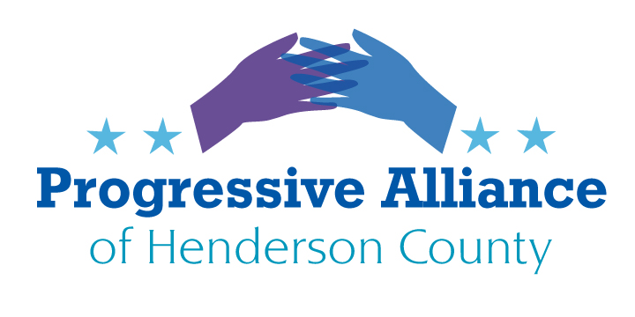
Post Card Party # 259 March 1, 2023
In line with the PAHC directing itself to more local issues for the forseeable future, this sheet is dedicated to issues at the State level, and especially to what is happening in the NCGA. Contact your State rep and senator on any of the issues that ruffle your feathers!

From: Progress NC Action, February 16

The North Carolina General Assembly has been back in session for just over a month now and the past couple of weeks have been hectic.

Left in the dust kicked up by legislative Republicans trying to expedite the process of taking away your rights, read below for a quick summary of the most critical bills working their way through the General Assembly.

House Speaker Tim Moore's proposed rule changes meant to give him unchecked power and the ability to take away your rights with (literally) no warning were approved on Wednesday by a 76 - 43 vote. The new rules will allow Moore to call for votes, including veto overrides, at any time. Previously, 48 hours' notice was required but now If a single Democrat is sick or has a family emergency, Republicans can vote to take away your rights. If the NCGOP were acting in good faith on behalf of the people they were elected to represent they would not need to resort to “gotcha” tactics and cheating.

This week, Republicans in the House fast-tracked an intentionally vague, racist and undemocratic "anti-riot" bill that will punish protesters with mandatory jail time. The "Prevent Rioting and Civil Disorder" bill, HB40, is part of a larger right-wing agenda that includes gaining power, silencing dissent and ending with North Carolinians' First Amendment freedoms being taken away. The bill passed the House by a 75-43 vote. It is currently in a Senate committee.

In another successful attempt to make all North Carolinians less safe, Senate Republicans advanced a bill this week that would make it easier for North Carolinians to buy handguns and carry concealed weapons in more places - such as churches and schools based in houses of worship. Separate companion bills, HB49 and HB50, also advanced through a House judiciary committee. Republicans have repeatedly shown they are focused on the wrong priorities. They are intent on making it even easier to obtain a gun - even bypassing common sense safety precautions supported by a majority of North Carolinians.

To end with some good news, more than 600,000 low-income North Carolinians could soon have health coverage through Medicaid after the House approved expansion legislation on Thursday by a 92-22 vote. HB76 is now headed to the Senate where it also has bipartisan support, but Republicans there want additional measures added. Democrats have been calling for Medicaid expansion for around a decade.

From: Progress NC Action February 23

Republicans are attempting yet another power grab in the North Carolina legislature. Earlier this month, a bill seeking to make the N.C. Board of Education an elected body instead of an appointed one, passed an important House committee. If it passes and gets adopted into law, HB17 would give North Carolinians the opportunity to amend the state's Constitution to make the board elected and to make the state superintendent the voting chairperson of it.

The North Carolina governor has the power to appoint 11 of the 14 board members, with legislative approval. Appointees serve eight-year terms. The state superintendent, lieutenant governor and state treasurer also serve on the board.At least 60% of the House and 60% of the Senate would need to approve HB17 in order for the constitutional amendment to be put to the voters.

Rep. Marcia Morey, D-Durham, voted against the bill and told WRAL, “I’m very worried about taking away that responsibility of the governor, putting it into another partisan political race.”

Thankfully, the bill still has a long way to go before it could even theoretically be adopted into law – the House Education Committee approved the bill on a 16-9 vote. It will need to pass through the House Rules Committee, then pass the full House, and then go through the same steps in the Senate.

NC Republicans vote to continue cycle of gun violence by making it easier to obtain handguns
Over the last two weeks, Republicans in the General Assembly have passed multiple gun bills with the apparent goal of making all North Carolinians less safe. Republicans in the Senate passed SB41 late last week on a 29-19 party line vote. The House passed HB49 and HB50 through their judiciary committee. House Bill 50, which removes the state's pistol permit requirements, passed the full House on Wednesday with all Democrats in opposition.

In the Senate, Republicans used parliamentary maneuvers to block floor votes on several proposed Democratic amendments to tighten gun laws, such as universal background checks for all weapon sales and “red flag” orders.

73% of North Carolina voters said it was too easy to get a gun in America and 50% said it was much too easy. The same poll showed that 78% of North Carolina voters said they supported red flag laws and 89% of voters said they support background checks for all purchasers. These results all include a majority of Republicans.

We lose too many North Carolinians to gun violence every year. On average, 1,470 North Carolinians die by guns every year, or one North Carolinian every six hours. Republicans have ensured we have more guns and less accountability for gun owners. But there are common sense safety precautions that are supported by most people. Republicans have repeatedly shown they are focused on the wrong priorities. This is just another example.

NCGOP Changes the Rules When They Lose

https://www.hendersonvillelightning.com/four-seasons-politics/12494-moffitt-files-bill-to-make-school-board-elections-partisan.html

Moffitt files bill to make School Board elections partisan
A bill to switch Henderson County School Board elections from nonpartisan to partisan has received strong support from voters in Henderson County, state Sen. Tim Moffitt said last week.“I would say (calls and emails run) probably 20-to-1 in favor of the bill and most of the folks that are objecting to the bill are not from Henderson County,” he said. “They’ve relocated to Henderson County from somewhere else.”
https://www.newsobserver.com/news/local/counties/wake-county/article272553204.html
State GOP wants to change Wake County E;ections
A state bill that would change how Wake County commissioners are elected received a favorable vote from its first North Carolina General Assembly committee, despite objections from some Wake County Democrats. State Rep. Erin Paré, the sole Republican in Wake County’s legislative delegation, filed the local bill to make the Wake County commissioners elections nonpartisan and require that commissioners be elected by district, instead of by the county at large. It’s the most recent attempt by the state to change how Wake County commissioners are elected since Democrats took control of the seven-person board in 2014.
https://www.newsobserver.com/news/local/counties/wake-county/article272553204.html#storylink=cpy

